高级咨询课程大纲
崔教授Email: ckchui1@gmail.com

课程名称：高级咨询。MN542
课程内容：所有课程内容均由马丁·路德的“Sola Scriptura”( 唯独圣经)评估。本课程将使学生了解高级咨询入门课程。每周将有不同的课题进行学习和研究。学生将被要求自己学习和研究。将给予每个章节的作业，并在可能的情况下在下一周完成。 2页的摘要报告将在下一章节之前提交。
课程目标：课程结束时，学生将对高级咨询的许多方面有很好的了解。重点将放在每节课的反映之上。反思是基于您的想法和感受。本课程将训练您使用圣经的真理帮助他人。每天记录您如何帮助别人，从您的家人开始，然后到邻居, 同学和同事。
成绩标准：学生必须提交所有作业，并且每周必须提交一份2頁详细摘要和反思报告, 及期末考试。作业可以手写或打字。每個學生都必須撰寫一份長達4頁关心他人的事实收集报告, 必須在學期論文末尾提供參考。
先决条件：学生必须有学习圣经的愿望，并希望深入学习每一课。
教科书：各种版本的中文圣经。 图书馆还提供其他参考书籍。 互联网对研究也非常有用。 用Google找到您想要的资料。

需要最后的考试, 400分。每周提交所有2页的总结和反思报告，及一个 4页关心他人的事实收集报告, 400分, 将构成本课程的成绩。每个2页的总结和反思报告值得200分 (摘要为175分，反思为50分) 。所有作业报告必须用中文书写或输入。末期一篇总结反思文章将提供您在课程中学到的内容。长度至少为4页。值得400分 (摘要为300分，反思为100分)。完成得分将为3200分。
你必须尽快地提交作业。

=====================================================================================================
第 1 周

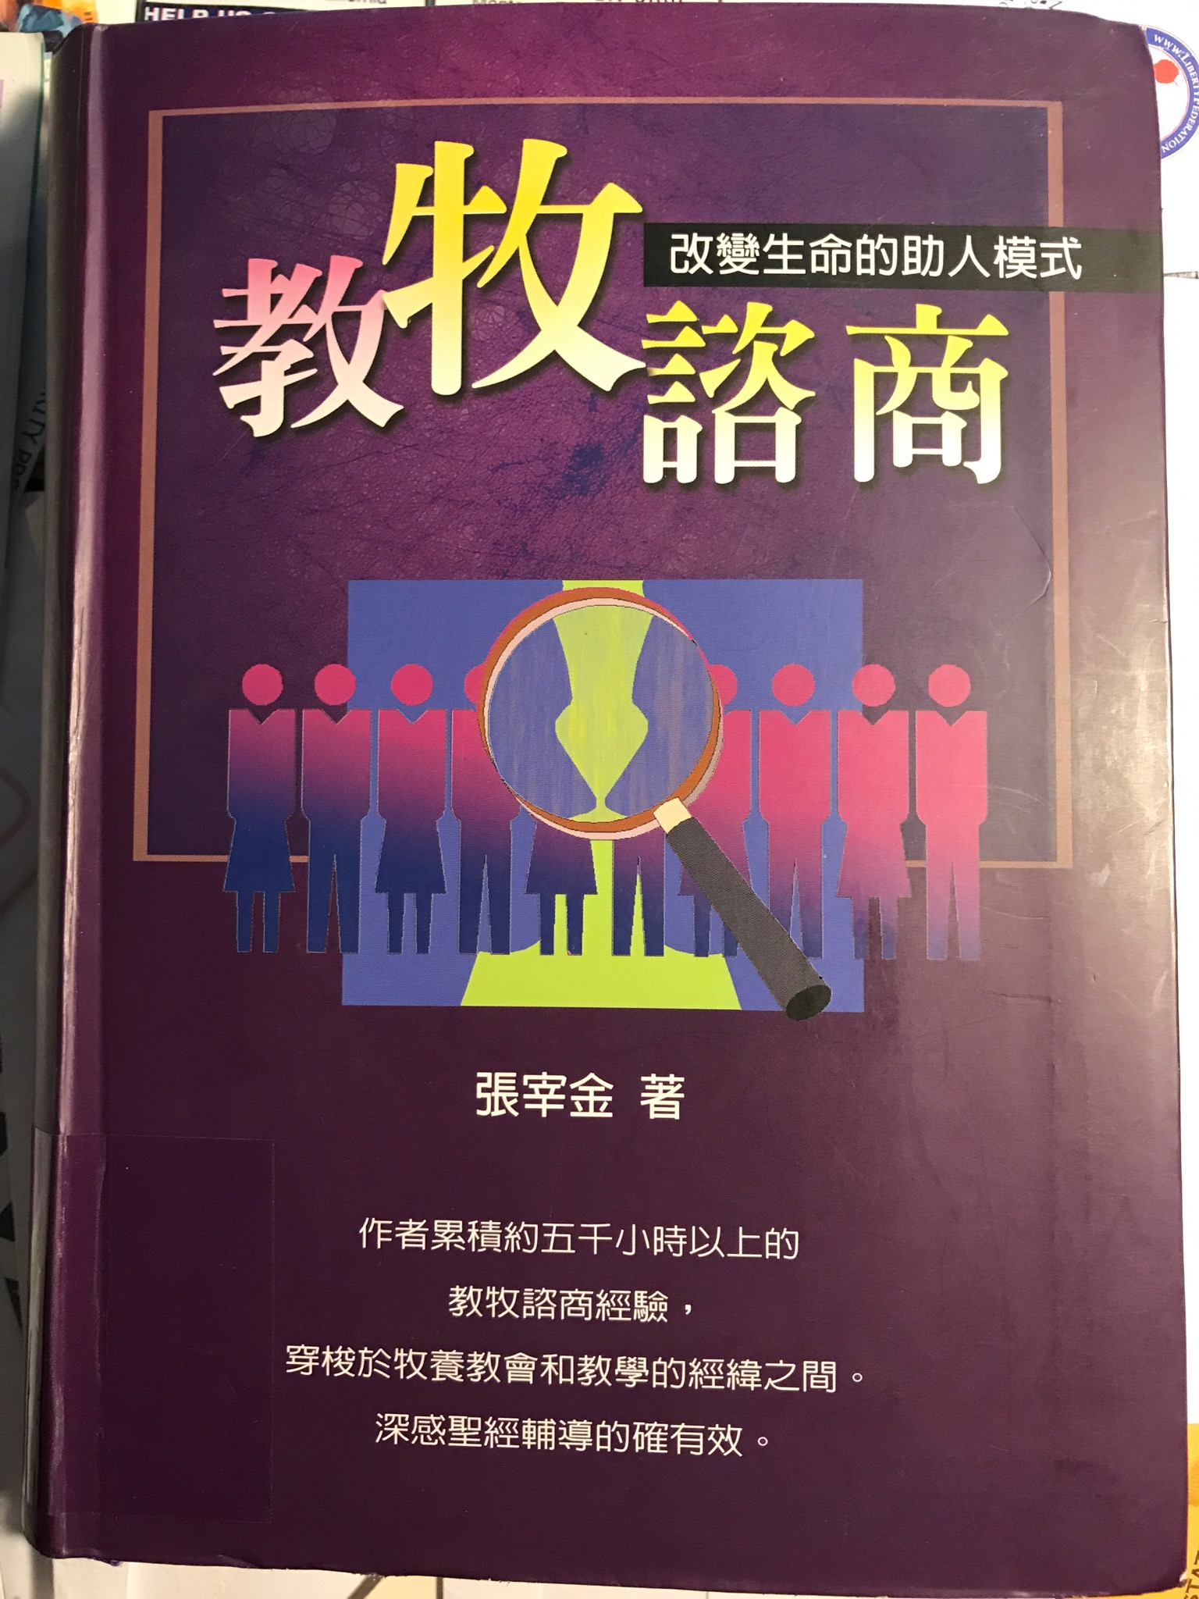
- Counseling is the responsibility of every Christian.
- The church is an organization for healing.
- Christians have the special privileged sources: The power of the Gospel; the presence of the Holy Spirit; spiritual gifts; Holy Sacraments—water baptism and holy sacrament; the authority of the Scripture; witnessing; and the support of other Christians and fellowship.

1. 咨询是每个基督徒的责任。
2. 教会是一个康复组织。
3. 基督徒有特殊的特权来源：福音的力量； 圣灵的存在； 属灵的恩赐； 圣礼-水洗和圣餐； 圣经的权威； 见证 以及其他基督徒团契和支持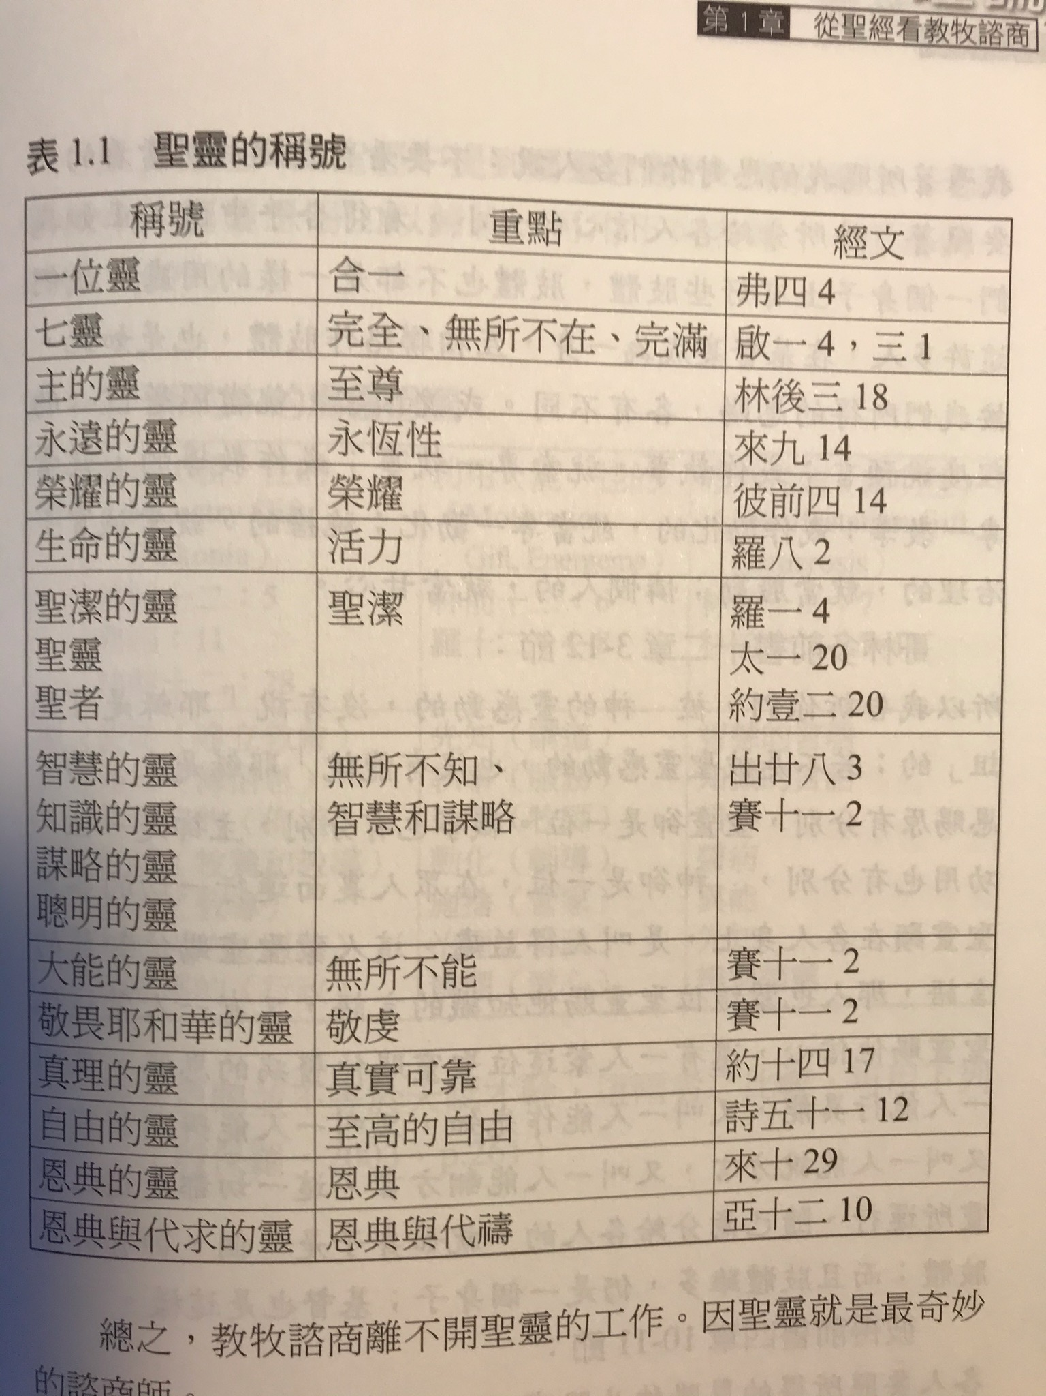

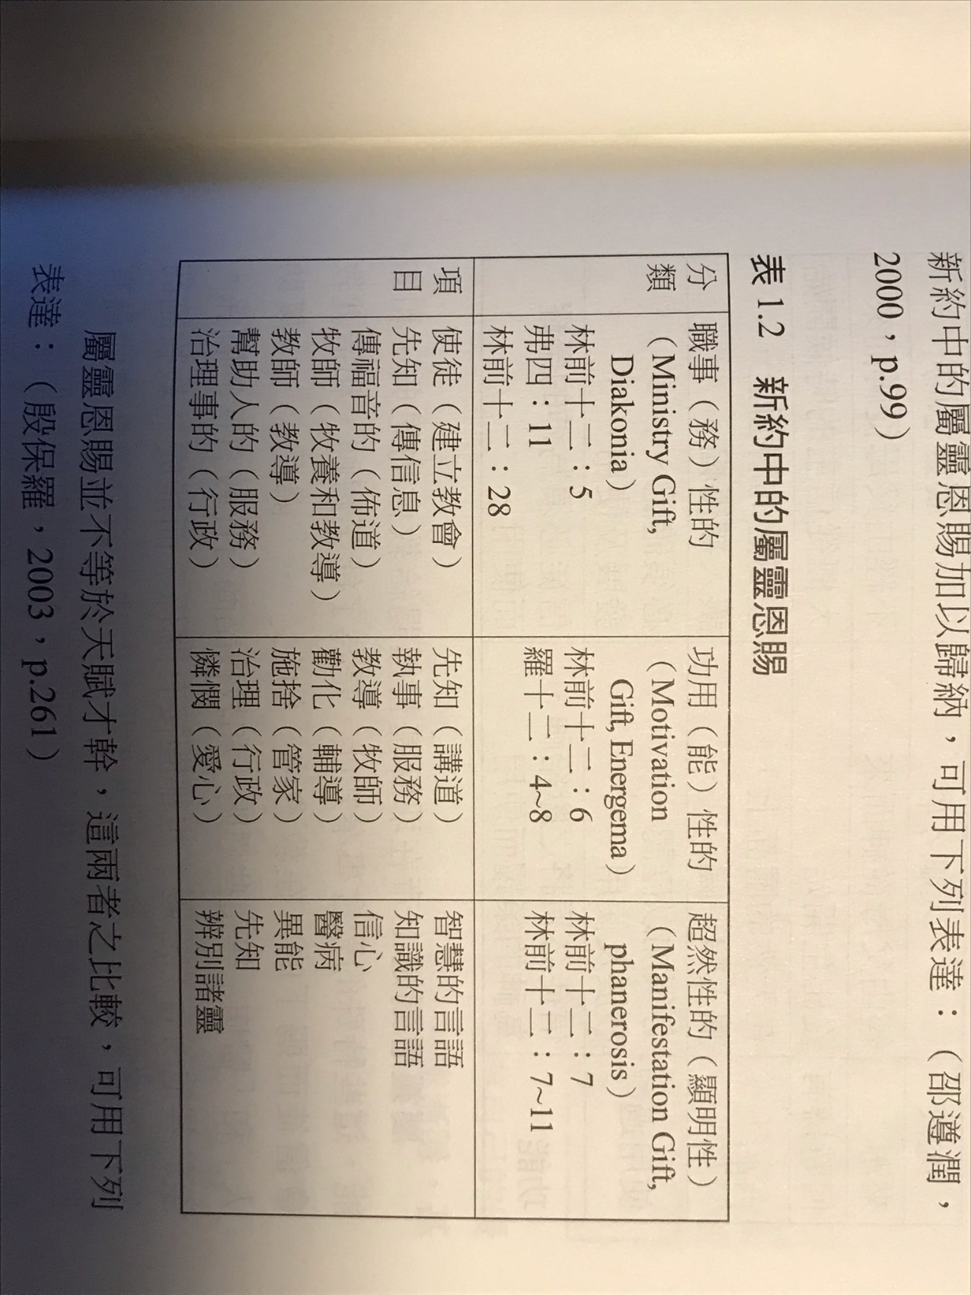

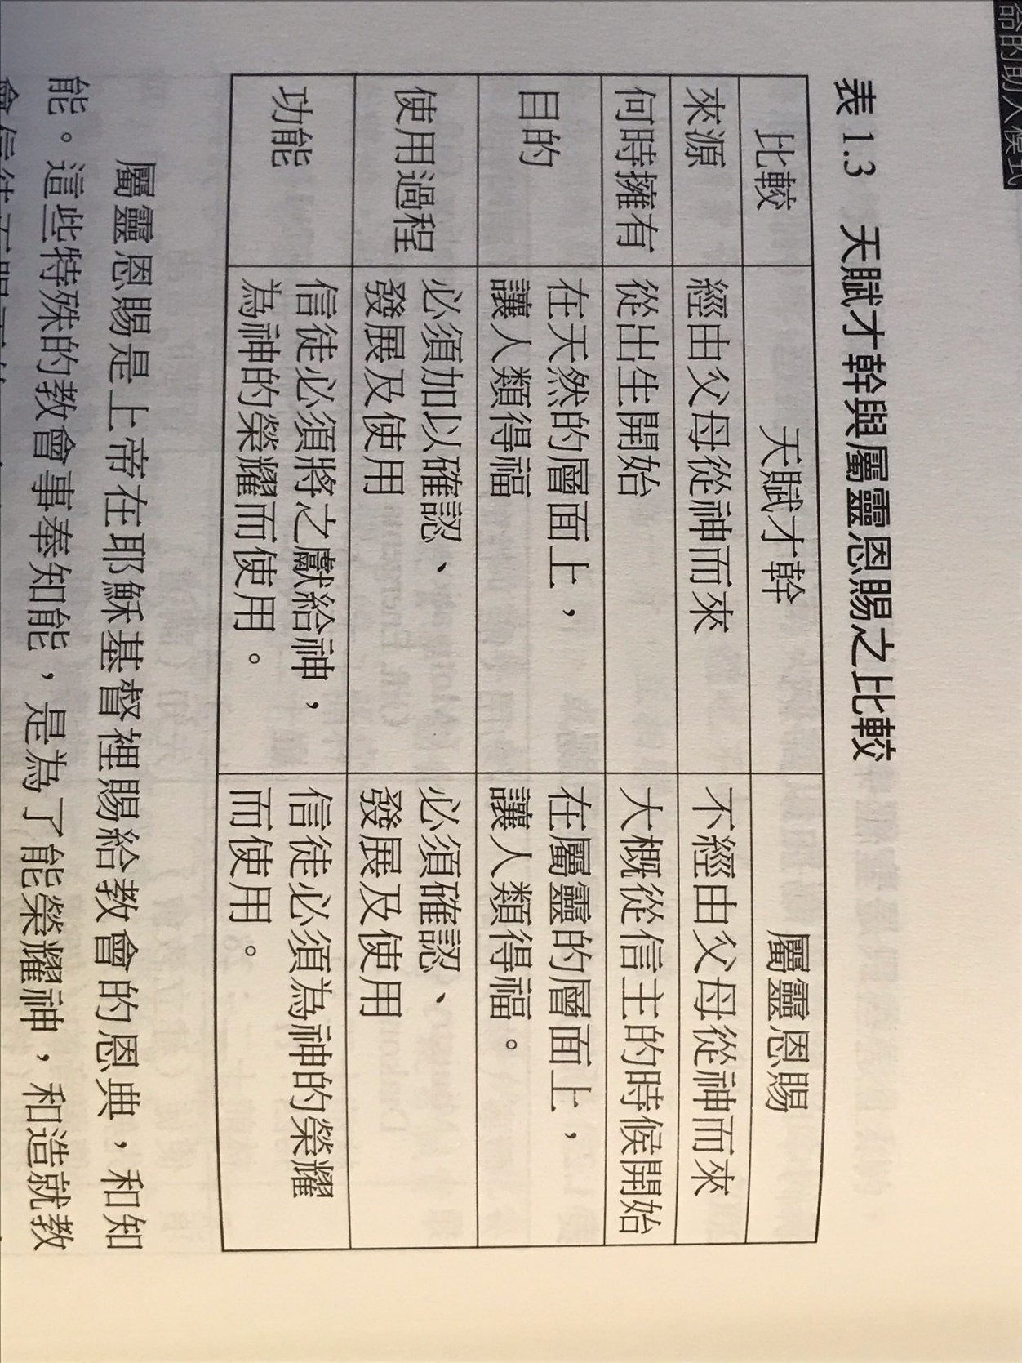

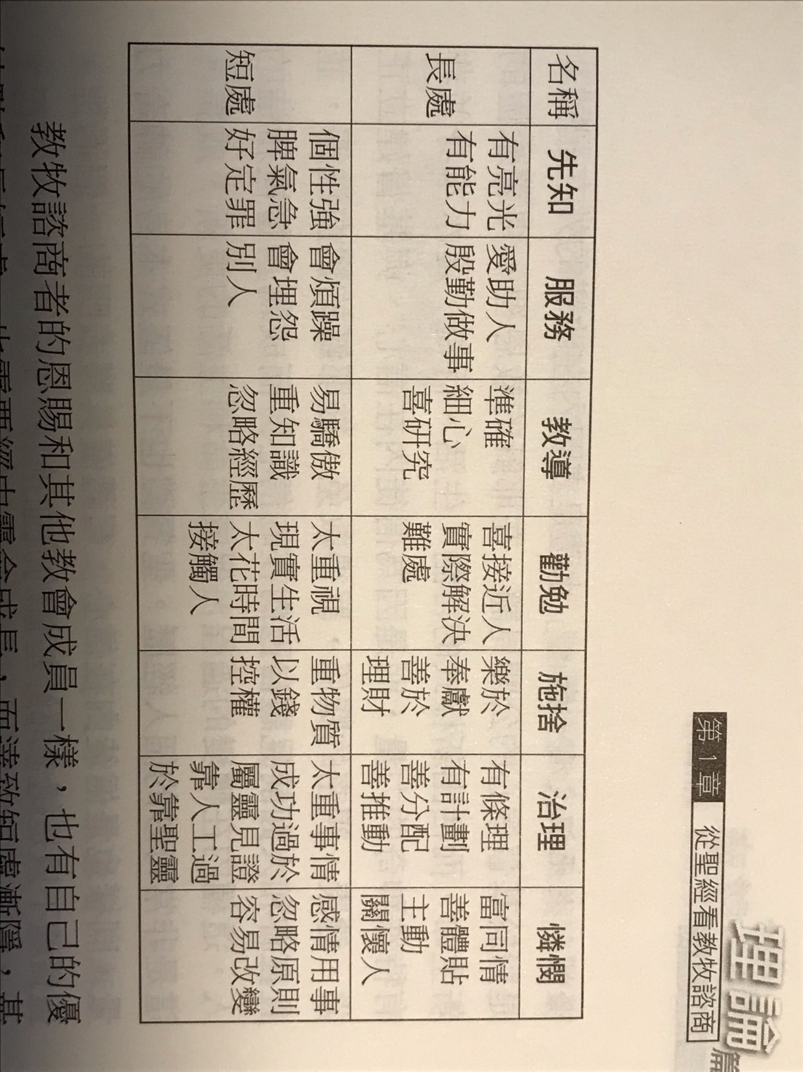

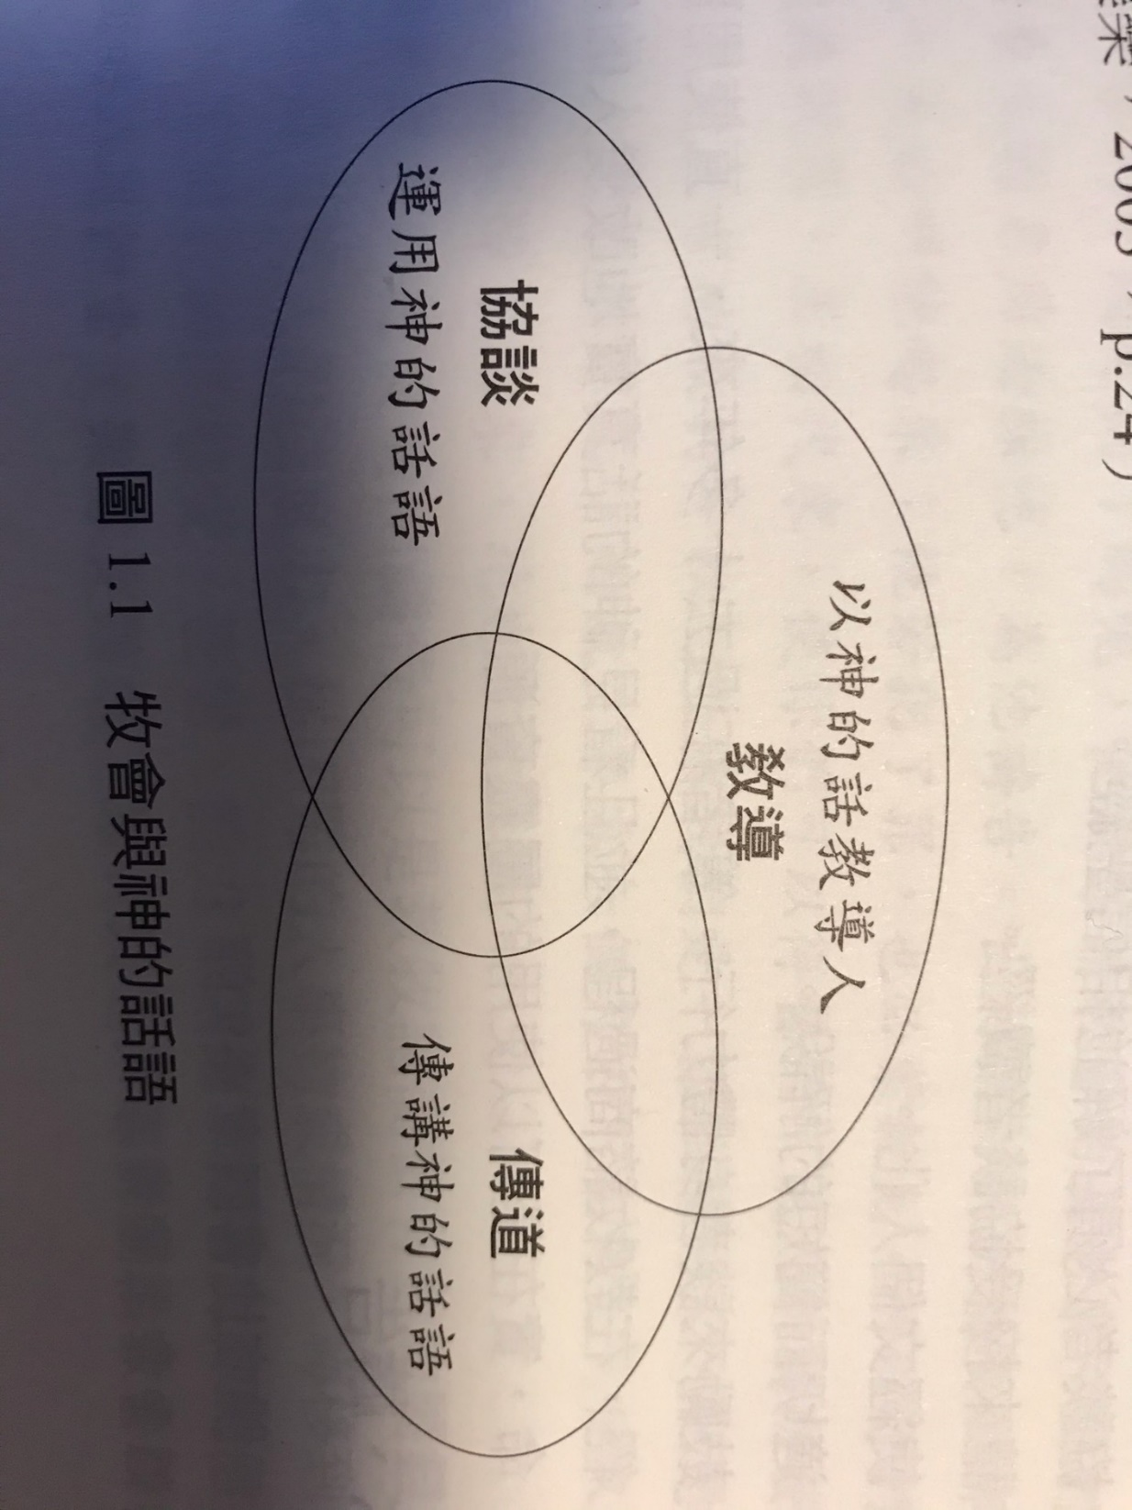

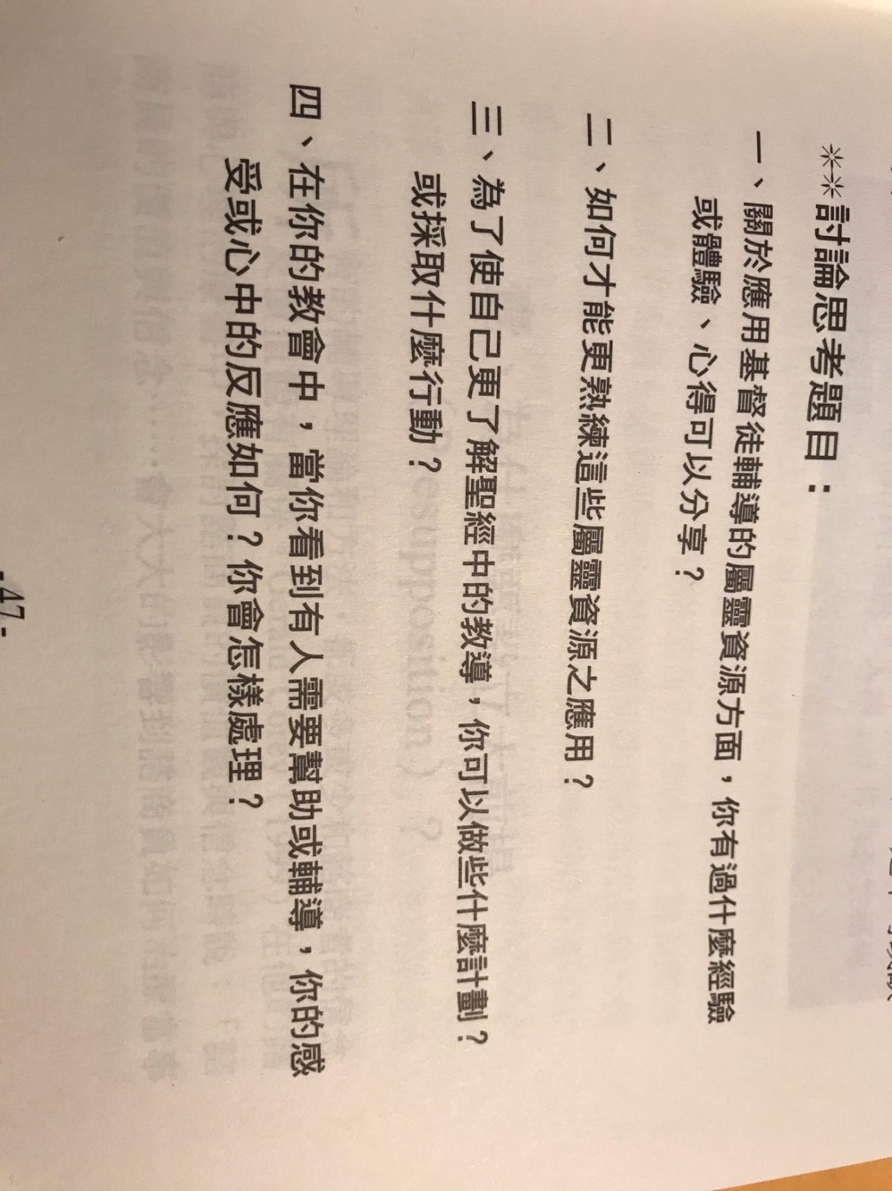

Big topics on counseling:
- Why we have presupposition?
- Counseling must be adhered to humanity views in the Bible: a man consists of mind, body, and soul; we are in God’s image.
- Man’s conditions when created; man’s conditions after fallen into sin.
1. 为什么会有预设？
2. 咨询必须遵循圣经中关于人性的观点：一个人由灵, 魂，体的组成； 我们拥有神的形像。
3. 人被创造的状况; 人陷入罪恶后的状况。
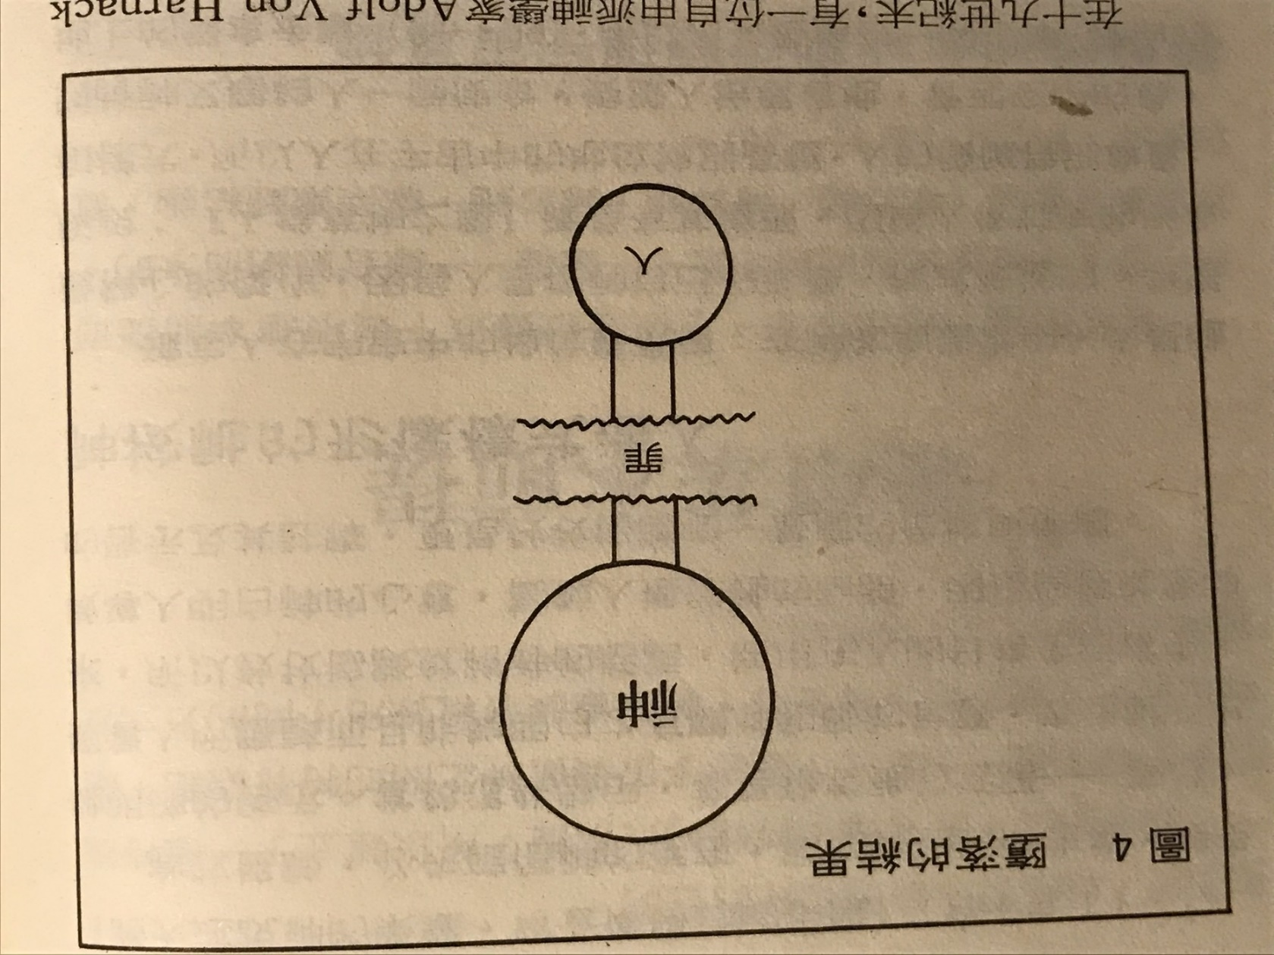
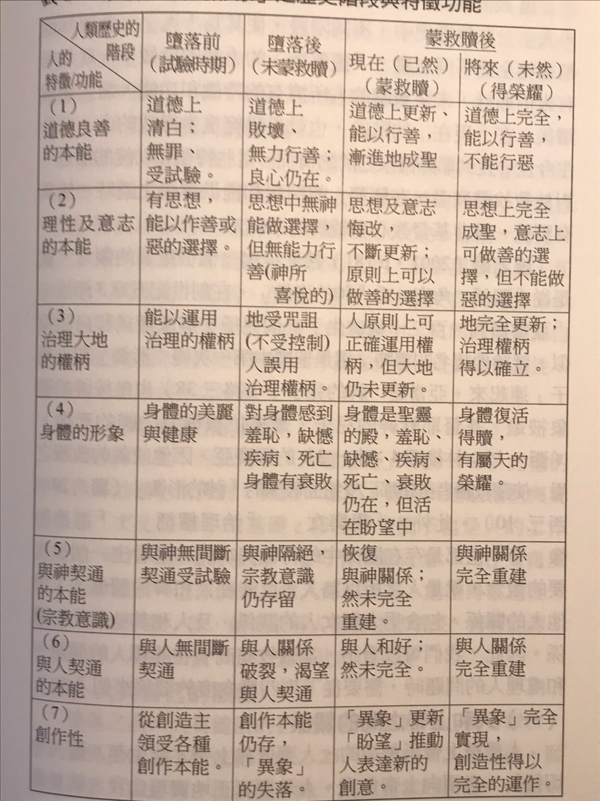

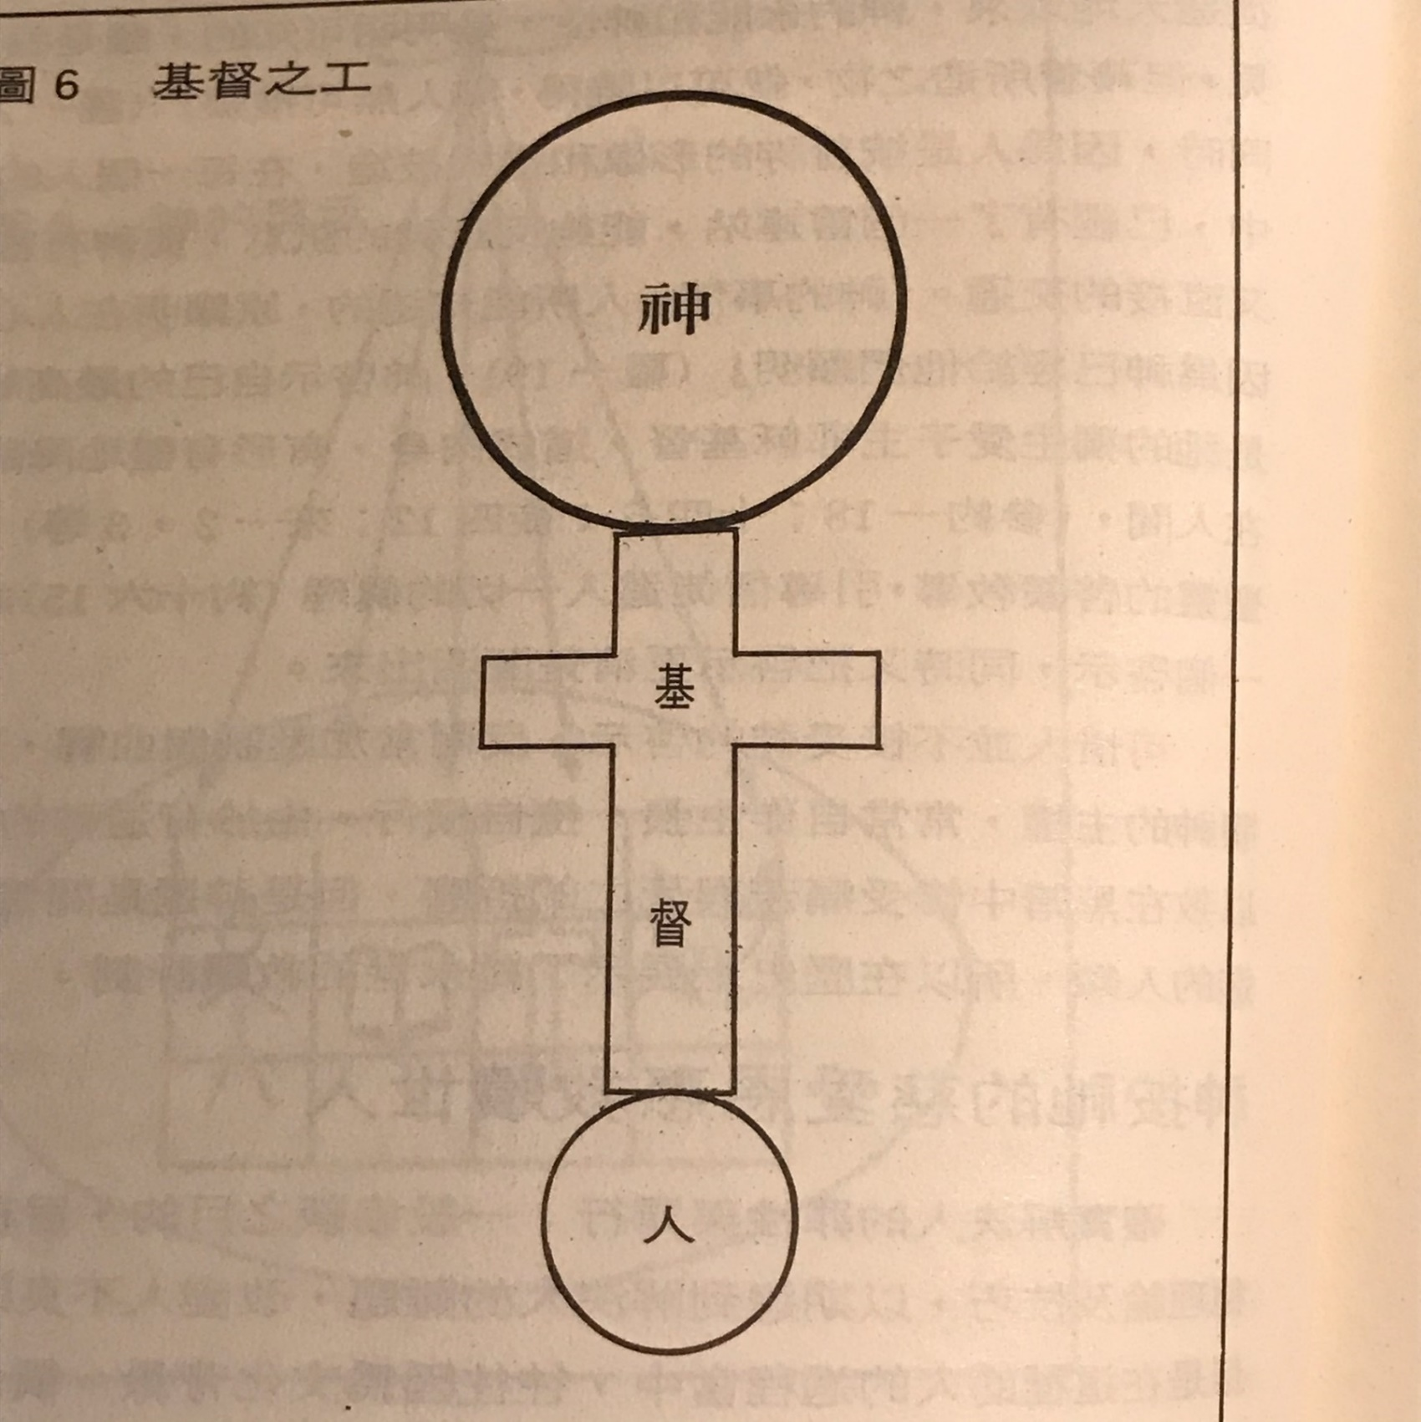

- The relation between God and man.
- The relation between man and man.
- The relation between man and nature.
- The relation between man with himself.

1. 上帝与人之间的关系。
2. 人与人之间的关系。
3. 人与自然之间的关系。
4. 人与自己之间的关系。

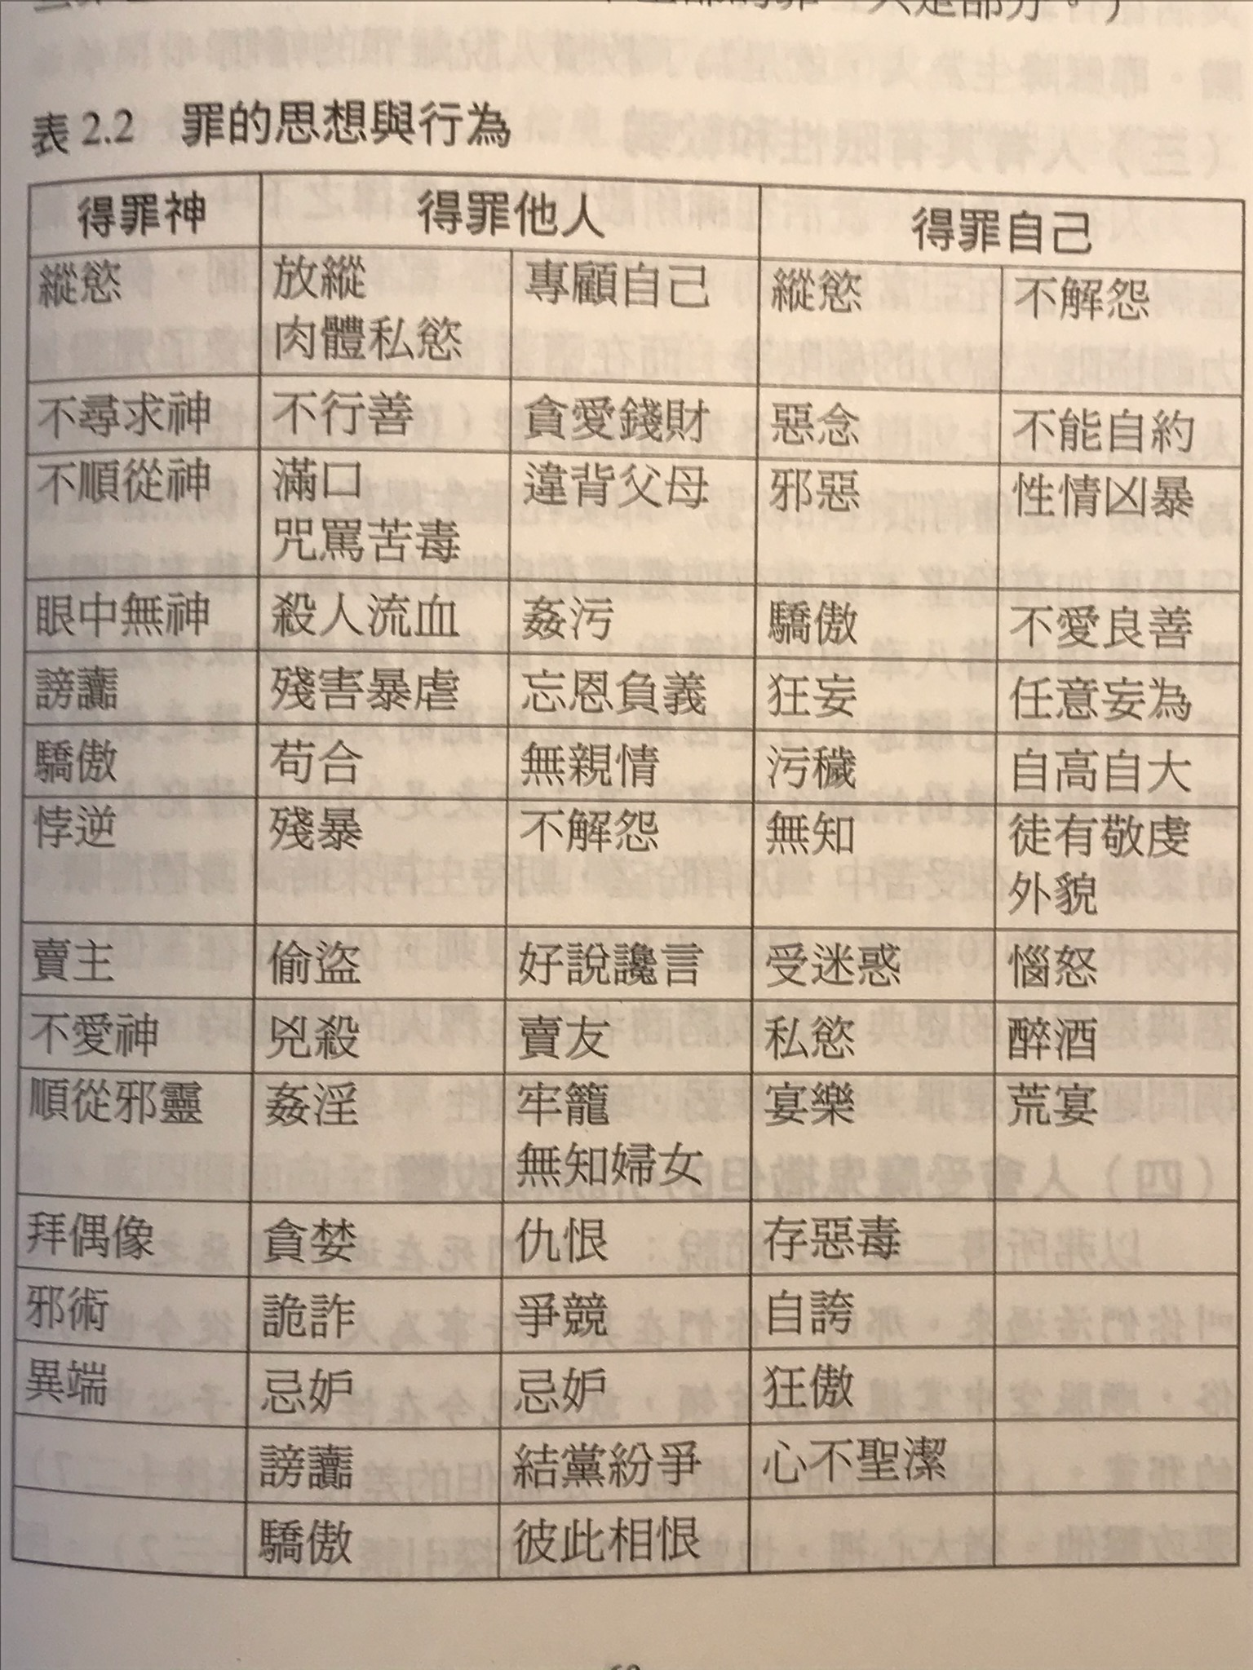

- Man dies.
- Man sins.
- Man has limits and weakness.
- Man is tempted and attacked by Satan.
- Man avoids God.
- Man make excuses for his sins.
1. 人会死。
2.人犯罪。
3.人有局限和软弱。
4.人被撒但诱惑和攻击。
5.人躲避上帝。
6.人为自己的罪过找借口。

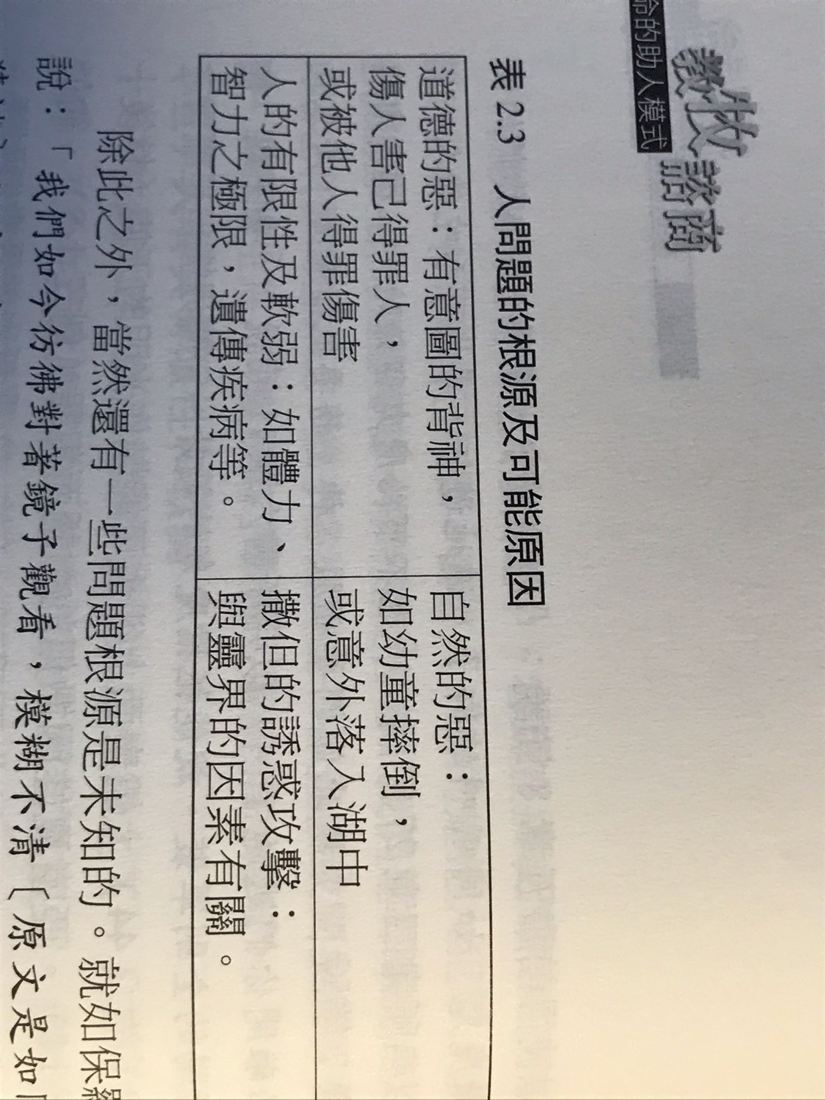

After being saved:
- Rebuild inner self.
- Sins are forgiven.
- Status was changed.
- Peace with others.
- Bear much good fruit.
- Life has hope, purpose, and meaning.
得救后：
1. 重建内在的自我。
2. 罪得赦免。
3. 地位更改。
4. 与他人和目。
5. 结出很多好的果子。
6. 生命具有希望，目的和意义。

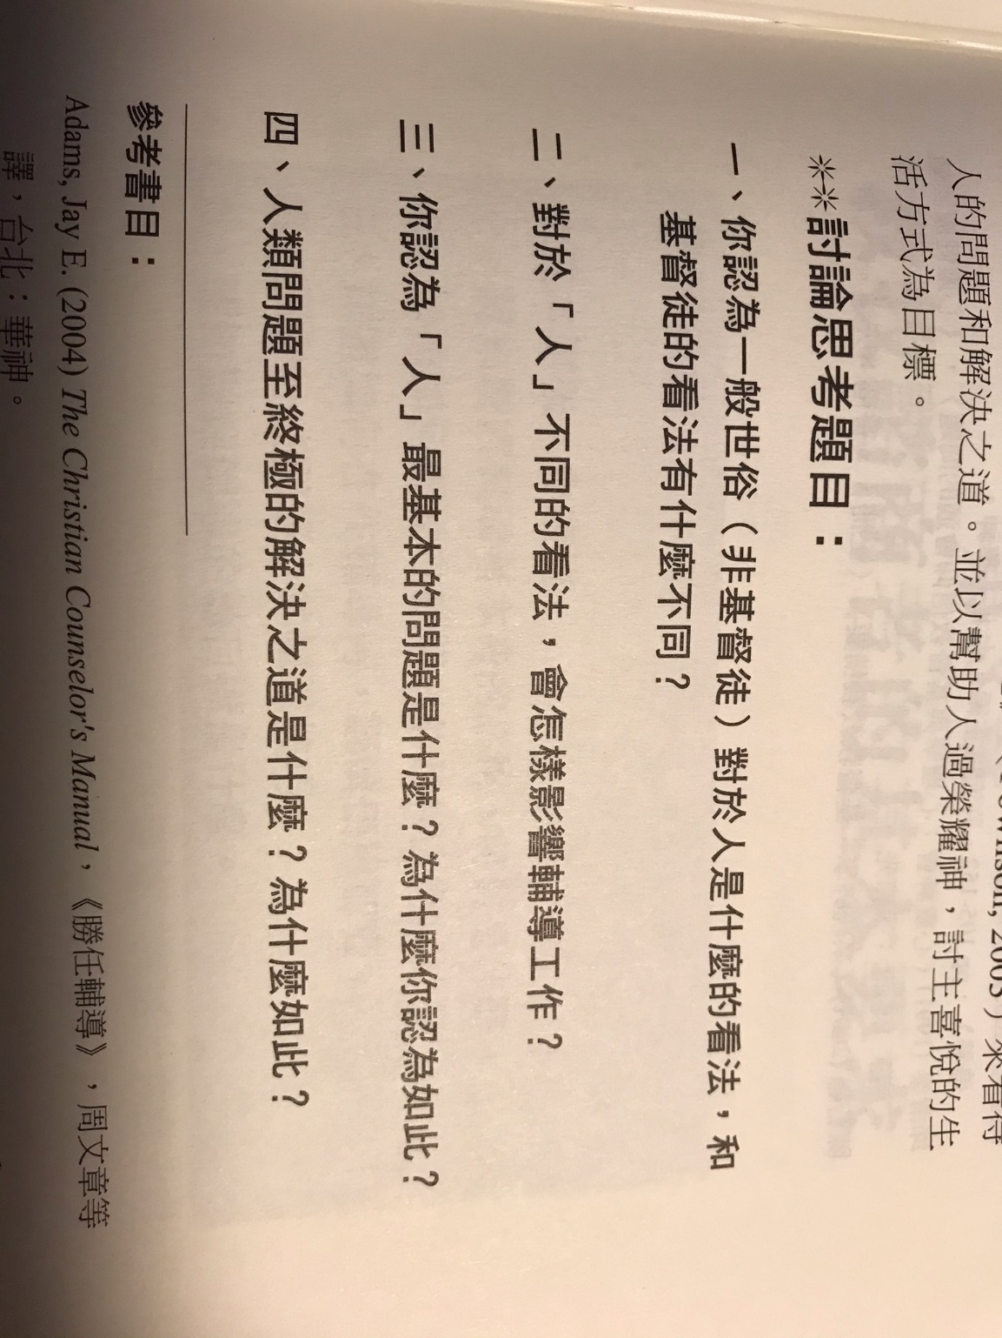

++++++++++++++++++++++++++++++++++++++++++++++++++++++++++++++++++++++++++++++++++++++++++++++++++++++++++++++++++++++++++++++++++++++++
第 2 周 2页的摘要和问题和解答到期。

Basic requirement of a counselor.
辅导员的基本要求。
- A counselor must be saved by the grace of God.
- A counselor must have Christ’s worldview and values of life.
- A counselor must have spiritual health such as prayers and good conduct.
- A counselor must have faith.
- A counselor must be good example to others. (I Timothy 4:12).
- A counselor must have a correct self-view.
- A counselor must have the love of Christ.
- A counselor must know the Bible well. (Colossians 3:16)
- A counselor must have a kind heart and knowledge of relationships.
- A counselor must be ethical and know the related laws.
- A counselor must teach according to the Bible.
- A counselor must choose methods of healing using the Bible.
- A counselor must not deny, distort, dilute, or devalue the Bible.
1. 辅导员必须靠上帝的恩典得救。
2. 辅导员必须具有基督的世界观和生命价值观。
3. 辅导员必须保持精神健康，例如祈祷和良好品行。
4. 辅导员必须有信心。
5. 辅导员必须成为他人的好榜样。 （提摩太前书4:12）。
6. 辅导员必须具有正确的自我评价。
7. 辅导员必须有基督的爱。
8. 辅导员必须精通圣经。 （歌罗西书3:16）
9. 辅导员必须有一颗善良的心和对关系的知识。
10. 辅导员必须具有道德操守, 并了解相关法律。
11. 辅导员必须按照圣经教导。
12. 辅导员必须选择使用圣经医治的方法。
13. 辅导员不得否认，歪曲，稀释或贬低圣经。

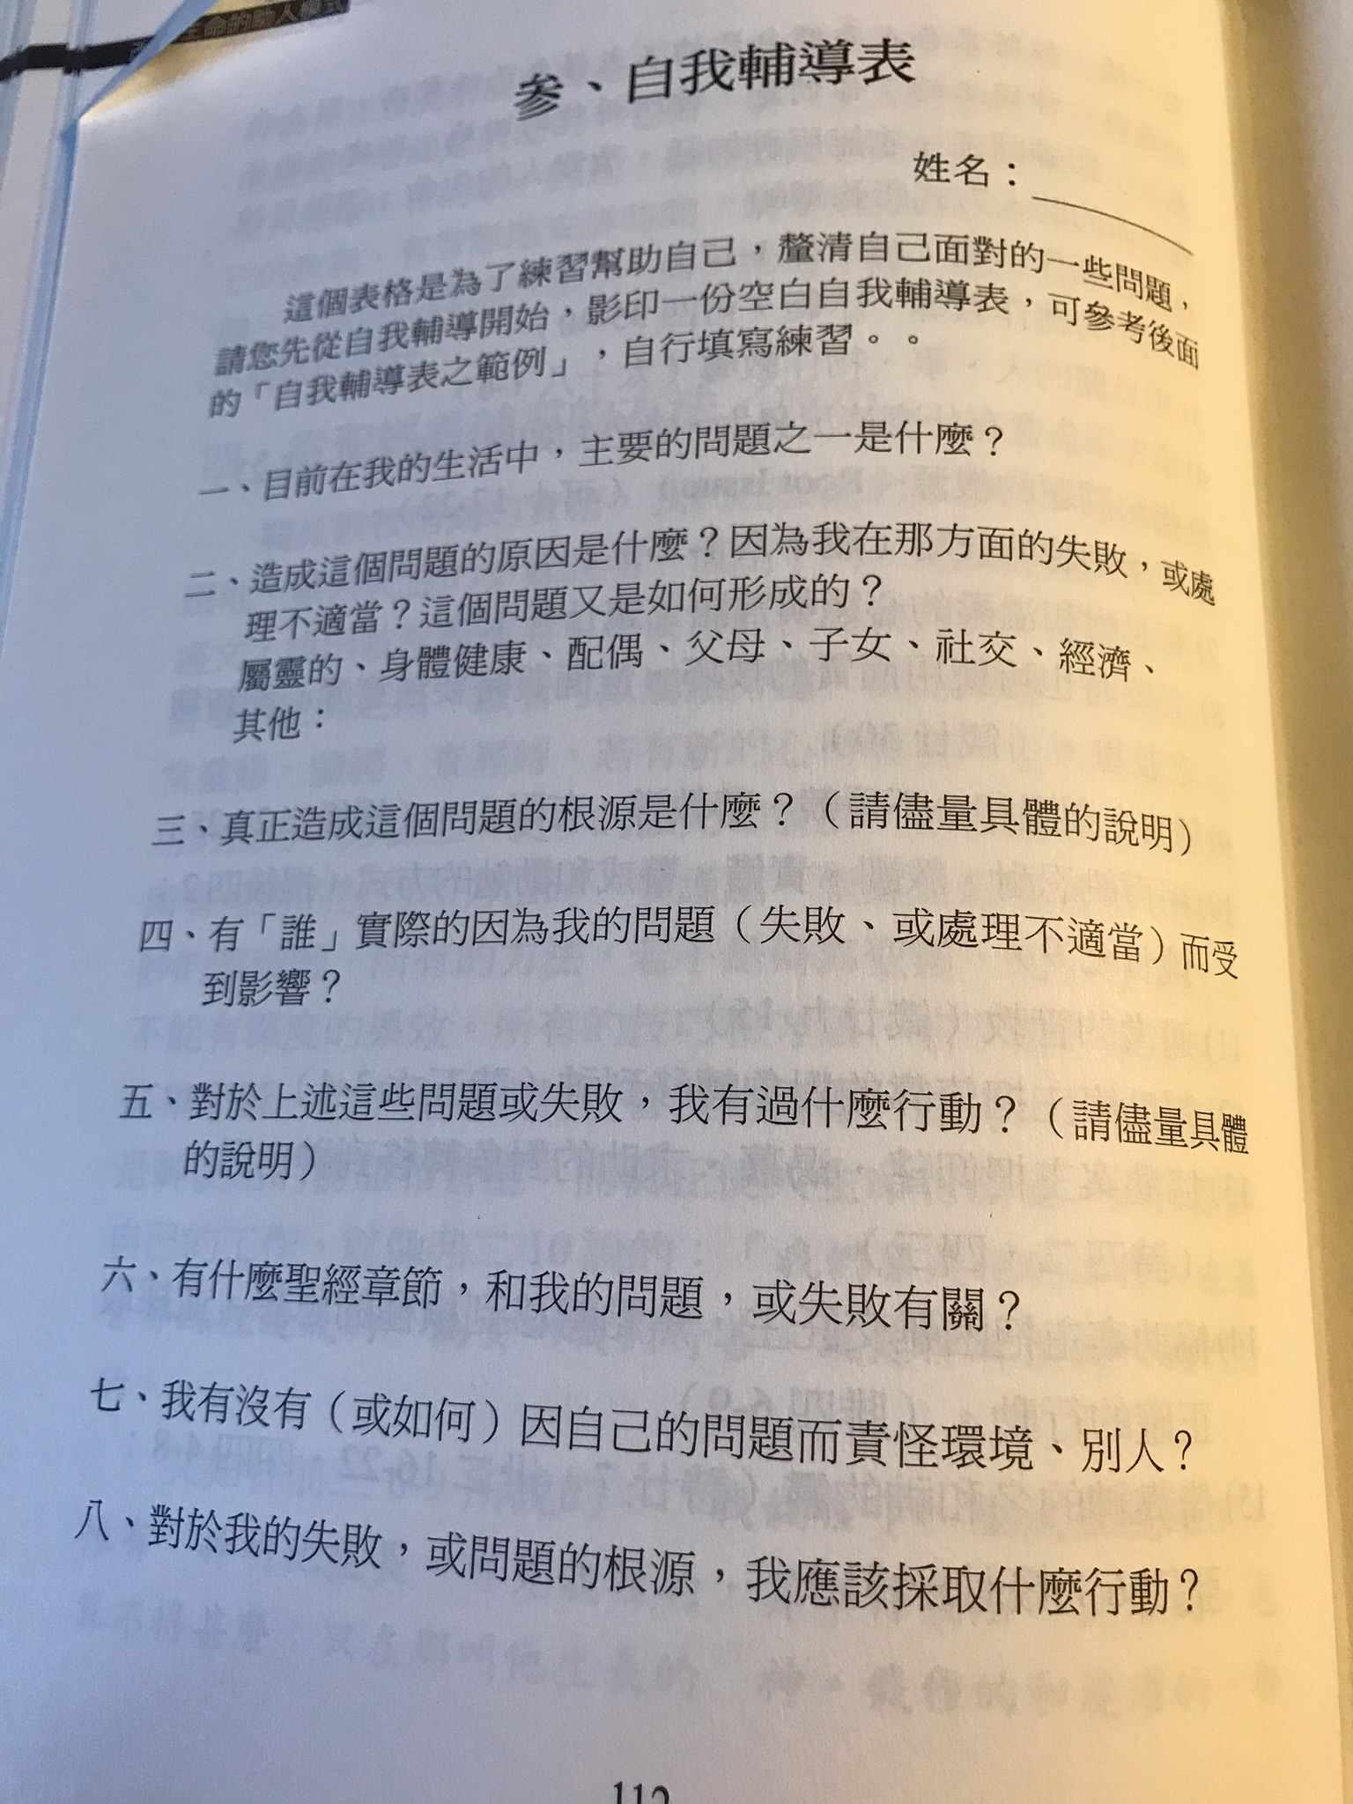
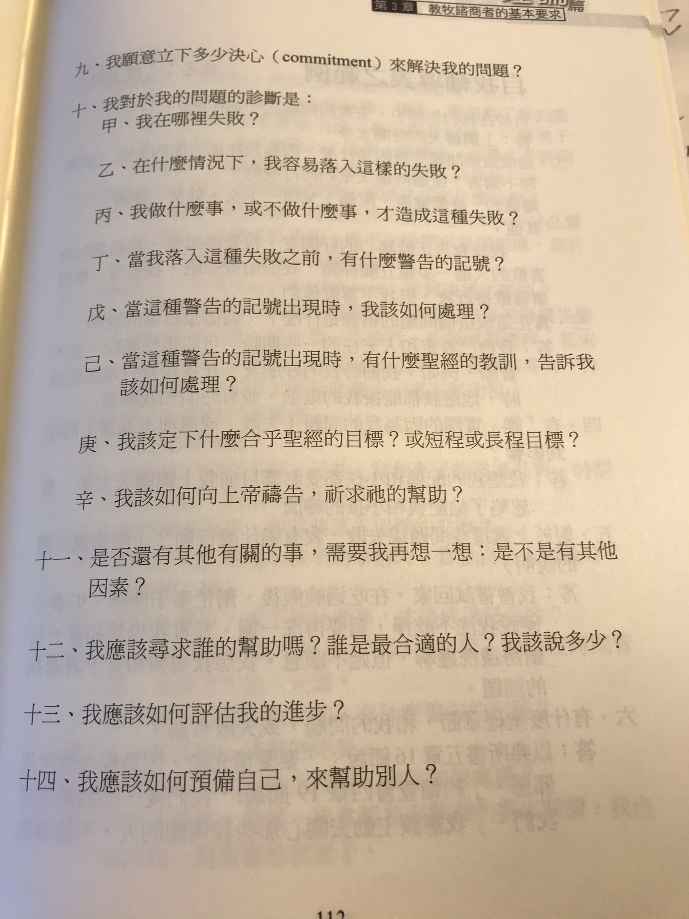

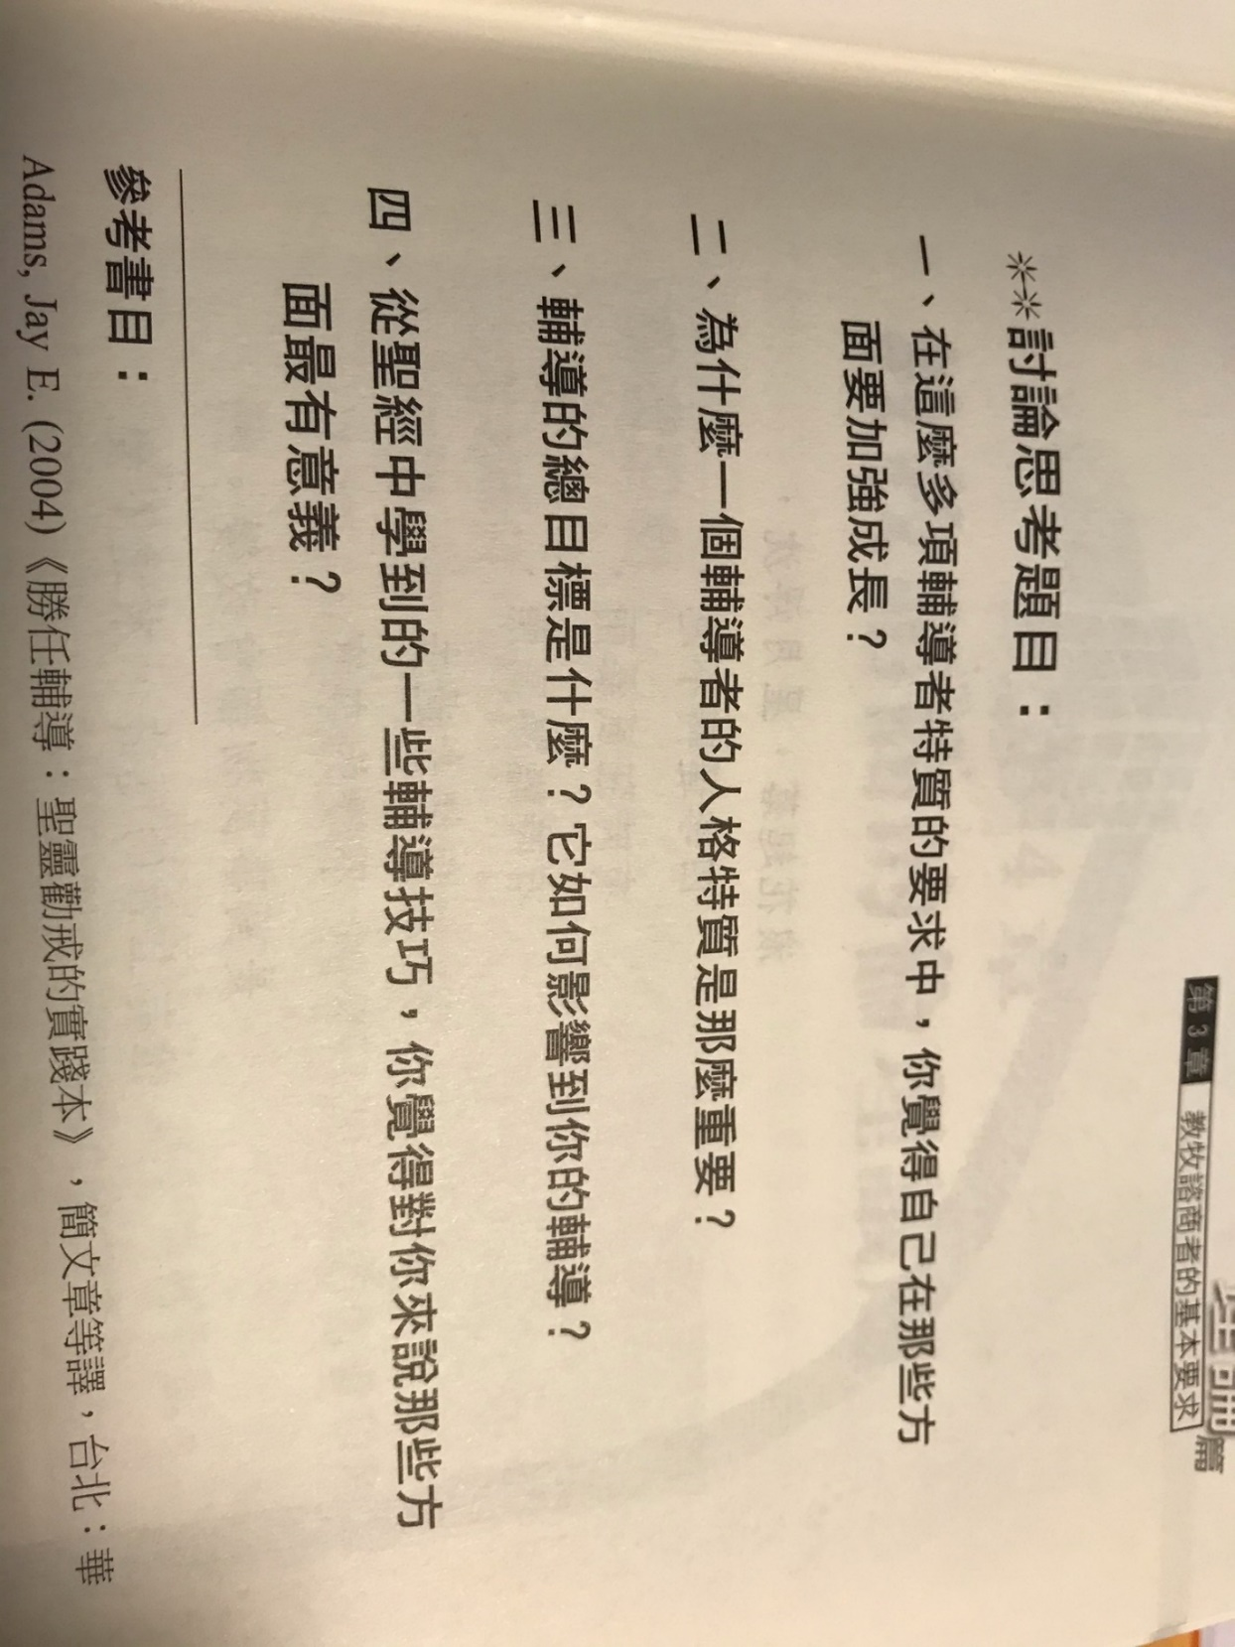

=============================================================================================================================================

- Use Christ as Lord and Center for counseling.
- Balance your time and energy.
- A counselor must keep personal secrets.
- A counselor must avoid being trapped in unwanted relationships.
- A counselor must be honest about his education background, expertise, and experience.
- A counselor must be careful about physical contacts to avoid traps in unwanted relationships.
- A counselor must know be able to discern the balance or imbalance.
- A counselor, dealing with a person of different faith or religion, must know when to decline or transfer.
- A counselor does not make a decision unless it is absolutely necessary.
- A counselor must follow the requirements of the law.
- A counselor must be sensitive to the needs of other cultures.
- Peer counseling must be kept confidential.
- Peer counseling must be competent.
- Peer counseling must give freedom of choice.

1. 以基督为中心的指导。
2. 平衡您的时间和精力。
3. 辅导员必须保守秘密。
4. 辅导员必须避免陷入不必要的关系中。
5. 辅导员必须对自己的教育背景，专业知识和经验诚实。
6. 辅导员必须谨慎对待身体接触，以免陷入不必要的关系。
7. 辅导员必须知道能够分辨出平衡或不平衡。
8.与不同信仰或宗教的人打交道的辅导必须知道什么时候该拒绝或转移。
9.除非绝对必要，否则辅导员不会做出决定。
10.辅导员必须遵守法律的要求。
11.辅导员必须对其他文化的需求敏感。
12.同伴咨询必须保密。
13.同伴咨询必须胜任。
14.同行辅导必须给予选择的自由。

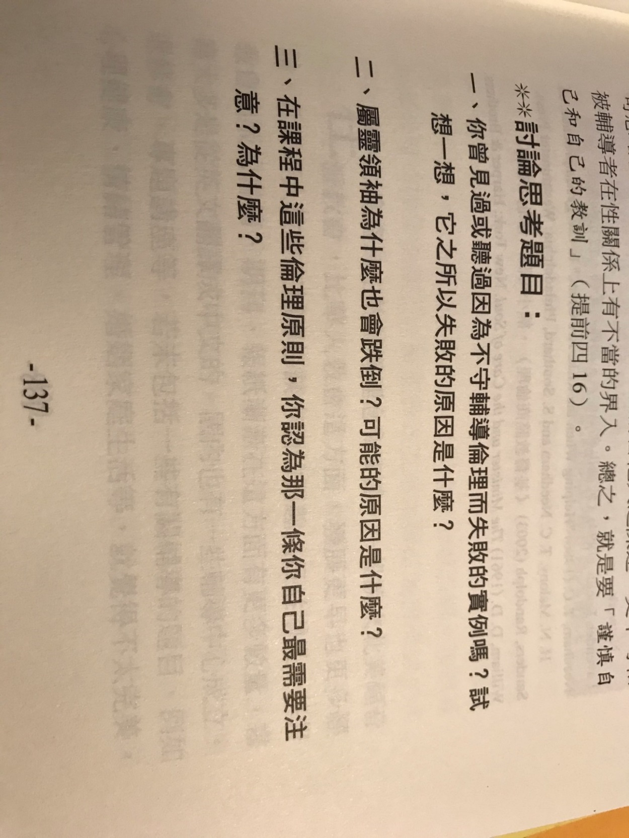

+++++++++++++++++++++++++++++++++++++++++++++++++++++++++++++++++++++++++++++++++++++++++++++++++++++++++++++++++++++++++++++++++++++++++++++++++
第 3 周 2页的摘要, .自我咨询, 问题和解答到期。

A bit of history:
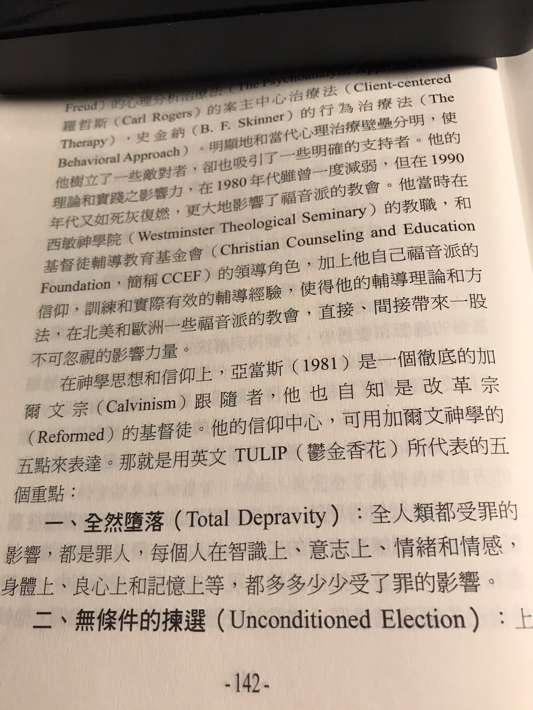
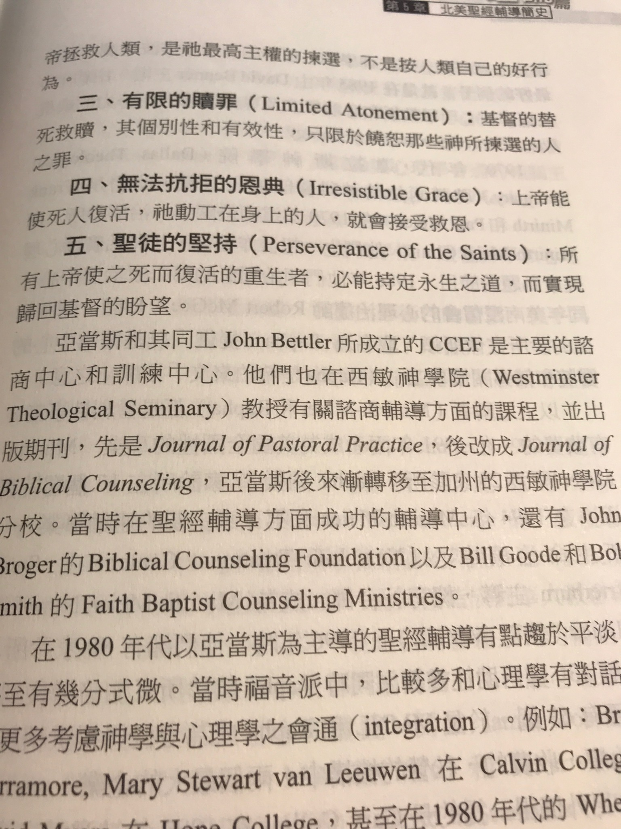

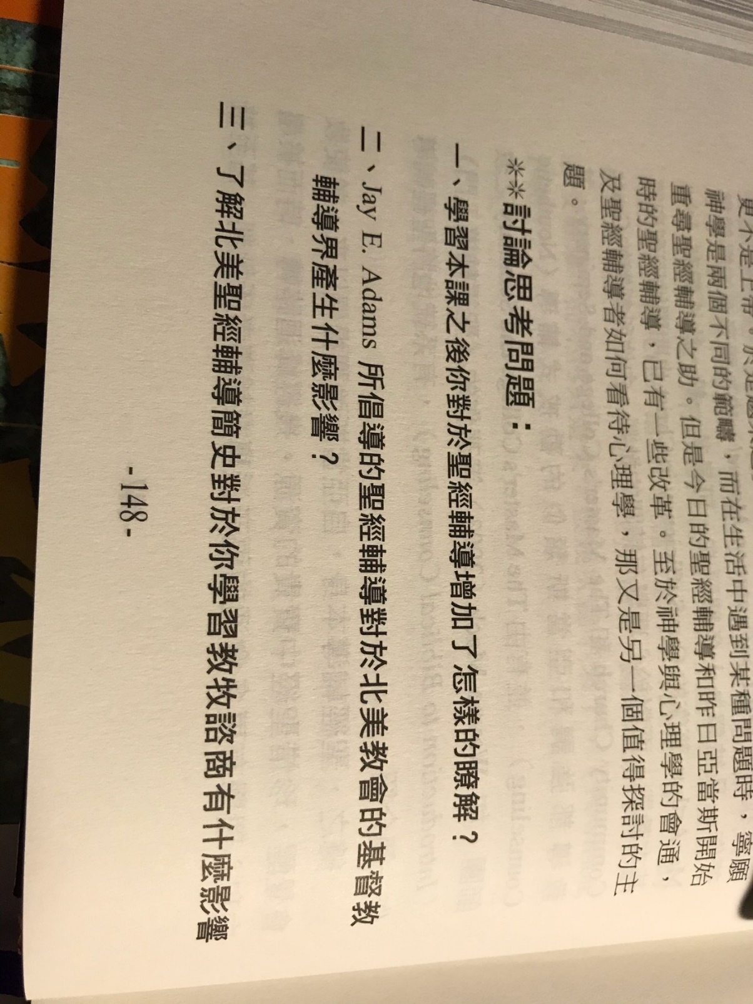

=================================================================================================================================================

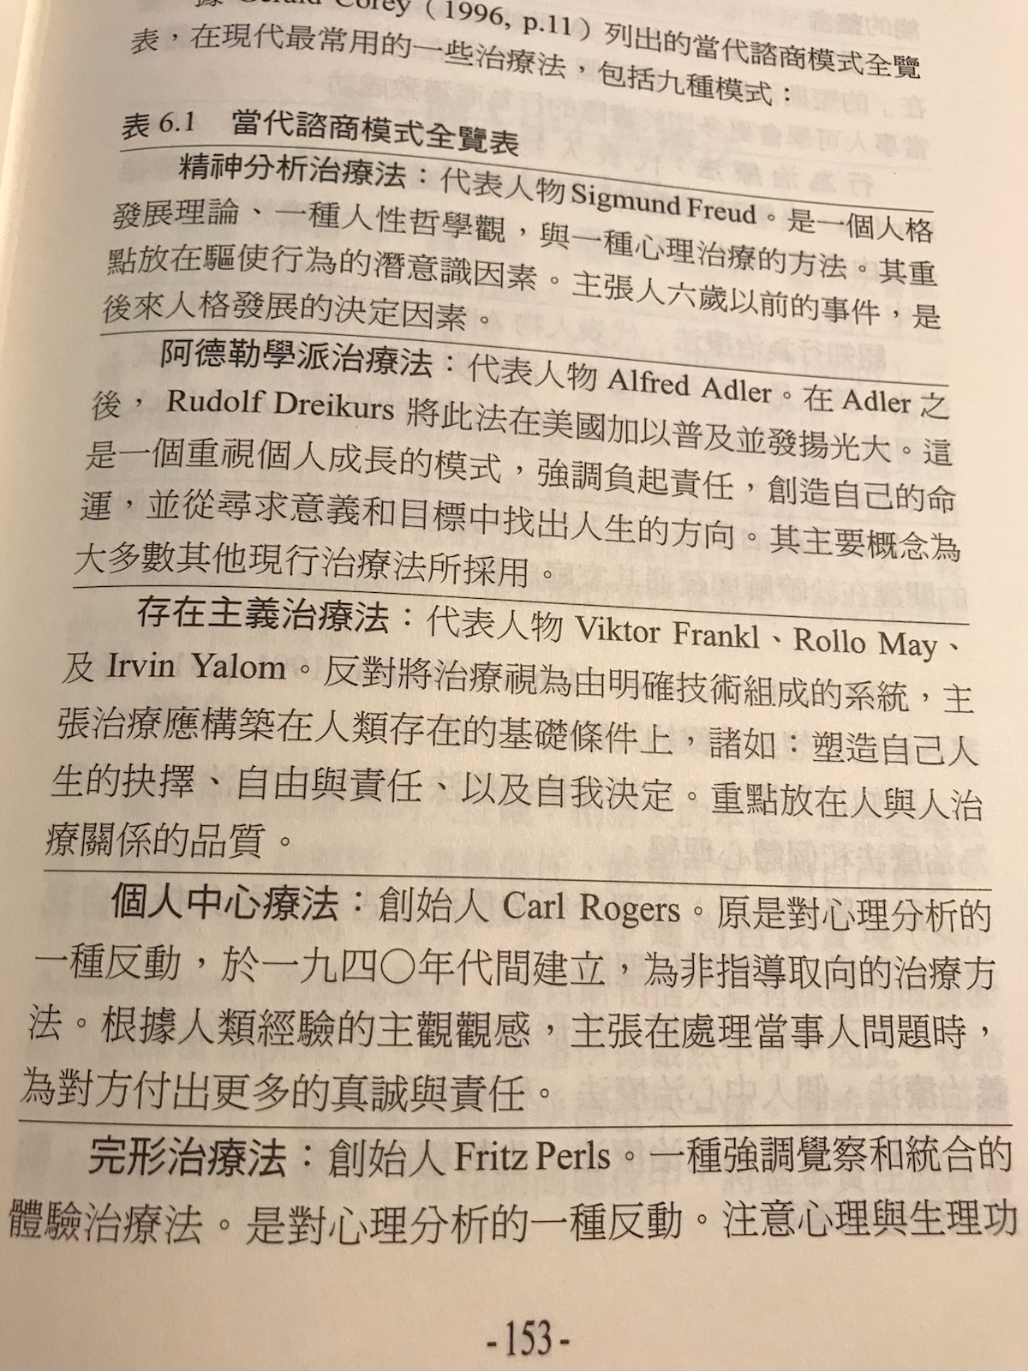
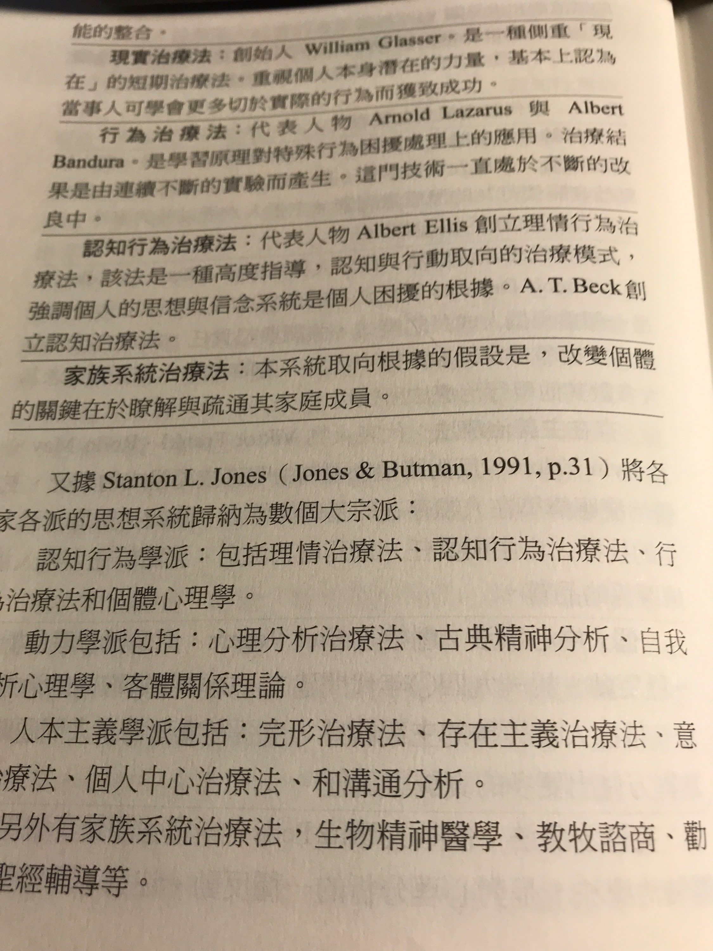
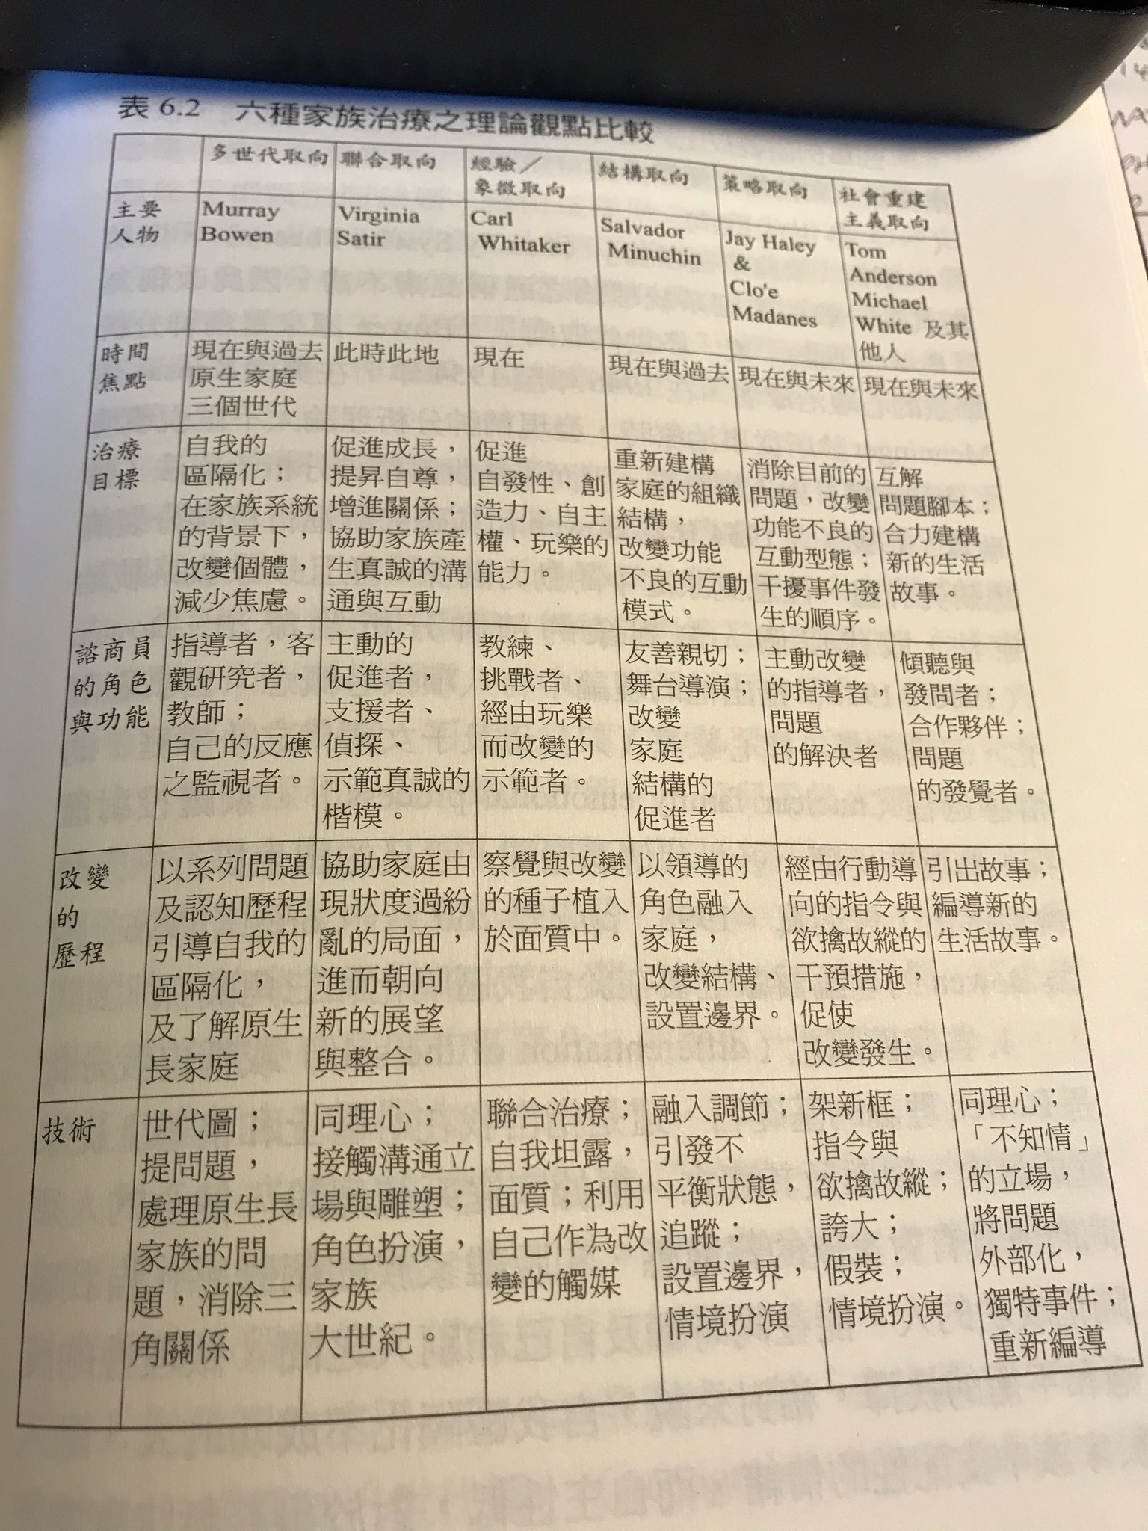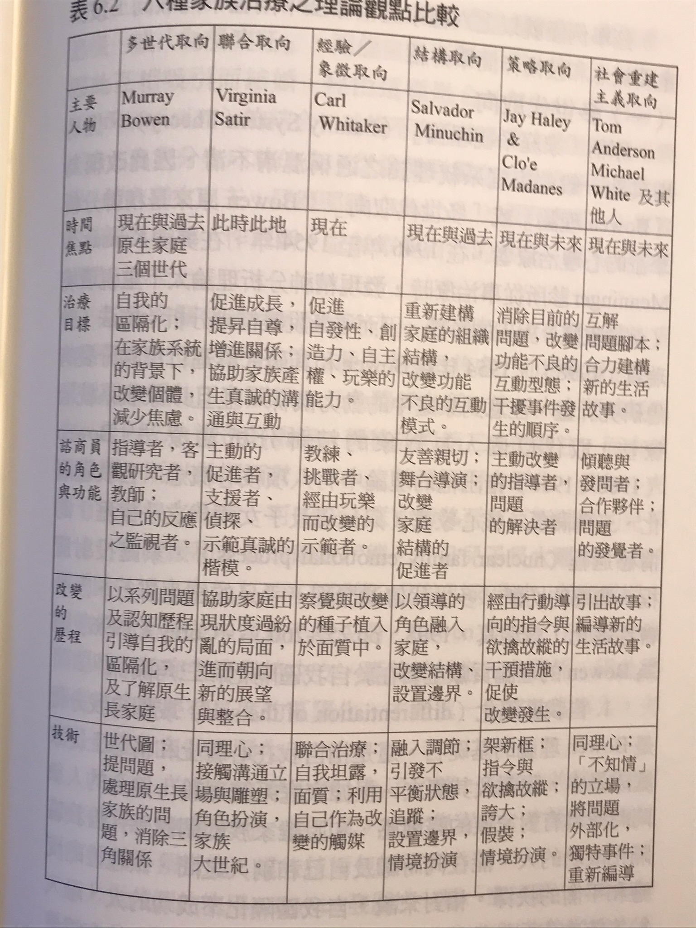
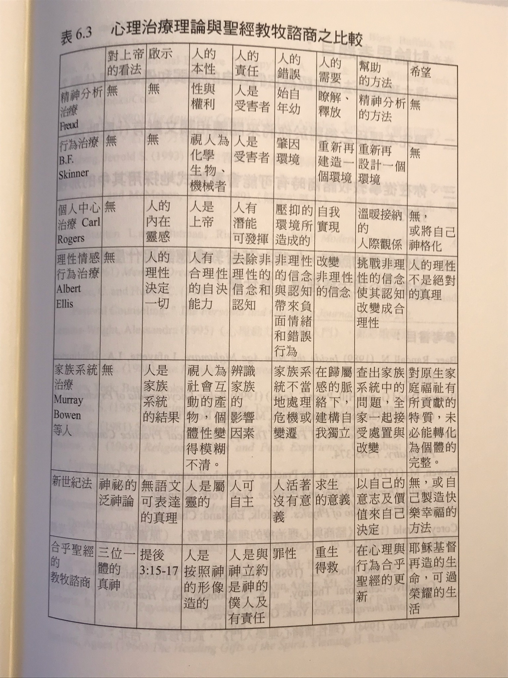

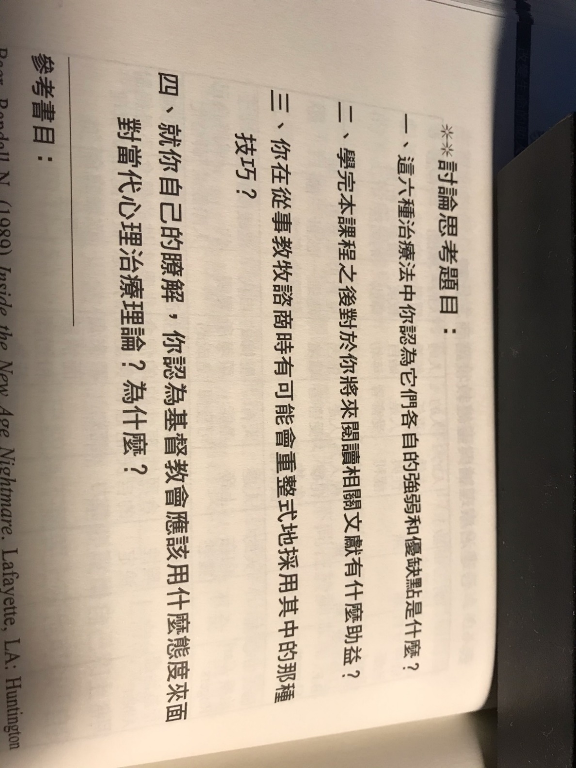

++++++++++++++++++++++++++++++++++++++++++++++++++++++++++++++++++++++++++++++++++++++++++++++++++++++++++++++++++++++++++++++++++++++++
第 4 周 2页的摘要, 问题和解答到期。

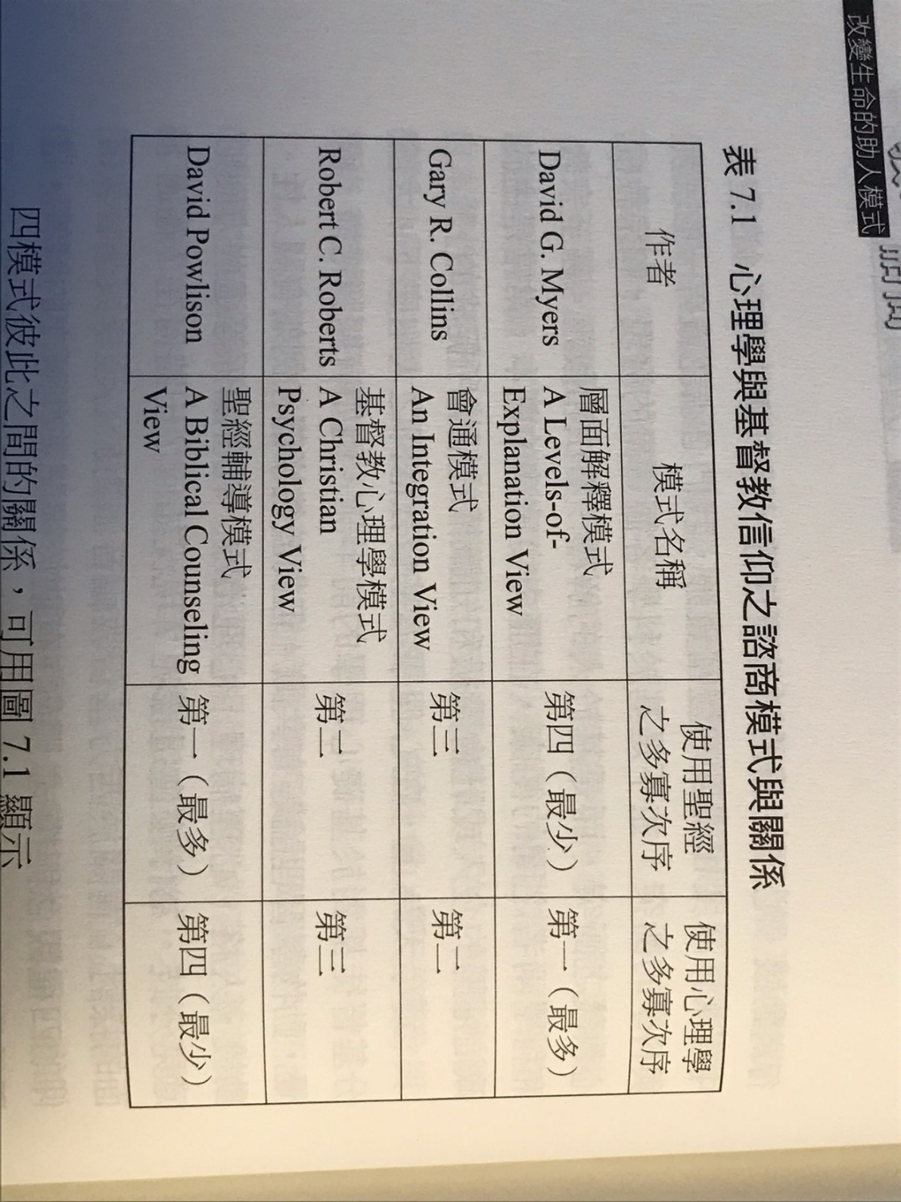

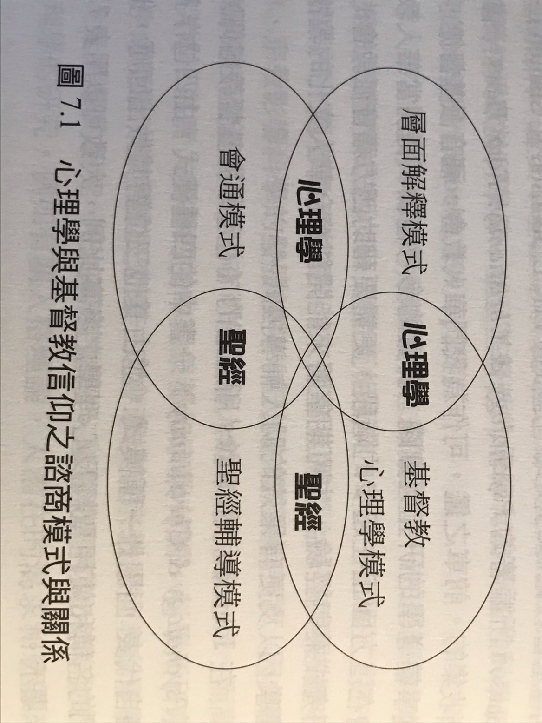

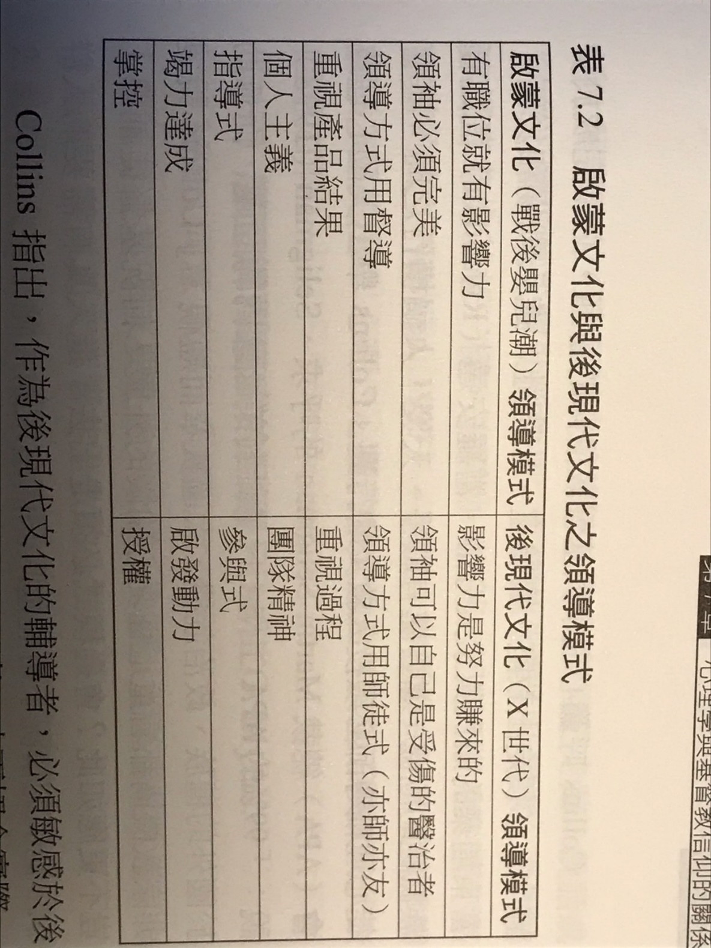
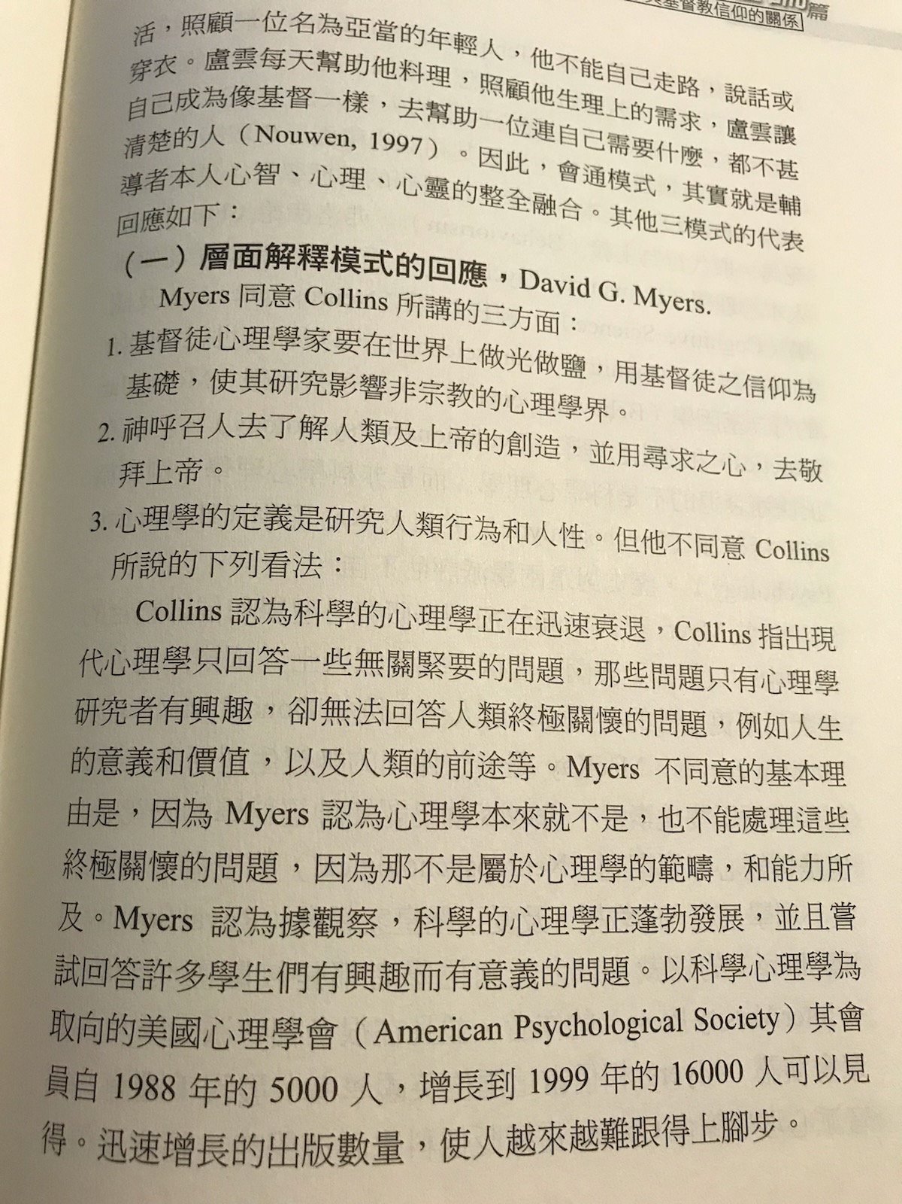
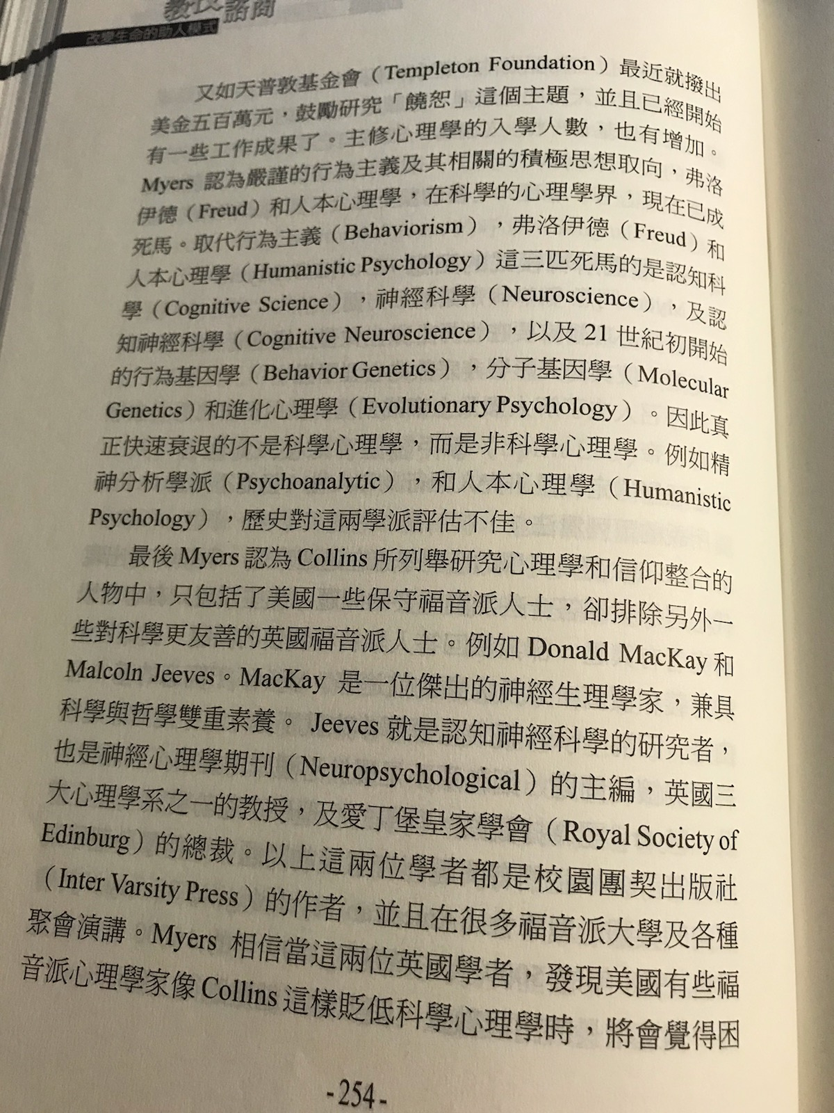
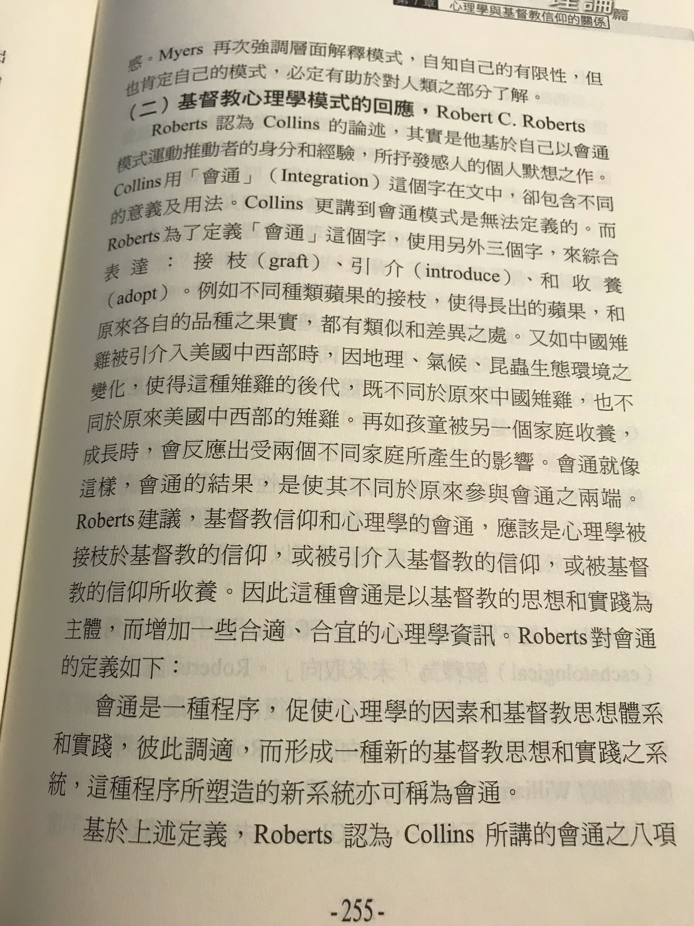
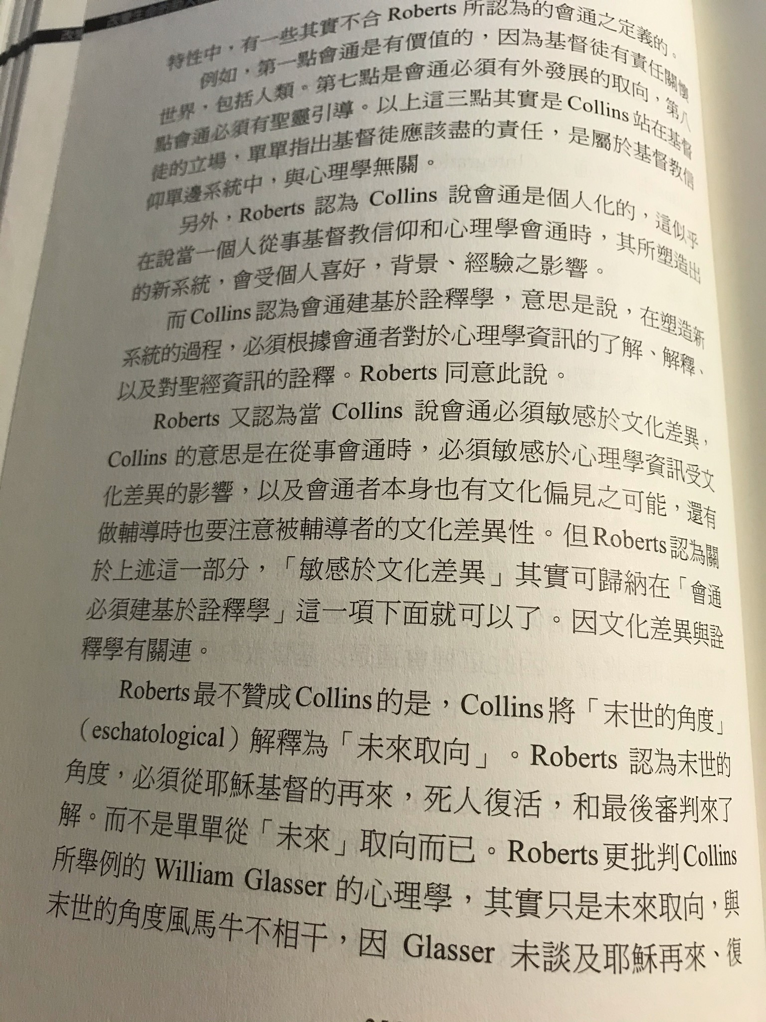
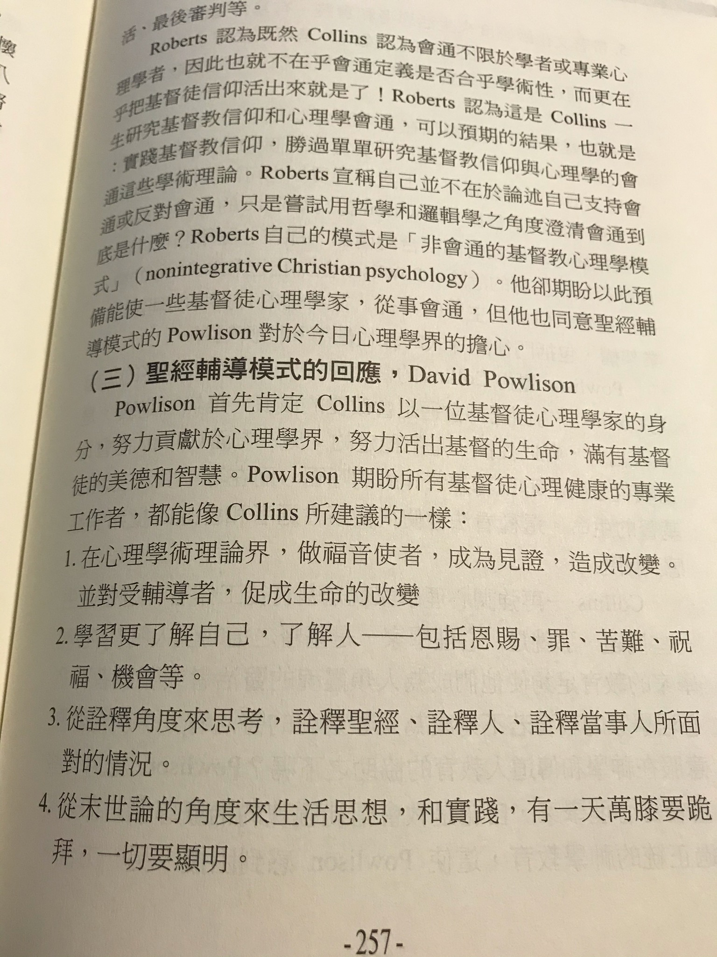
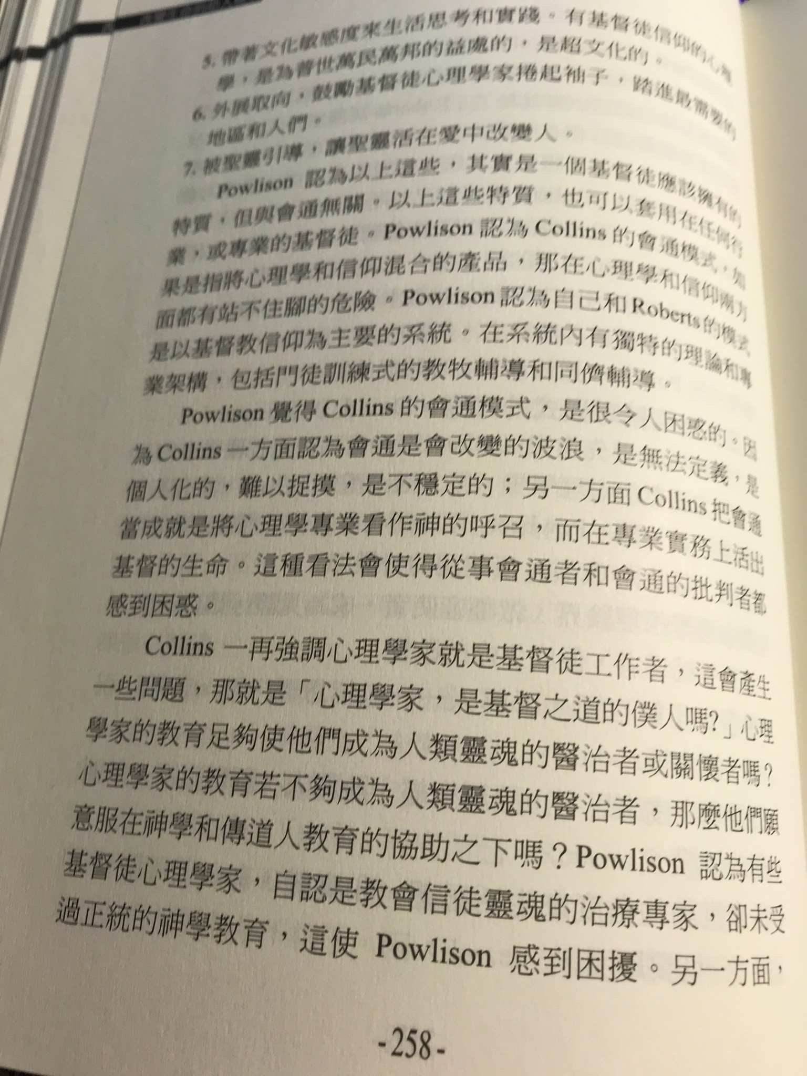
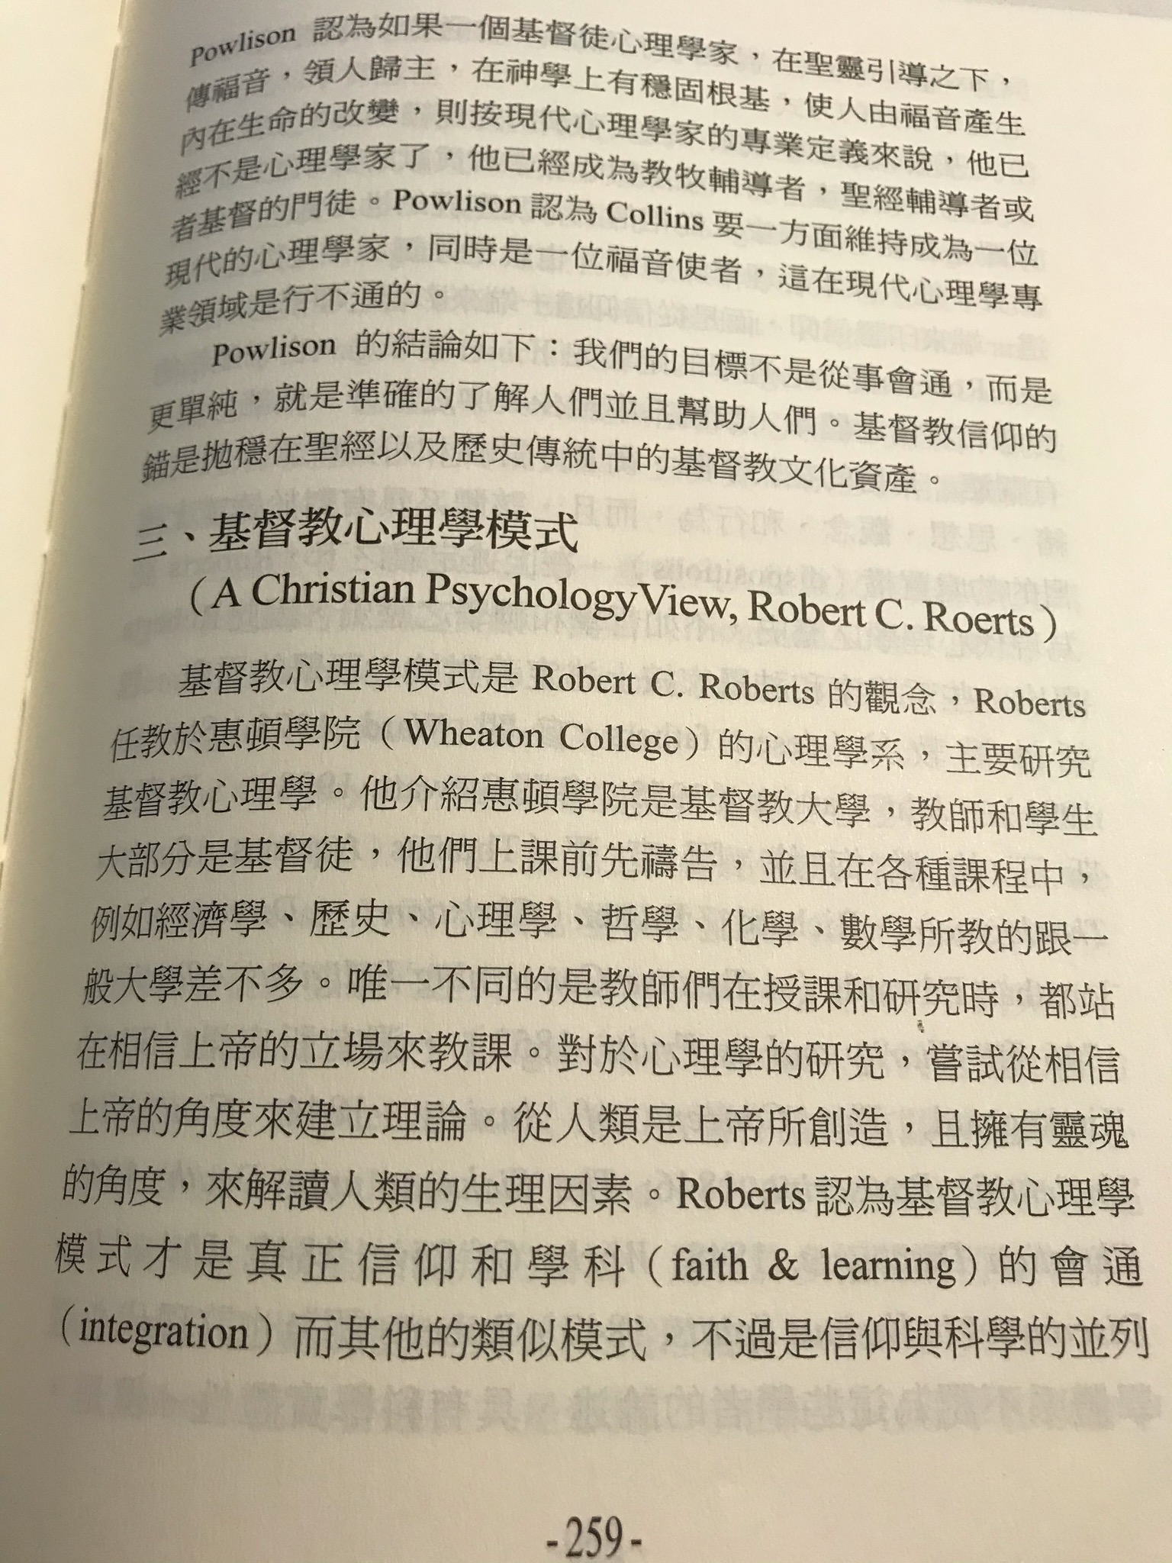
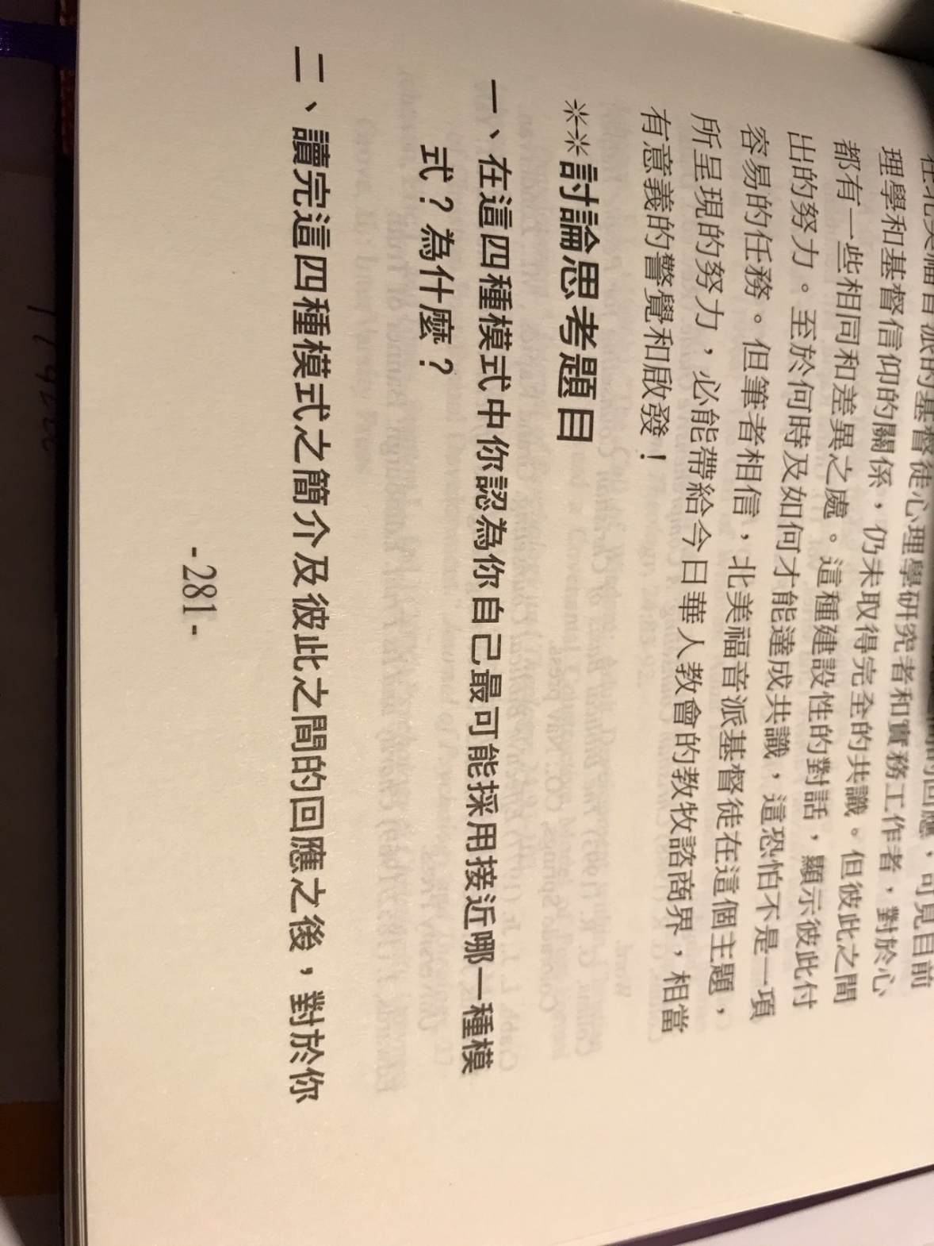

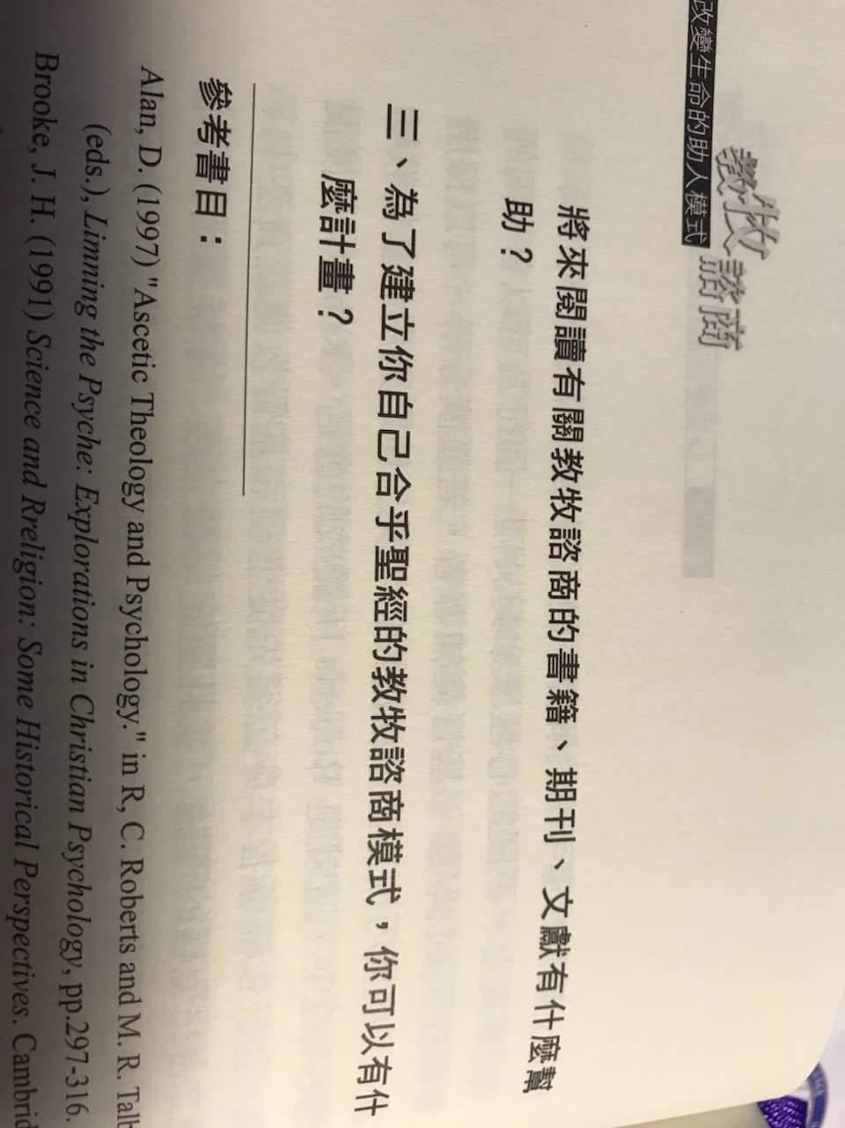
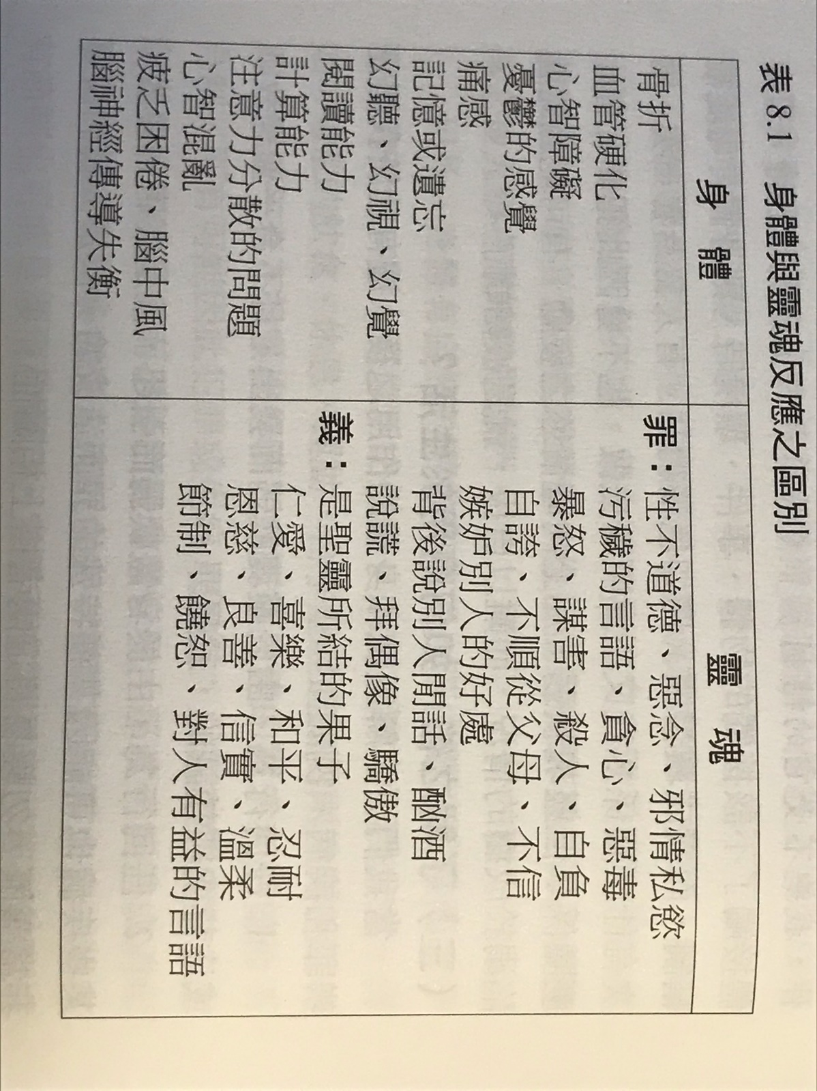

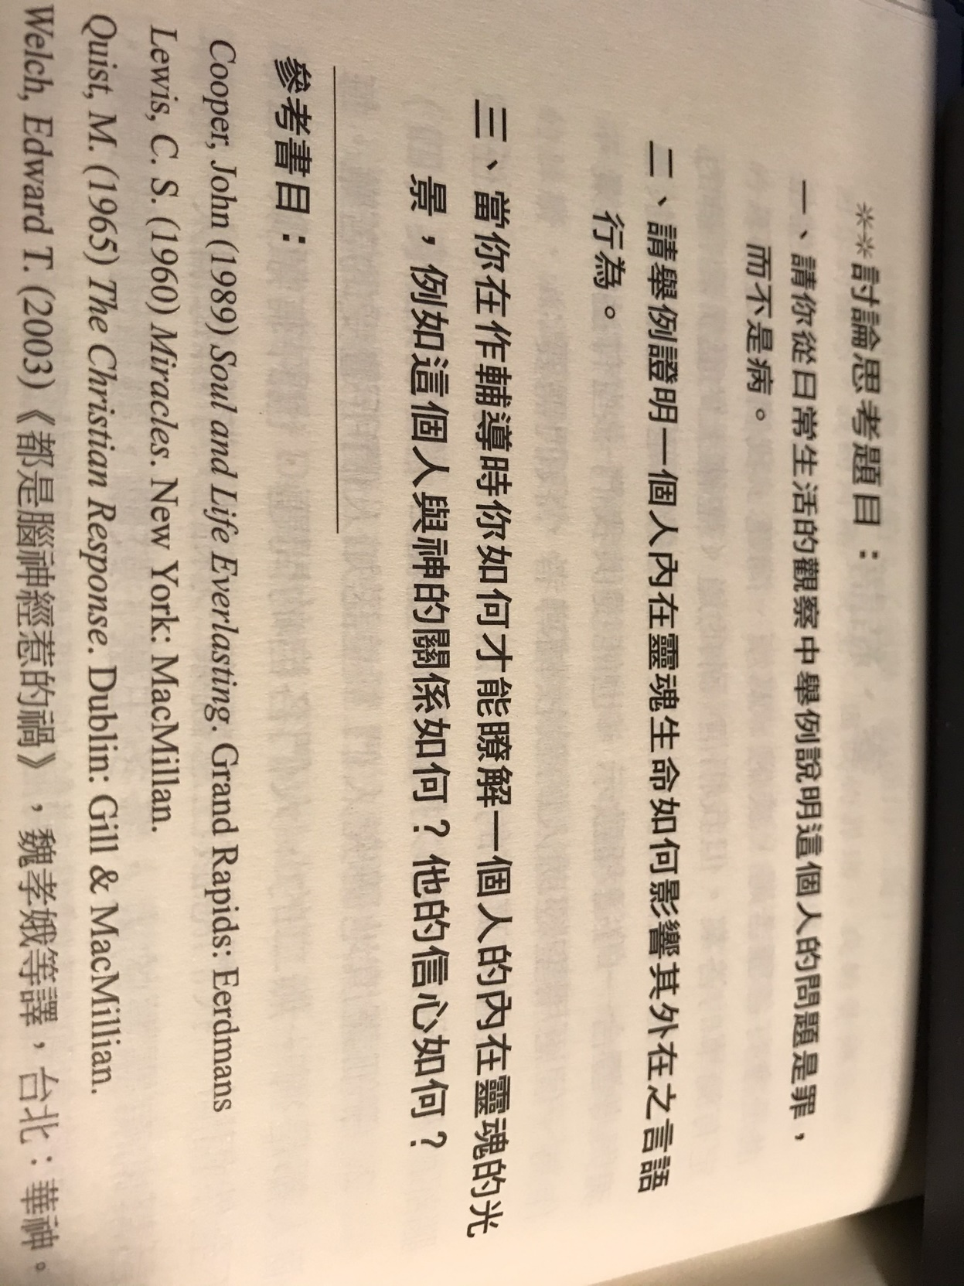
++++++++++++++++++++++++++++++++++++++++++++++++++++++++++++++++++++++++++++++++++++++++++++++++++++++++++++++++++++++++++++++++++++++++++
第 5 周 2页的摘要, 问题和解答到期。

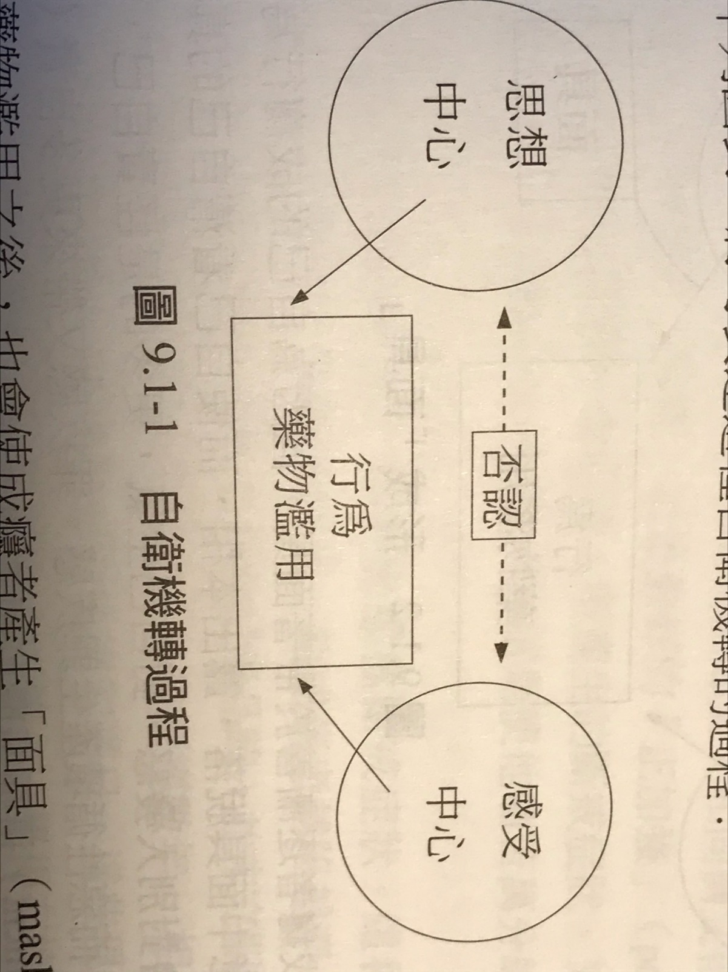

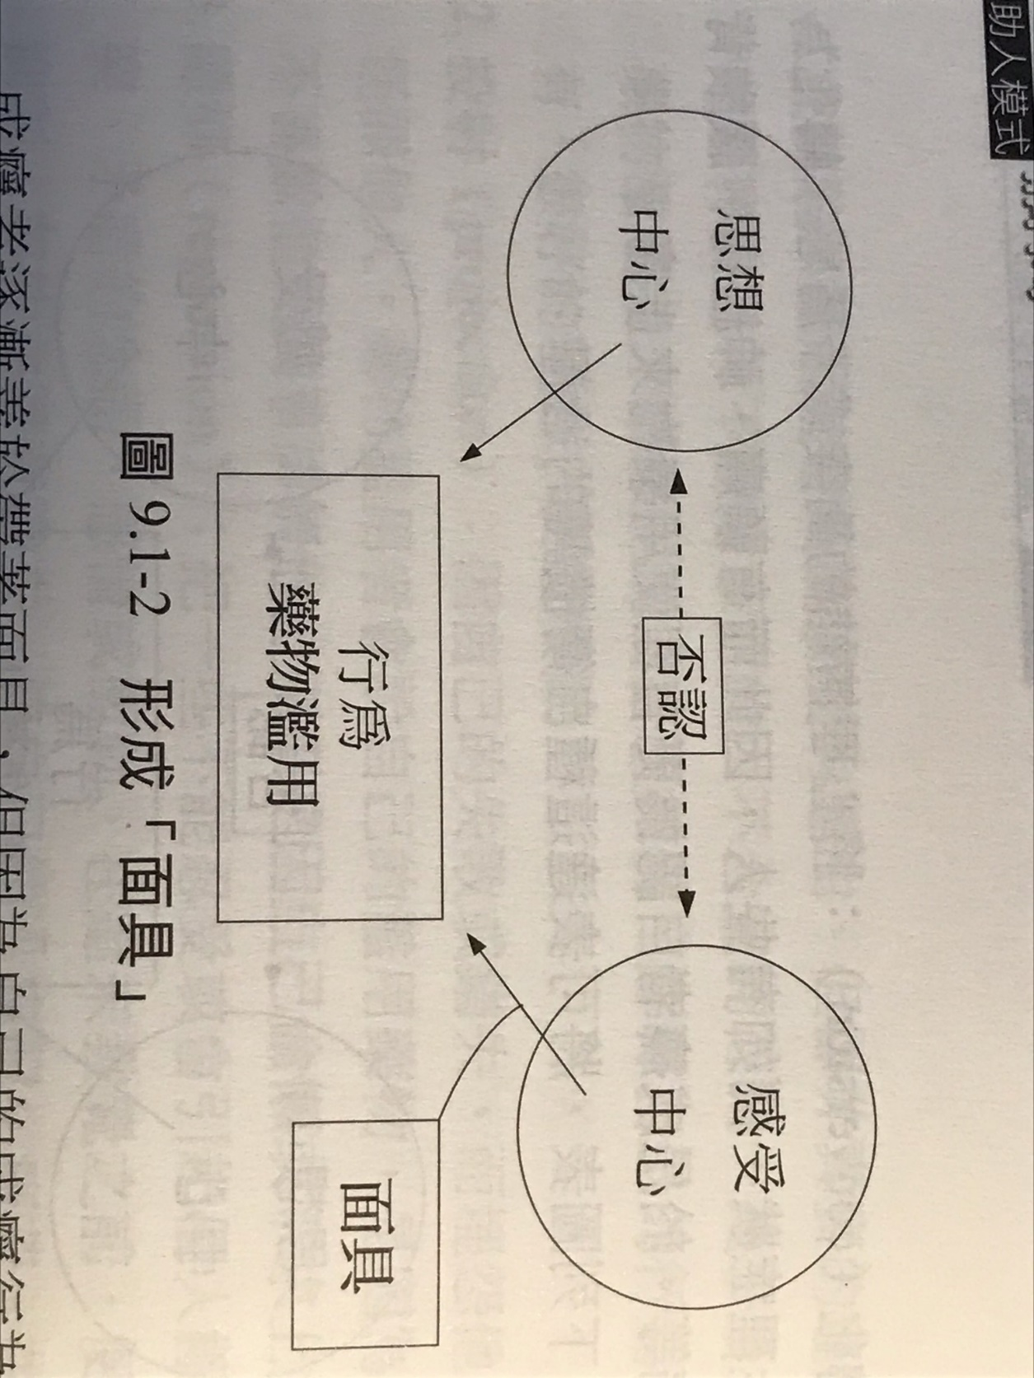

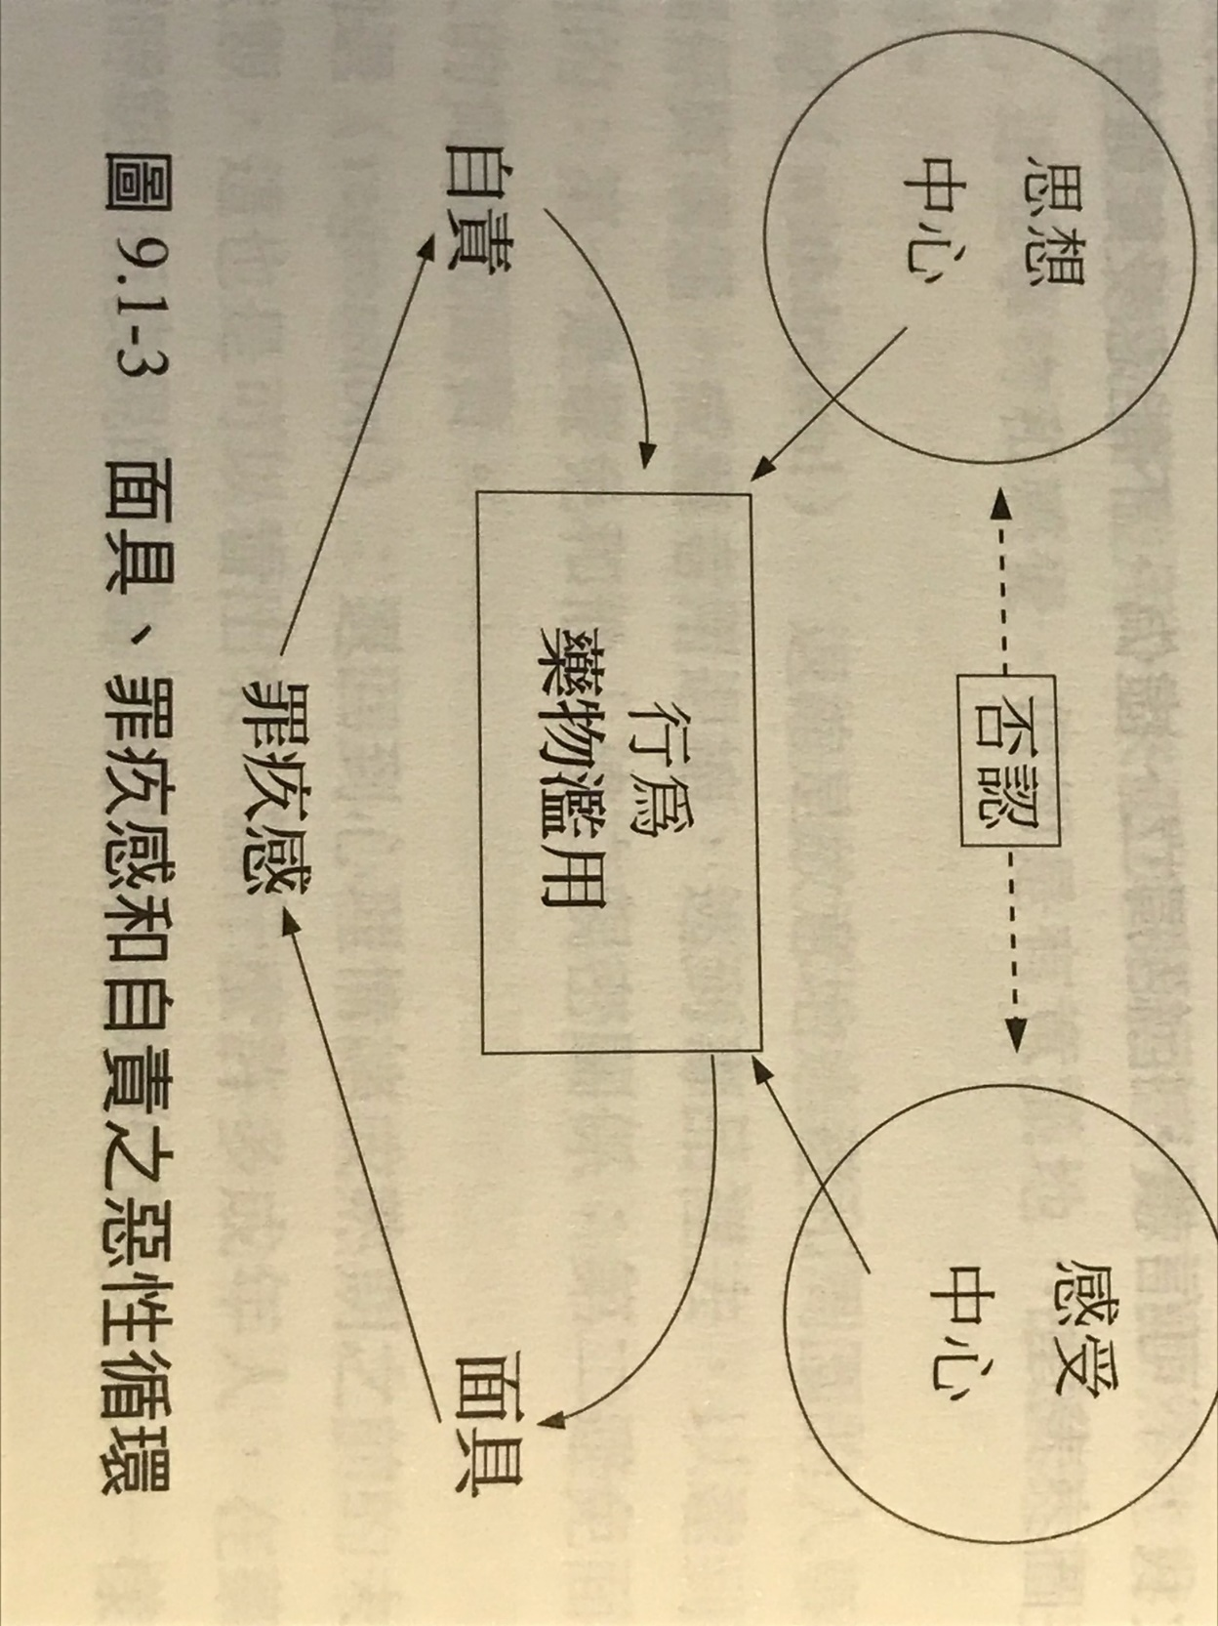
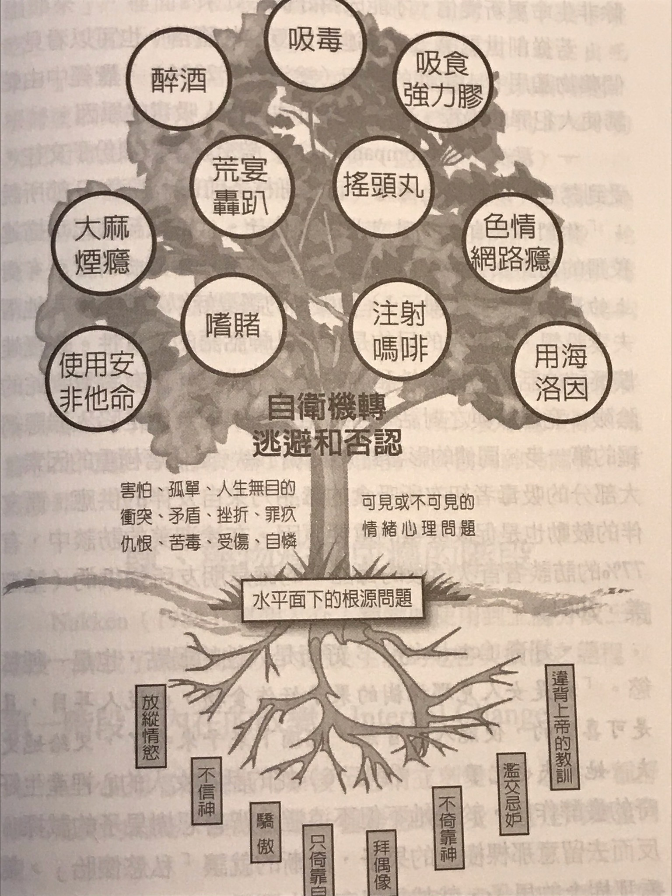
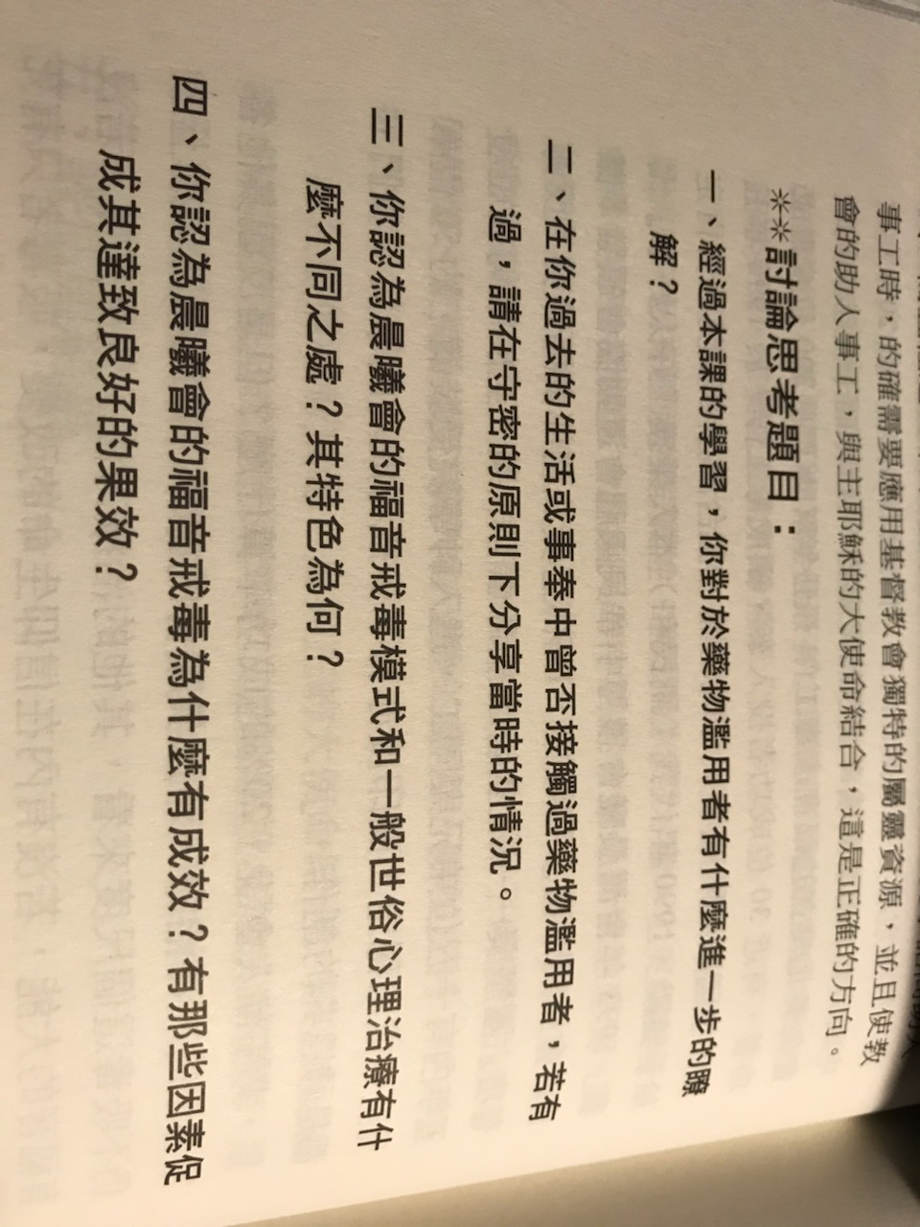

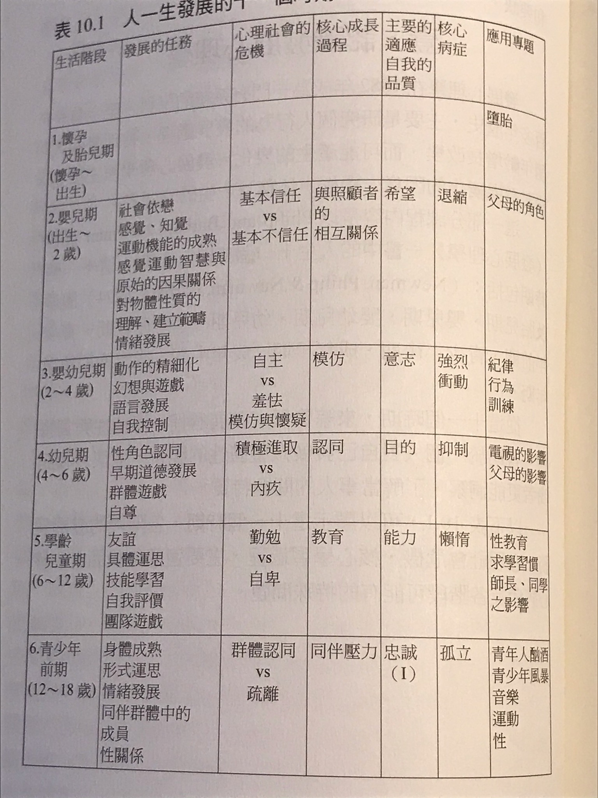

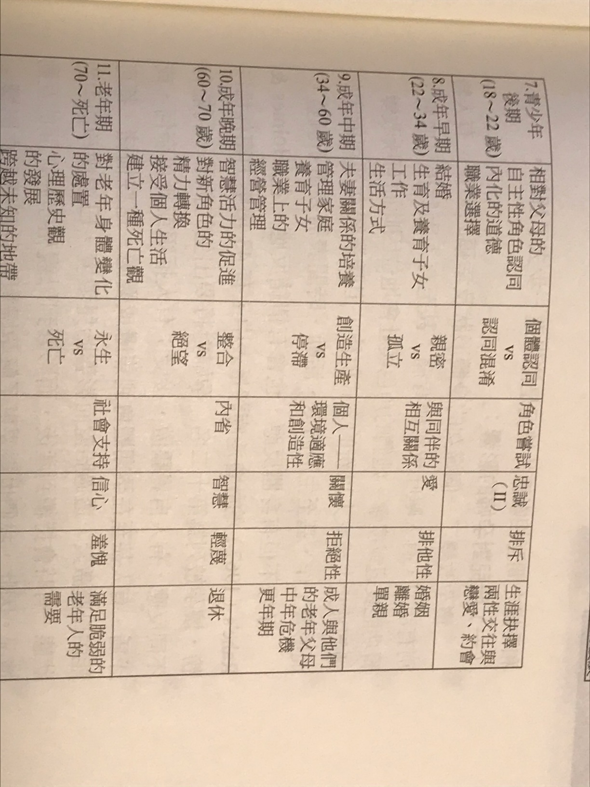

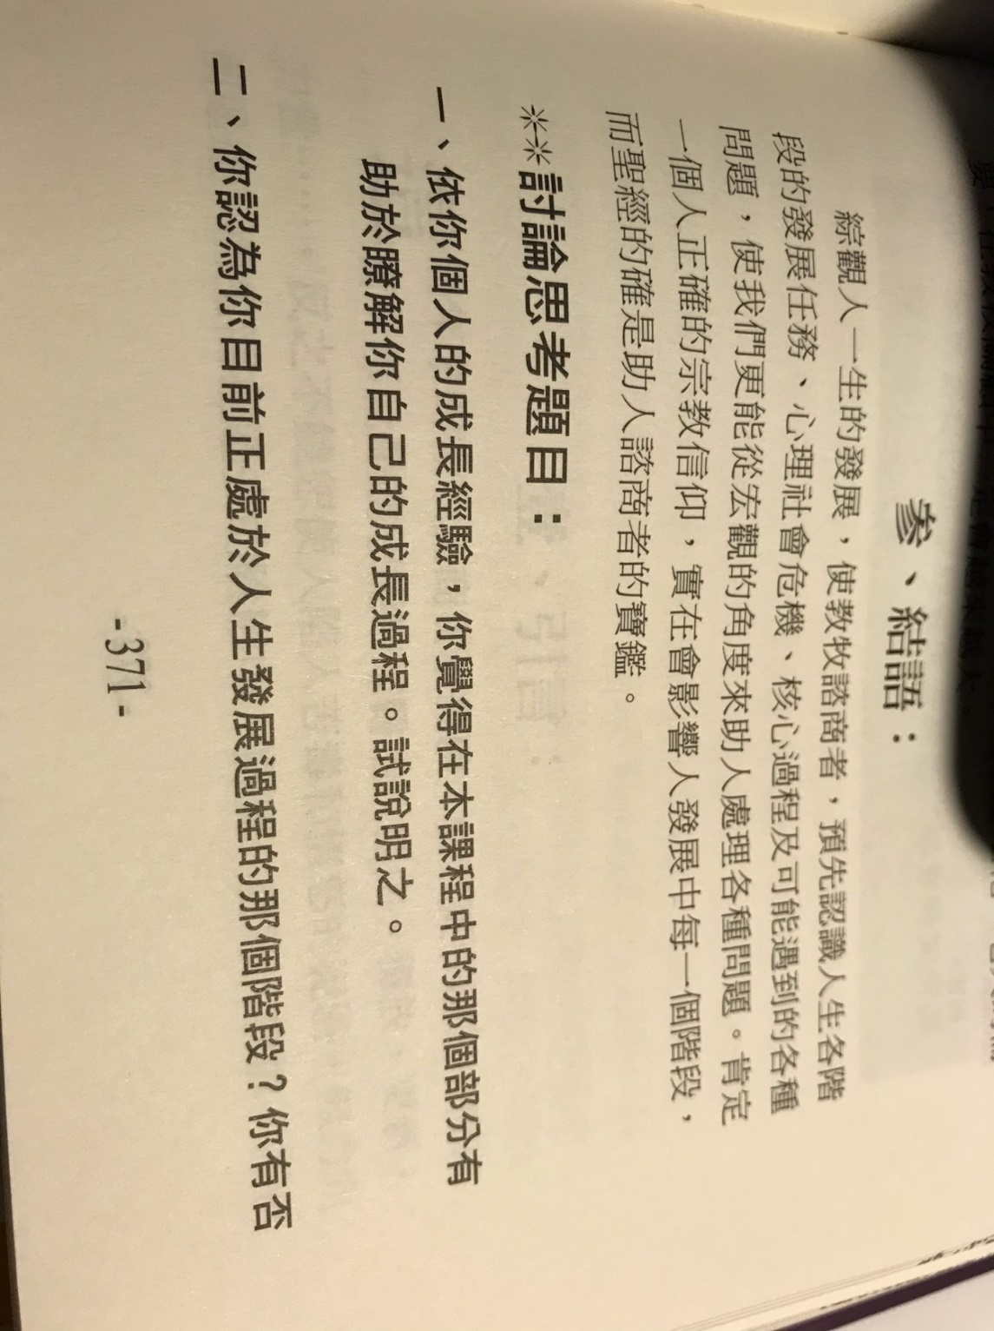

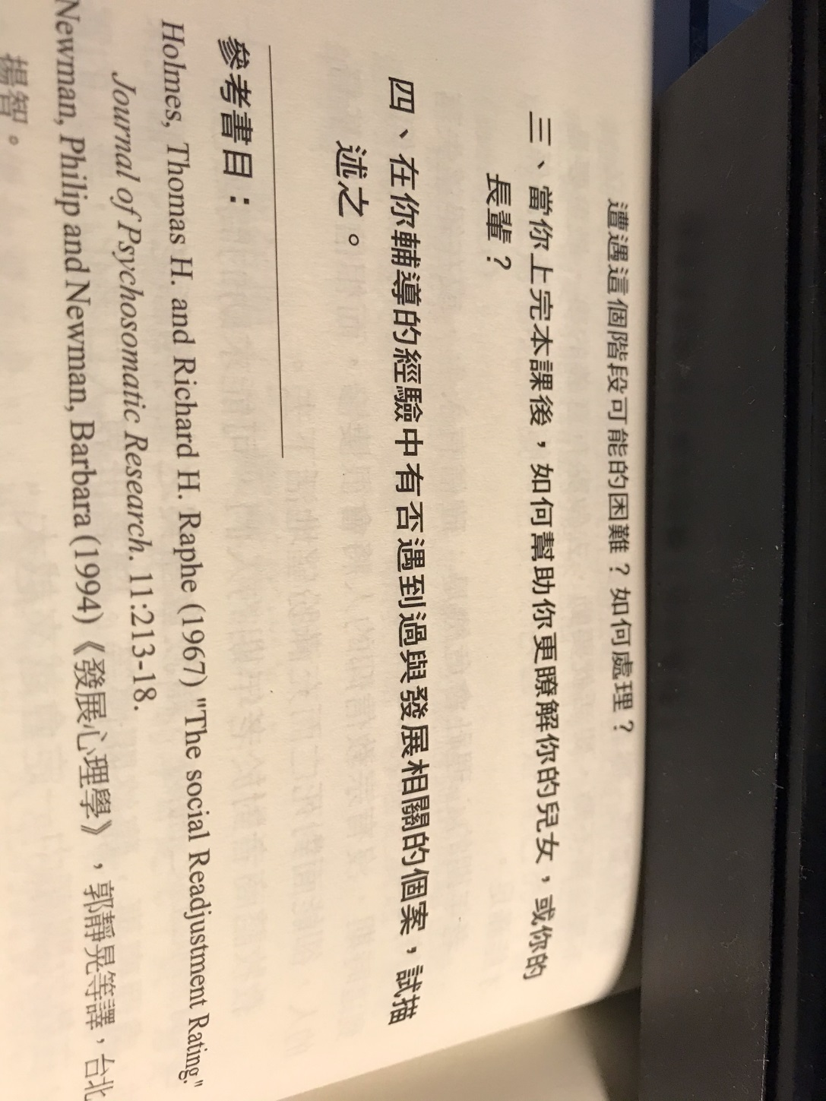

+++++++++++++++++++++++++++++++++++++++++++++++++++++++++++++++++++++++++++++++++++++++++++++++++++++++++++++++++++++++
第 6 周 2页的摘要, 问题和解答到期。

- Forgiveness is not a feeling or emotion.
- Forgiveness is not forgetting.
- Forgiveness is not finding excuse for others.
- Forgiveness is not to accommodate sin.
- Forgiveness is not to suppress self.
- Forgiveness is to decide not to think about it.
- Forgiveness is not to attack others.
- Forgiveness is not to talk about this anymore.
- Forgiveness is not let the past to block our communications.
- Forgiveness is what the Bible teaches.
- Forgiveness is to realize our benefits.
- Forgiveness is to understand what has been hurt.
- Forgiveness is to discern our reactions.
- Forgiveness is actively to communicate amicably.
- Forgiveness is to forgive the debts.
- Forgiveness is mutual acceptance.
- Forgiveness is to ask others to forgive you.
- Forgiveness is self-examination on speech, action, and motivation.
- Forgiveness is true repentance.
- Forgiveness is to recognize our own faults.
- Forgiveness is to pray, to learn, and to practice.
- We forgive because Jesus forgives us first.

1.宽恕不是一种感觉或情感。
2.宽恕不是不会忘记的。
3.宽恕不是为别人找借口。
4.宽恕不是容忍罪恶。
5.宽恕不是压制自己。
6.宽恕是决定不考虑它。
7.宽恕不是要攻击别人。
8.宽恕是不再谈论这个。
9.宽恕不是让过去阻碍我们的沟通。
10.宽恕是圣经所教导的。
11.宽恕是实现我们的利益。
12.宽恕是要了解遭受了什么伤害。
13.宽恕是辨别我们的反应。
14.宽恕是积极地进行友好交流。
15.宽恕是为了免除债务。
16.宽恕是相互接受。
17.宽恕是要别人宽恕你。
18.宽恕是对言语，行动和动机的自我检查。
19.宽恕是真正的悔改。
20.宽恕是承认我们自己的错。
21.宽恕是祈祷，学习和练习。
22.我们宽恕是因为耶稣首先宽恕了我们。

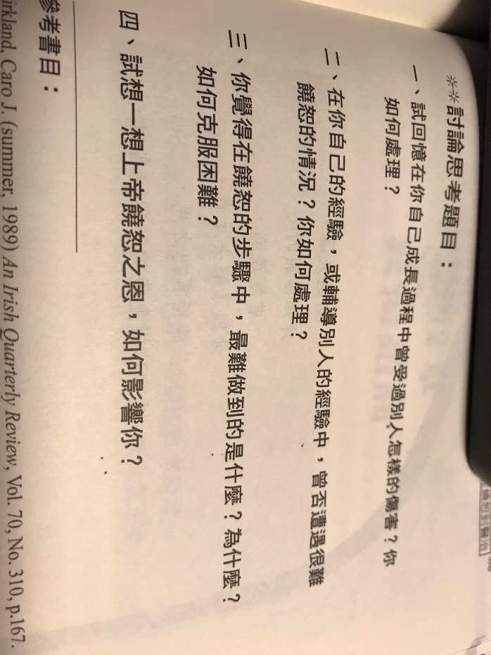

- Accept the fact of loss.
- Experience the pain of the loss.
- Adjust to a new situation of the loss.
- Put the energy on other matters.
- Help the survivors to recognize the loss.
- Help the survivors to calm down to realize the present situation.
- Help the survivors to live normal lives.
- Direct emotions away from the loss.
- Allow time to mourn.
- Recognize normal mourning.
- Allow individual differences.
- Propose continued support.
- Ask for help if necessary.
- Use the Bible appropriately.
- Arrange funeral carefully.
1.接受损失的事实。
2.体验失去的痛苦。
3.适应新的损失情况。
4.将精力放在其他事项上。
5.帮助幸存者识别损失。
6.帮助幸存者冷静下来以了解当前情况。
7.帮助幸存者过正常的生活。
8.引导情绪远离损失。
9.留出时间哀悼。
10.认识正常的哀悼。
11.允许个人差异。
12.提出继续支持的建议。
13.必要时寻求帮助。
14.正确使用圣经。
15.认真安排葬礼。

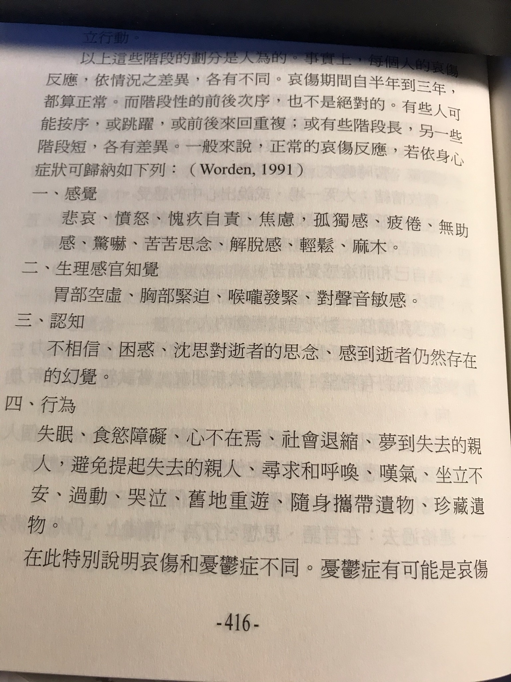
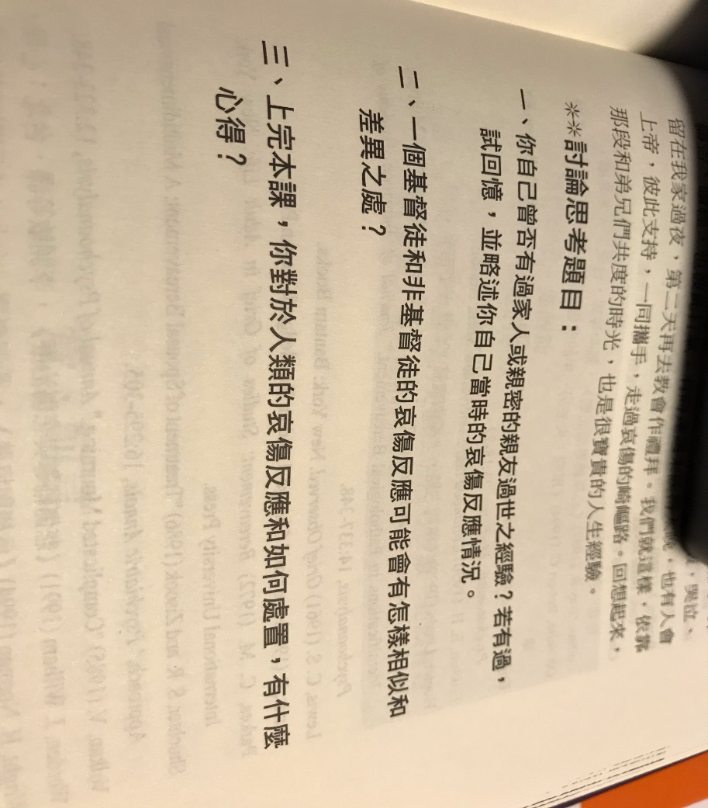

+++++++++++++++++++++++++++++++++++++++++++++++++++++++++++++++++++++++++++++++++++++++++++++++++++++++++++++++++
第 7 周 2页的摘要, 问题和解答到期。
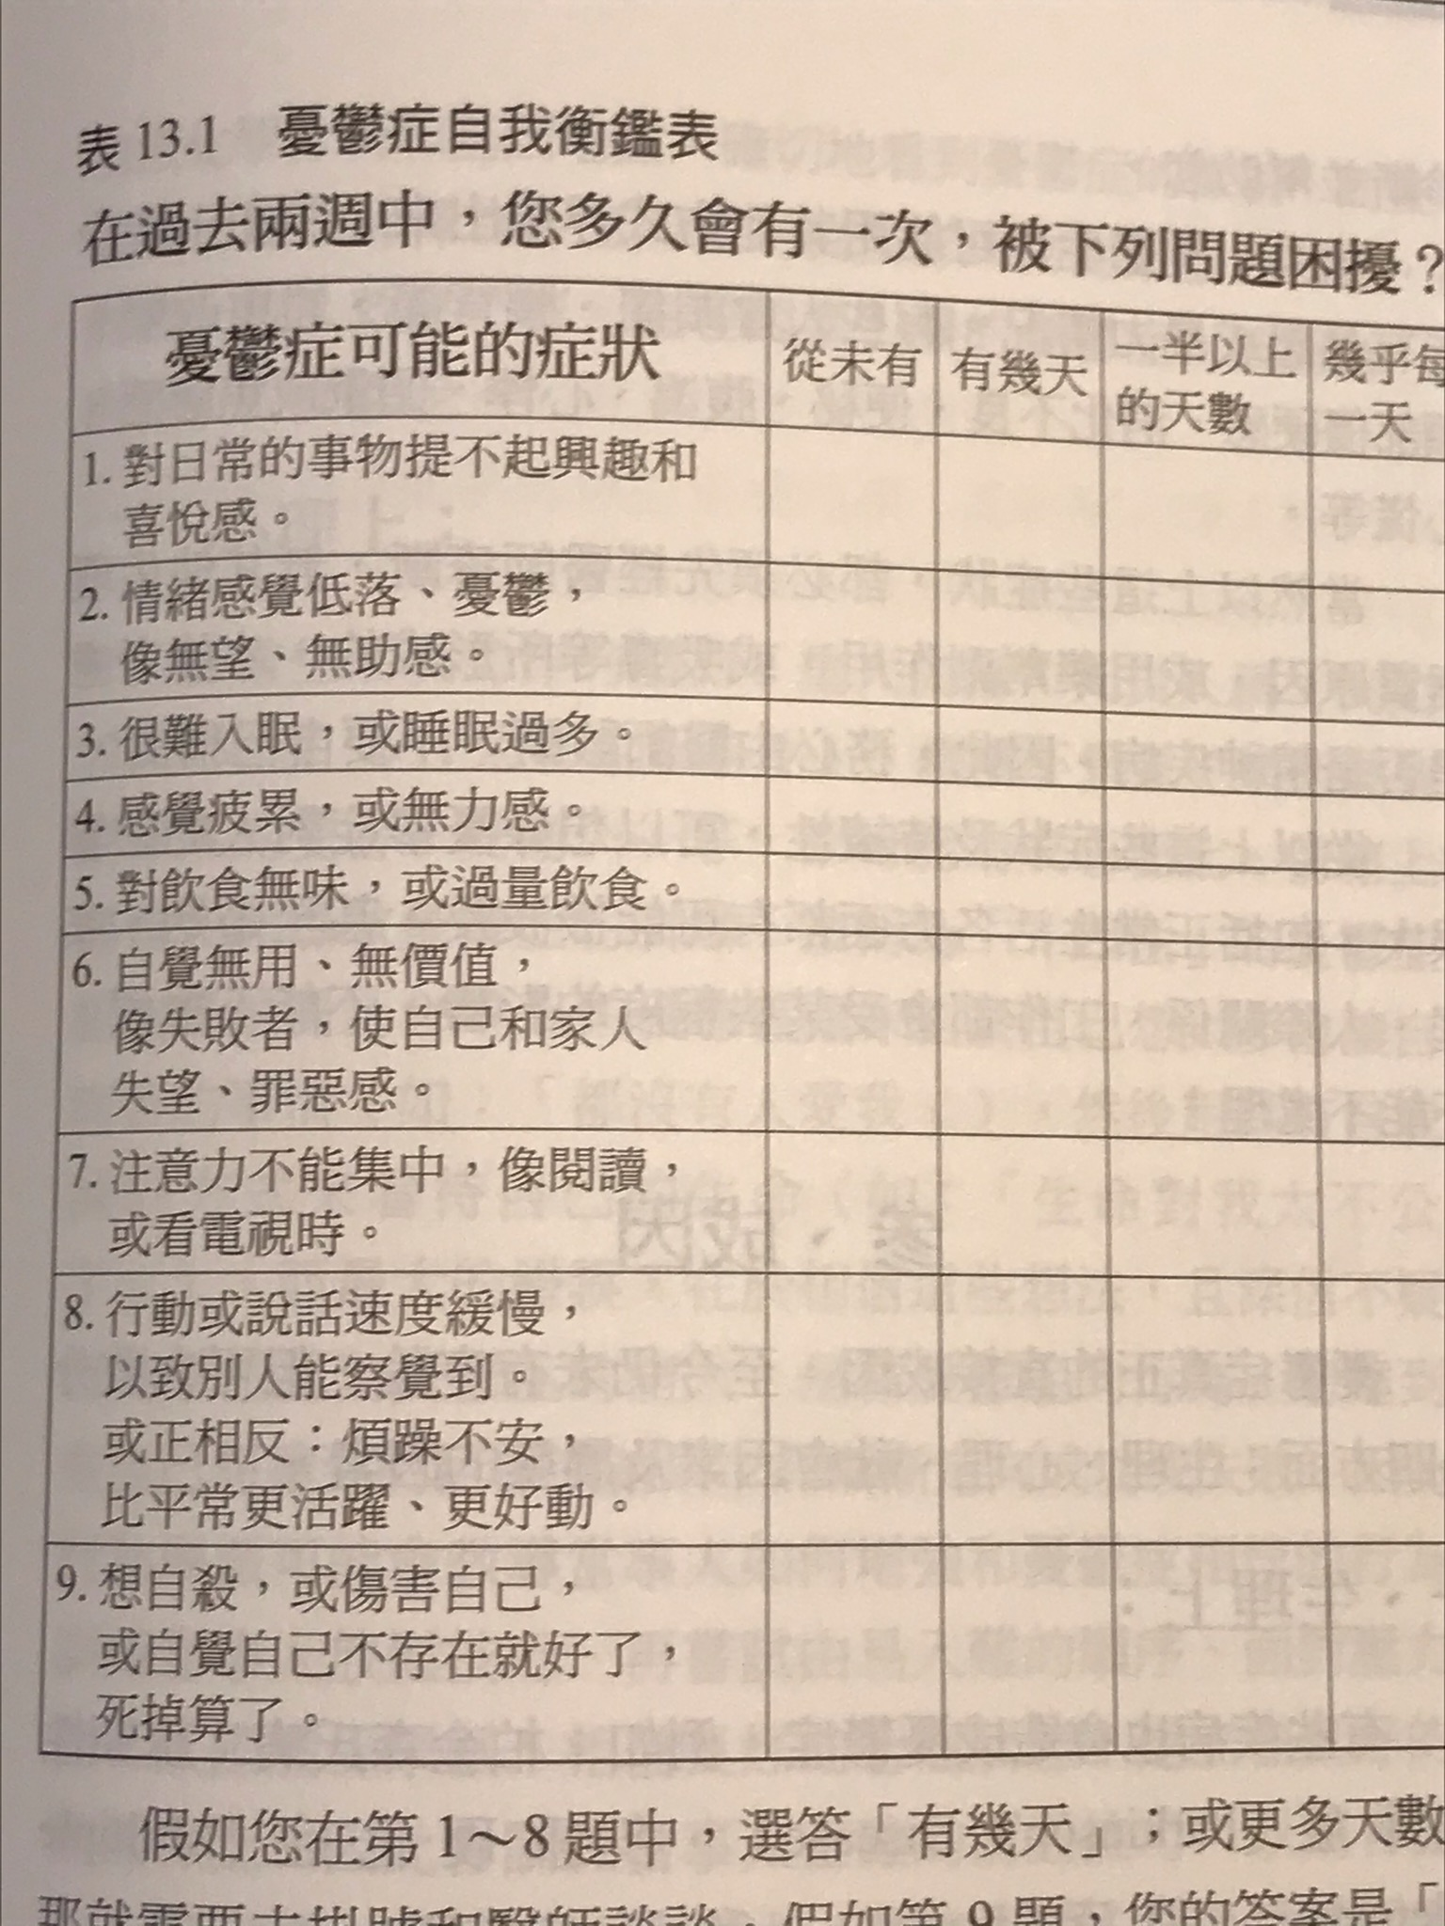

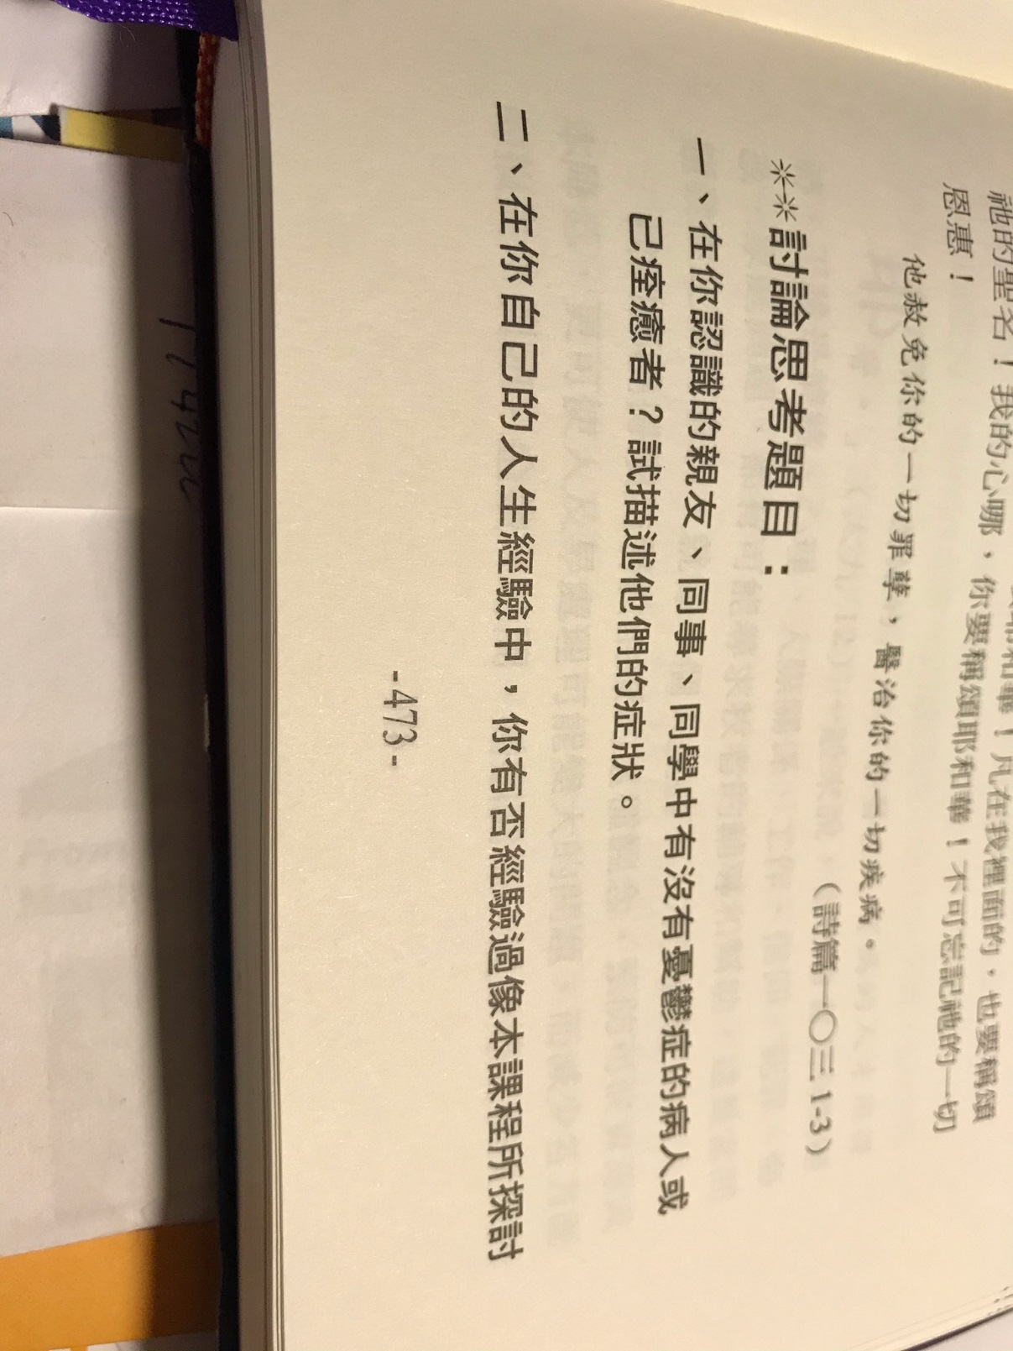

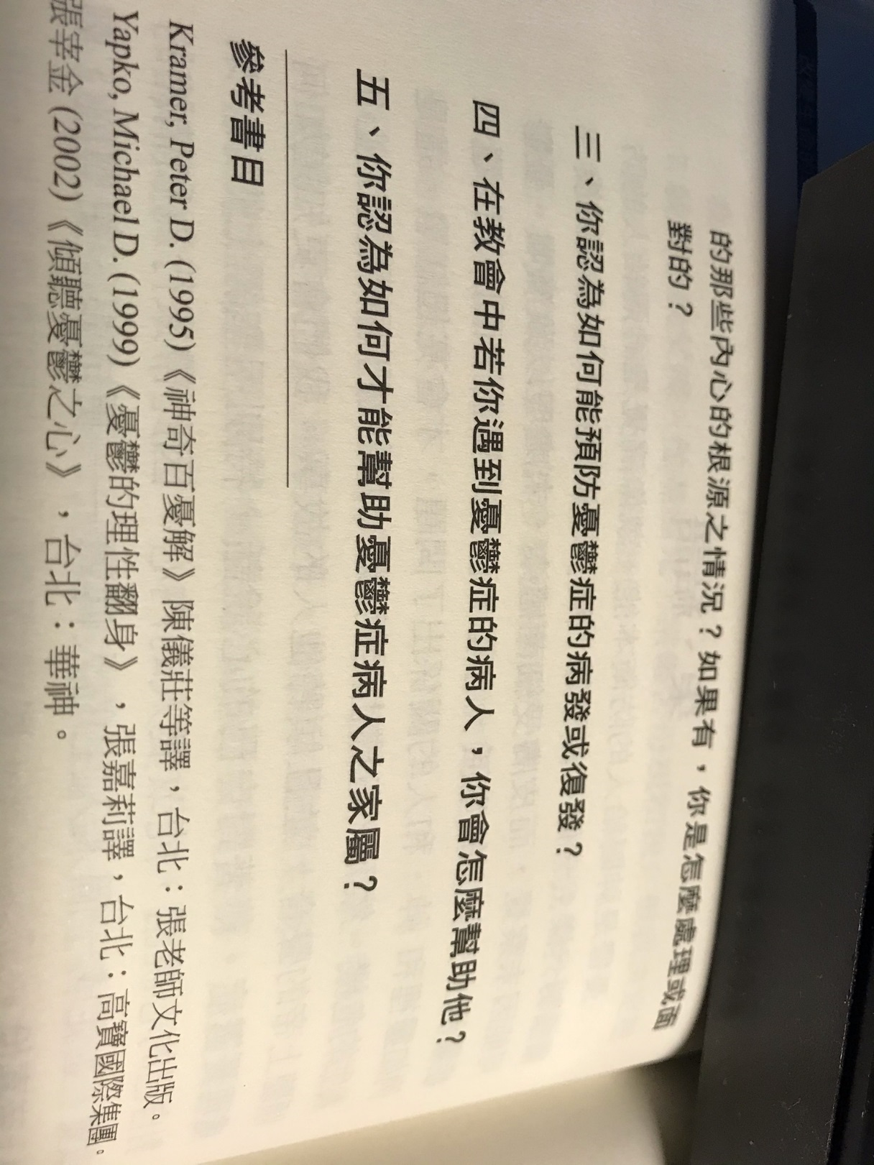

Chapter 14: Prevention is better than cure.
第14章：预防胜于治疗。
- Counseling before marriage.
- Sponsor Seminars or Camps on Faith and Living.
- Set up Special Support Group in the church.
- Training Lay Counselors in the church.
- If crisis is discovered, help survivor to understand loss; to normalize emotions; to allow time to recover; allow individual differences; provide continued support; provide adjustments; refer to medical authorities if necessary.

1.婚前咨询。
2.赞助关于信仰和生活的研讨会或训练营。
3.在教会中设立特别支持小组。
4.在教会中训练平时的辅导员。
5.如果发现危机，帮助幸存者了解损失； 使情绪正常化； 腾出时间恢复； 允许个人差异； 提供持续的支持； 提供调整； 如有必要，请咨询医疗机构。

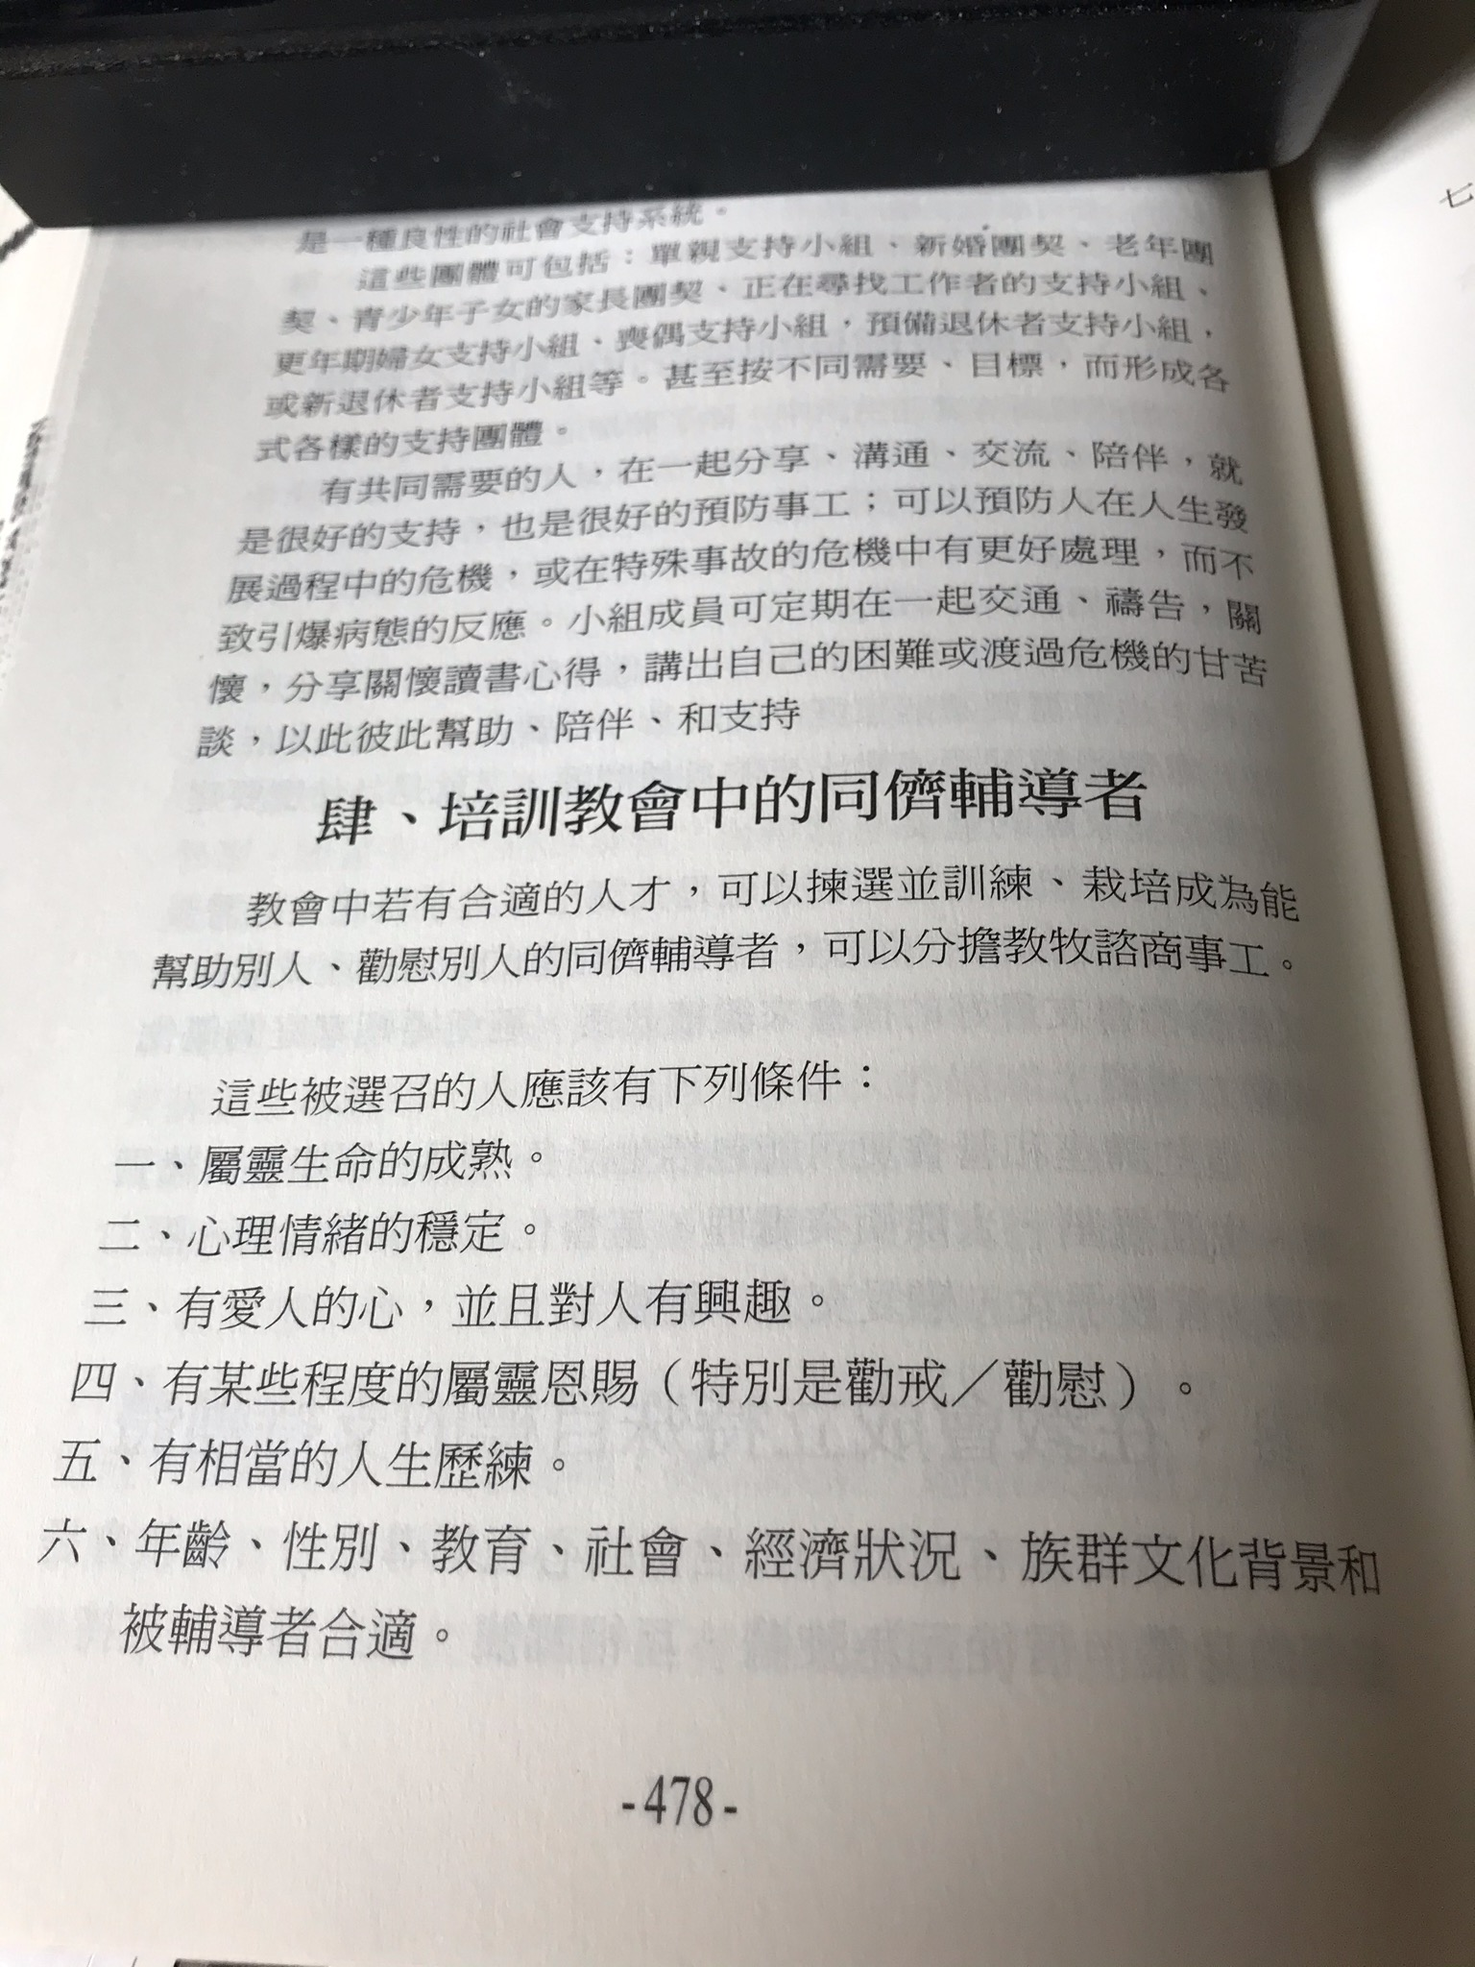
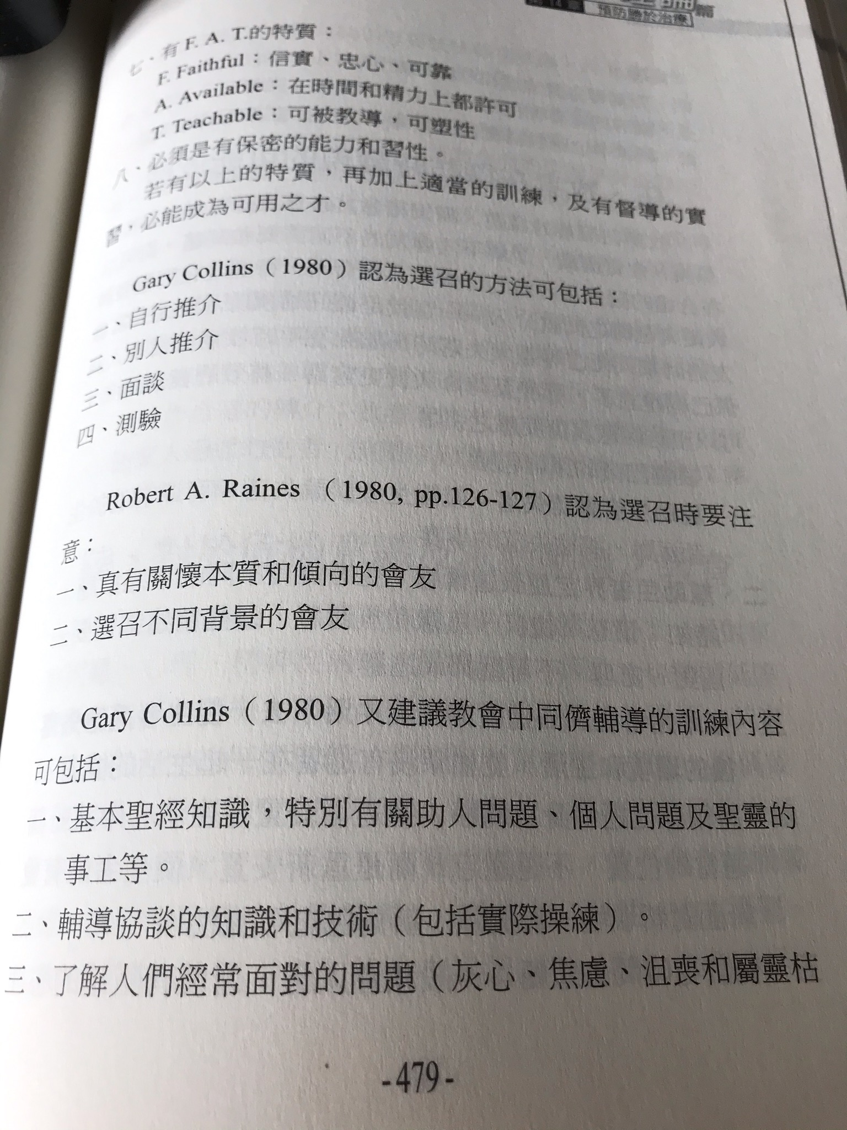
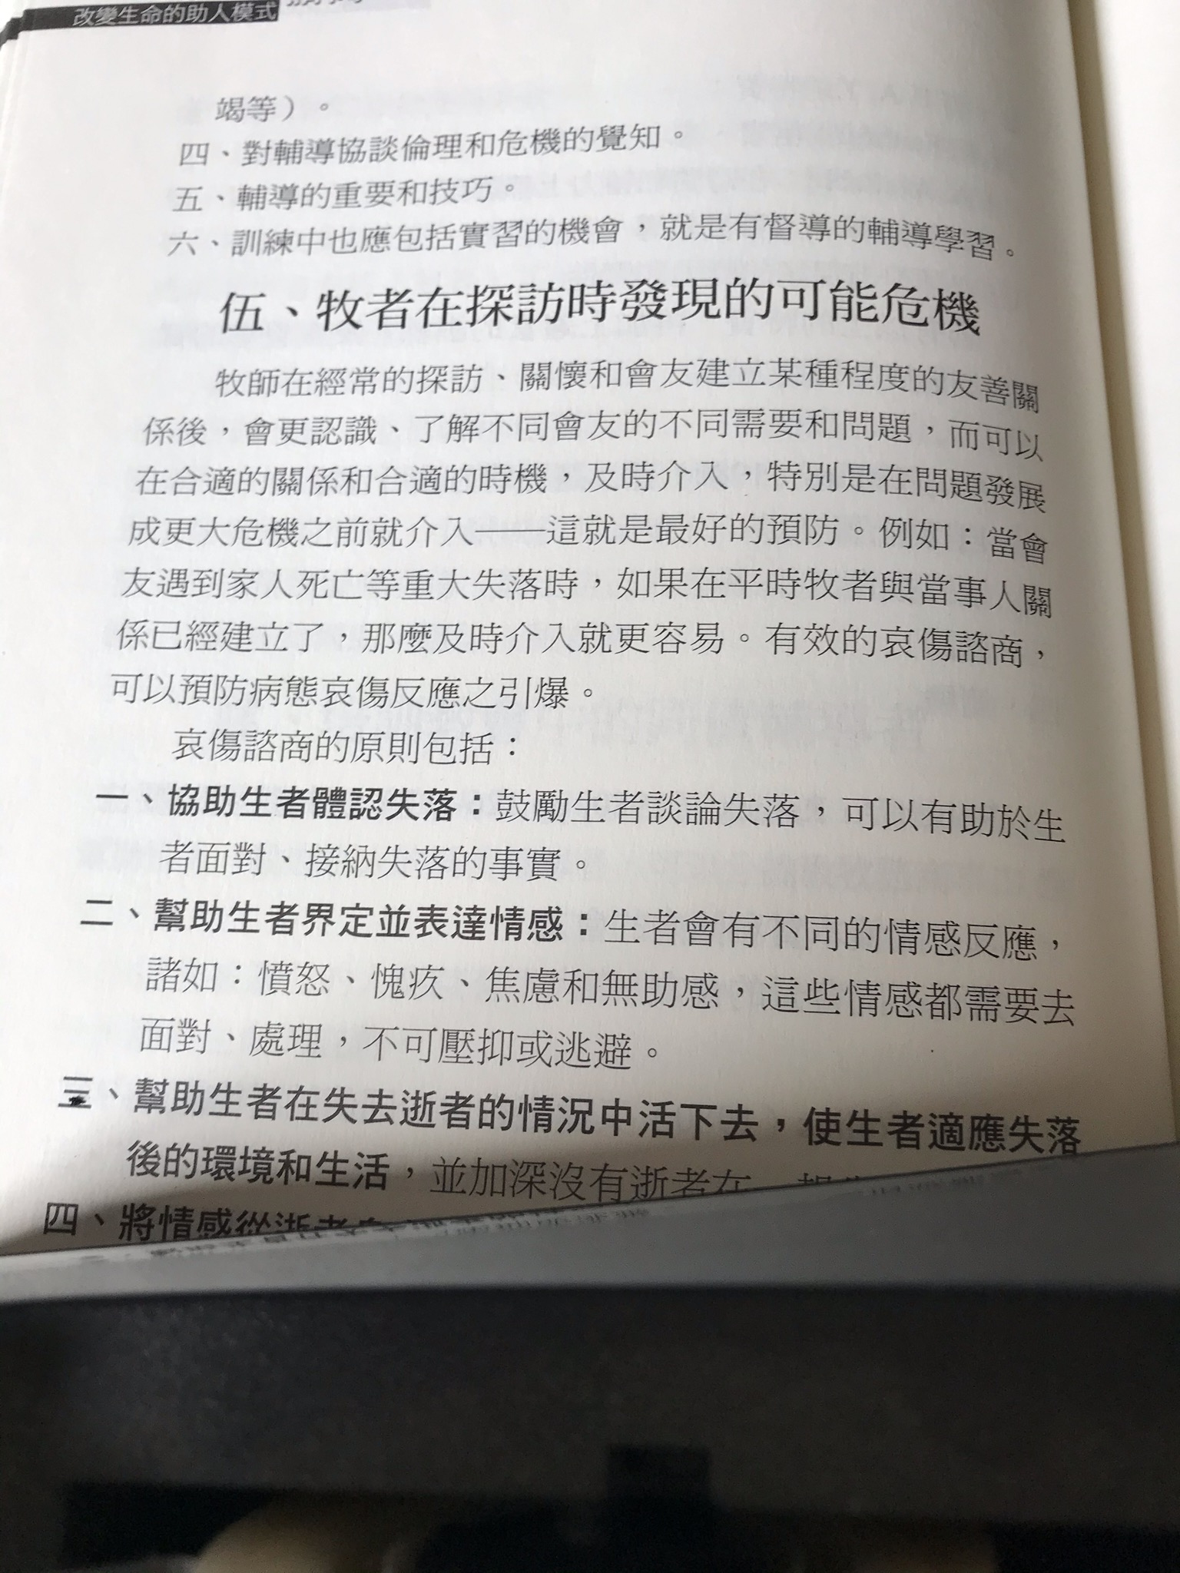

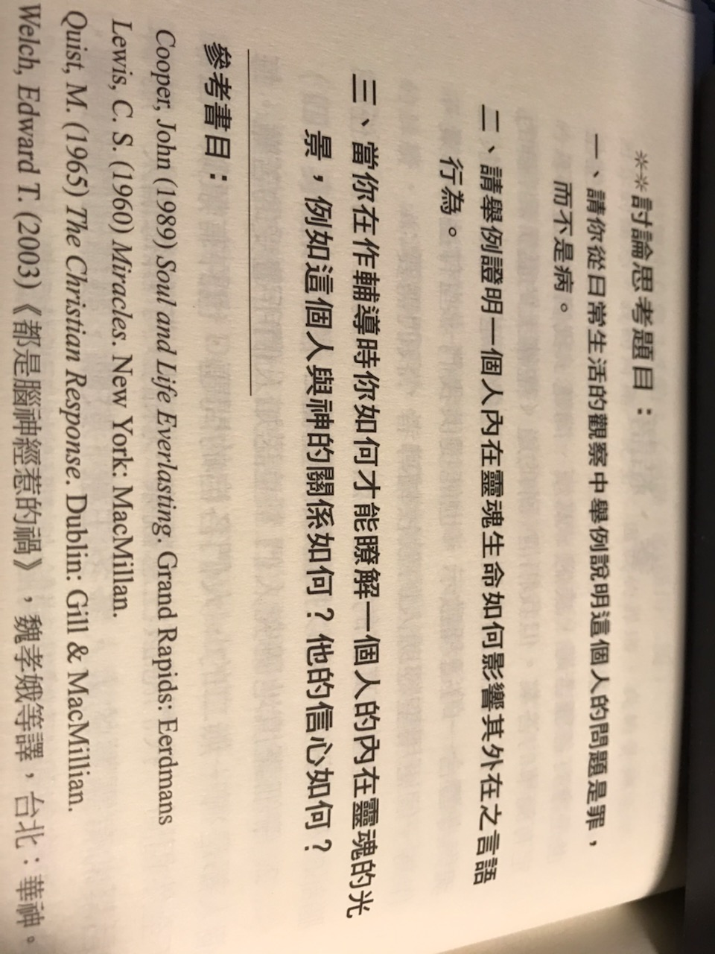

+++++++++++++++++++++++++++++++++++++++++++++++++++++++++++++++++++++++++++++++++++++++++++++++++++++++++++++++++++

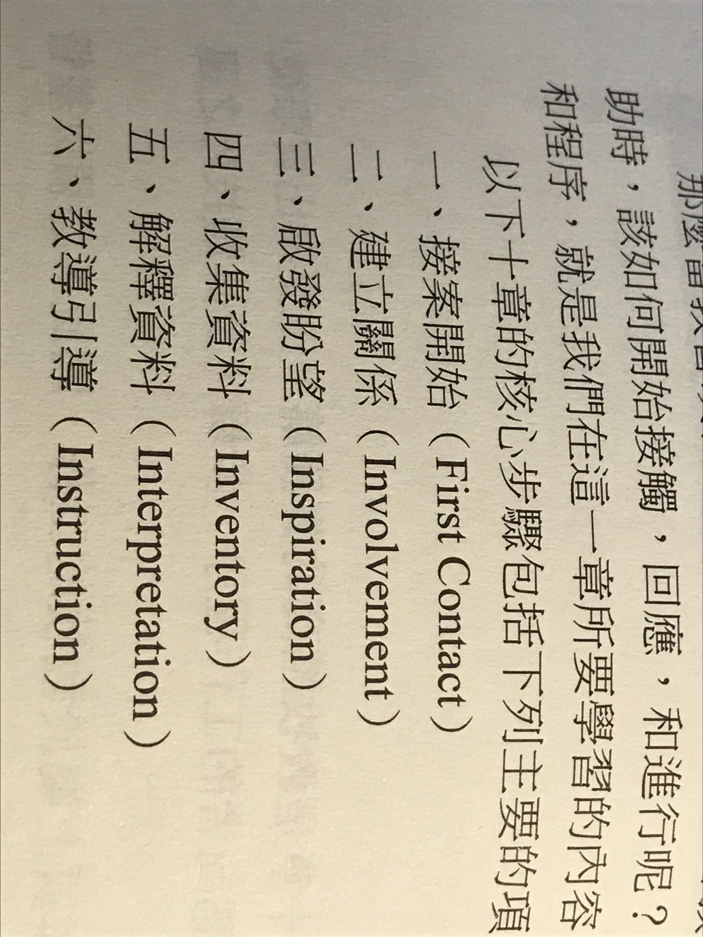

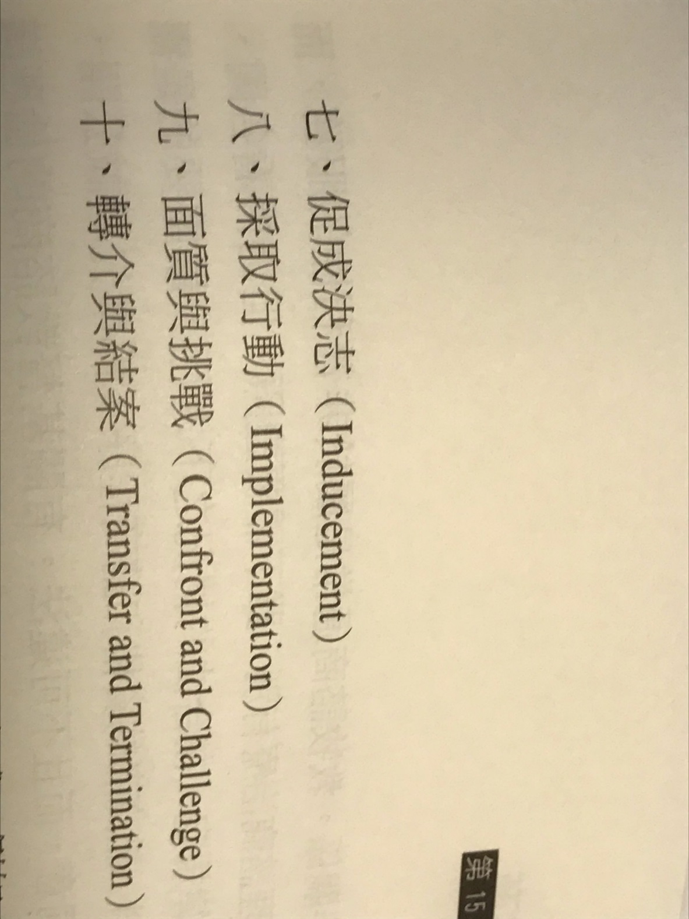

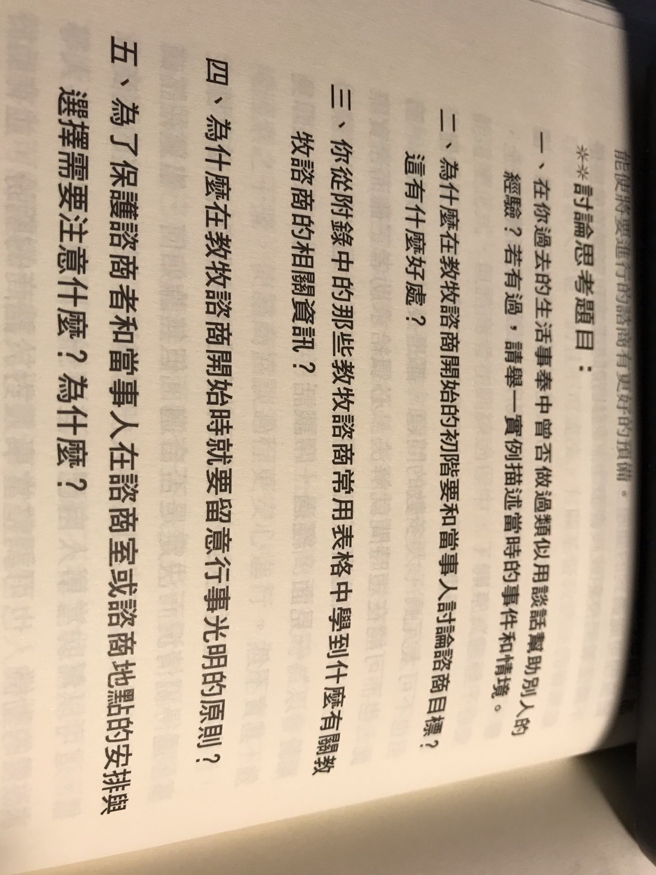

第 8 周 2页的摘要, 问题和解答到期。

Chapter 16: Building Relationships
- Relationships are built when others feel that you are concerned: Jesus’s examples; Paul’s examples; cultivate a heart of concern.
- Thinking about Jesus’s love; standing on other’s foot.
- See others as a family; realizing our weaknesses; decide to love others just as Christ loves us.
- Practice loving acts using language, prayers together; standing with those in difficulties.
- Empathize others; appropriate bodily actions; tender attitudes; language to build up others.
- Forgiving attitude; concern about others’ needs; understand others’ needs.
- Persist in tender attitude; respect others; not judge others dogmatically.
- Using Biblical principles; sensitive seating; openness; leaning forward; appropriate eye contact.
- Relax; touch; environment; accommodating attitude.

第十六章：建立关系
1.当别人感到您关注时建立关系：耶稣的榜样； 保罗的榜样； 培养一颗关注的心。
2.考虑耶稣的爱； 站在别人的脚上。
3.将他人视为一个家庭； 意识到我们的弱点； 决定爱别人就像基督爱我们一样。
4.运用语言，祷告一起实践爱心行为； 与困难者站在一起。
5.善待他人； 适当的身体动作； 温柔的态度； 语言来培养他人。
6.宽容的态度； 关注他人的需求； 了解他人的需求。
7.坚持温柔的态度； 尊重他人； 不能专断地评判别人。
8.使用圣经原则； 敏感的座位； 开放性, 向前倾, 适当的眼神交流。
9.放松； 触摸; 环境; 宽容的态度。

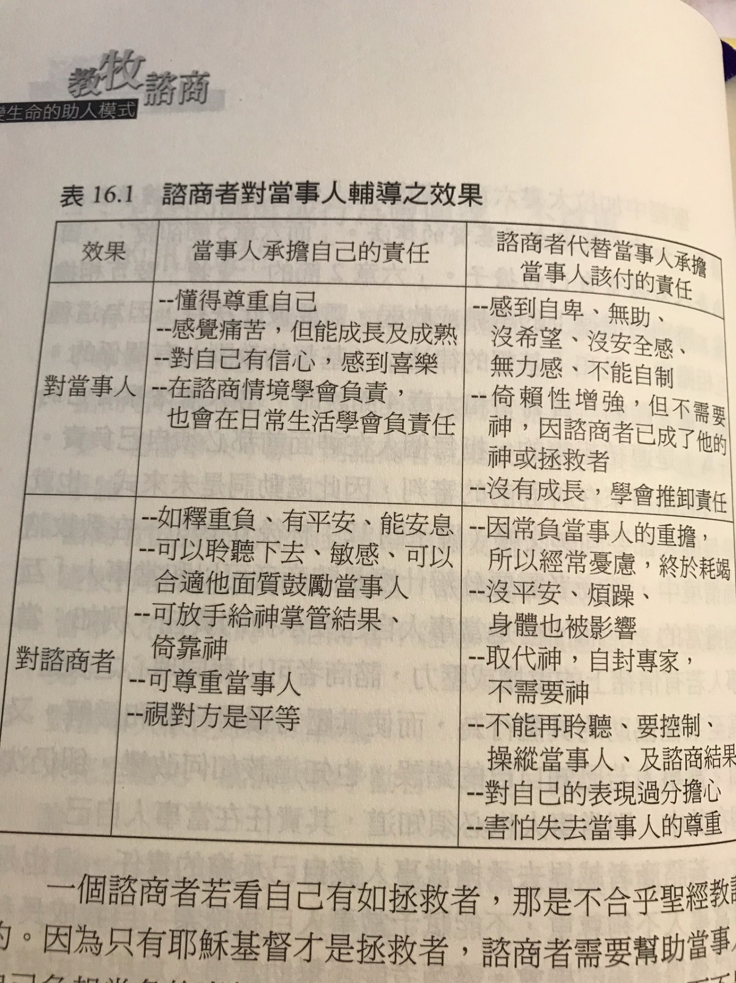

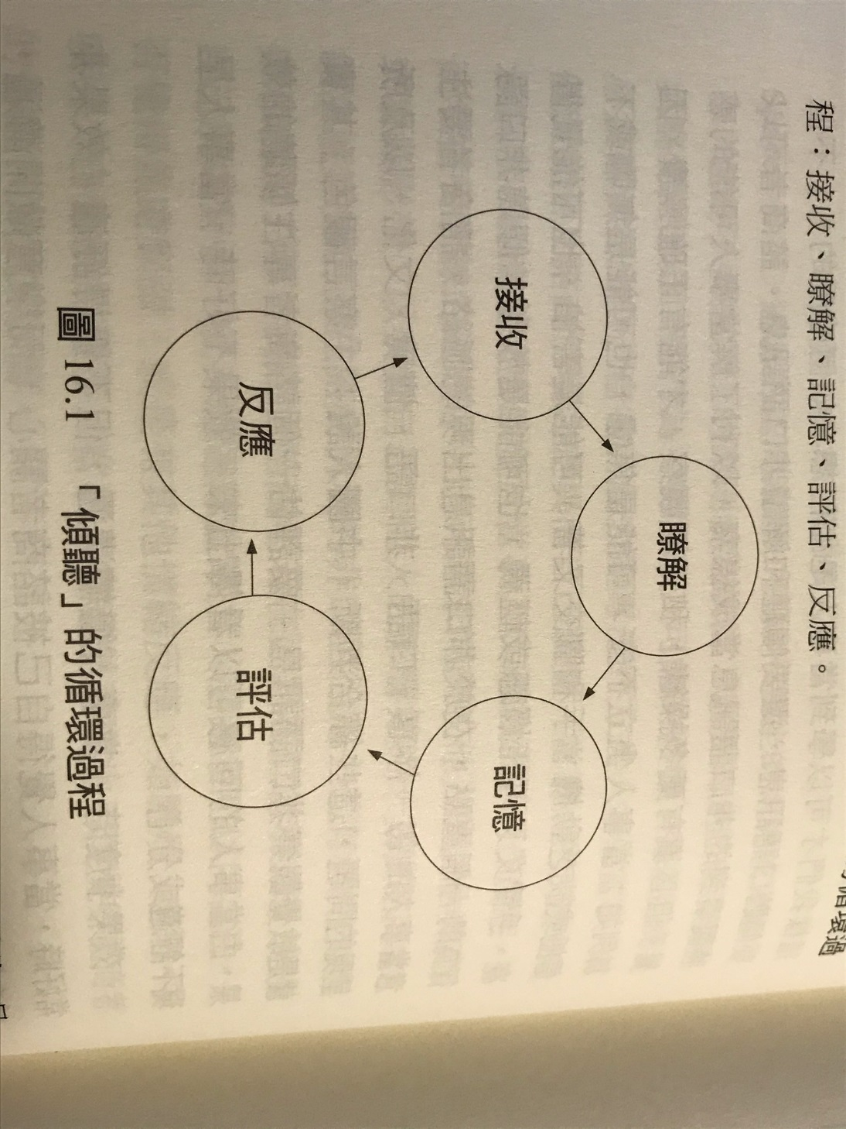

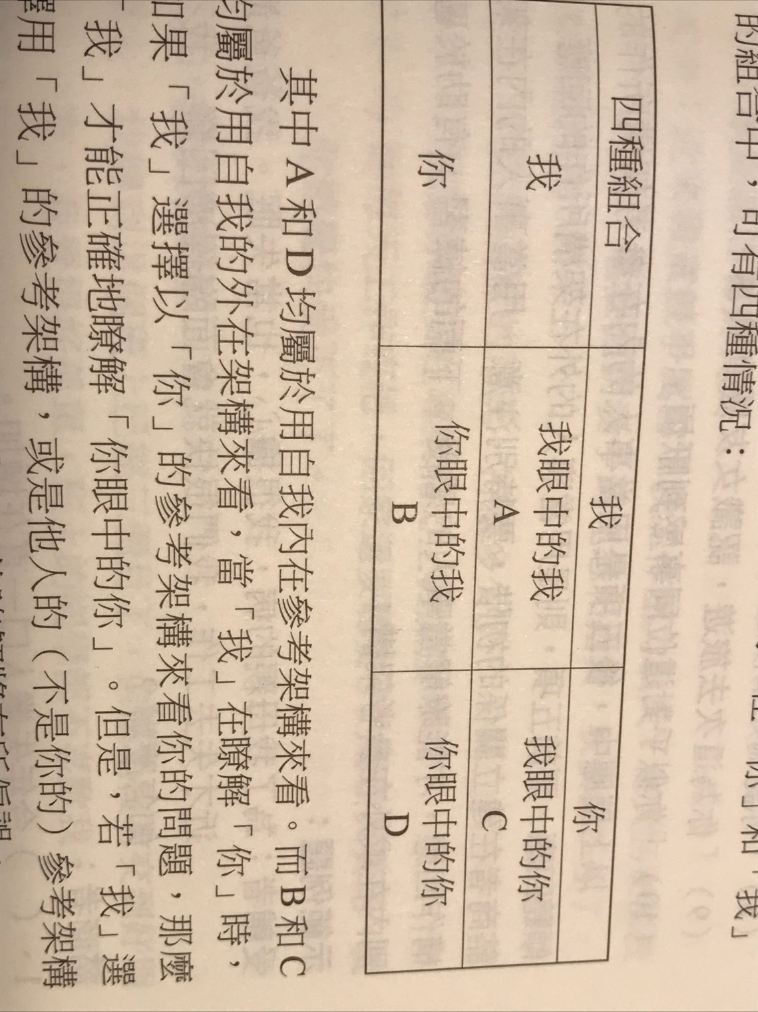
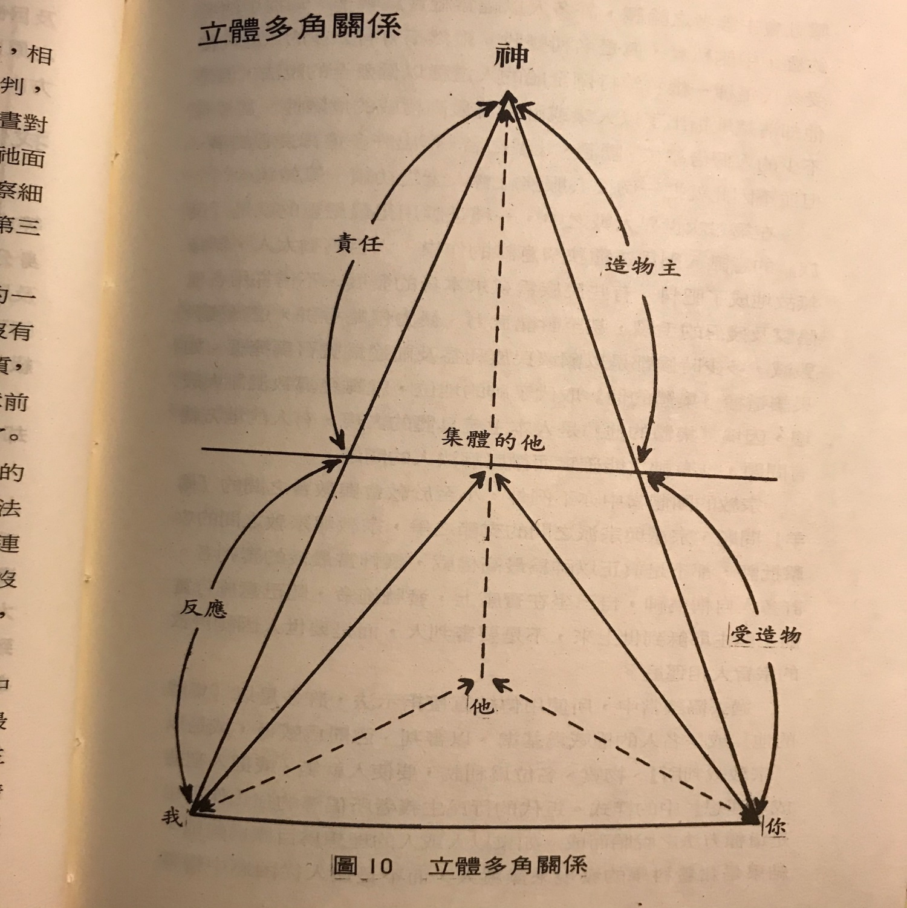

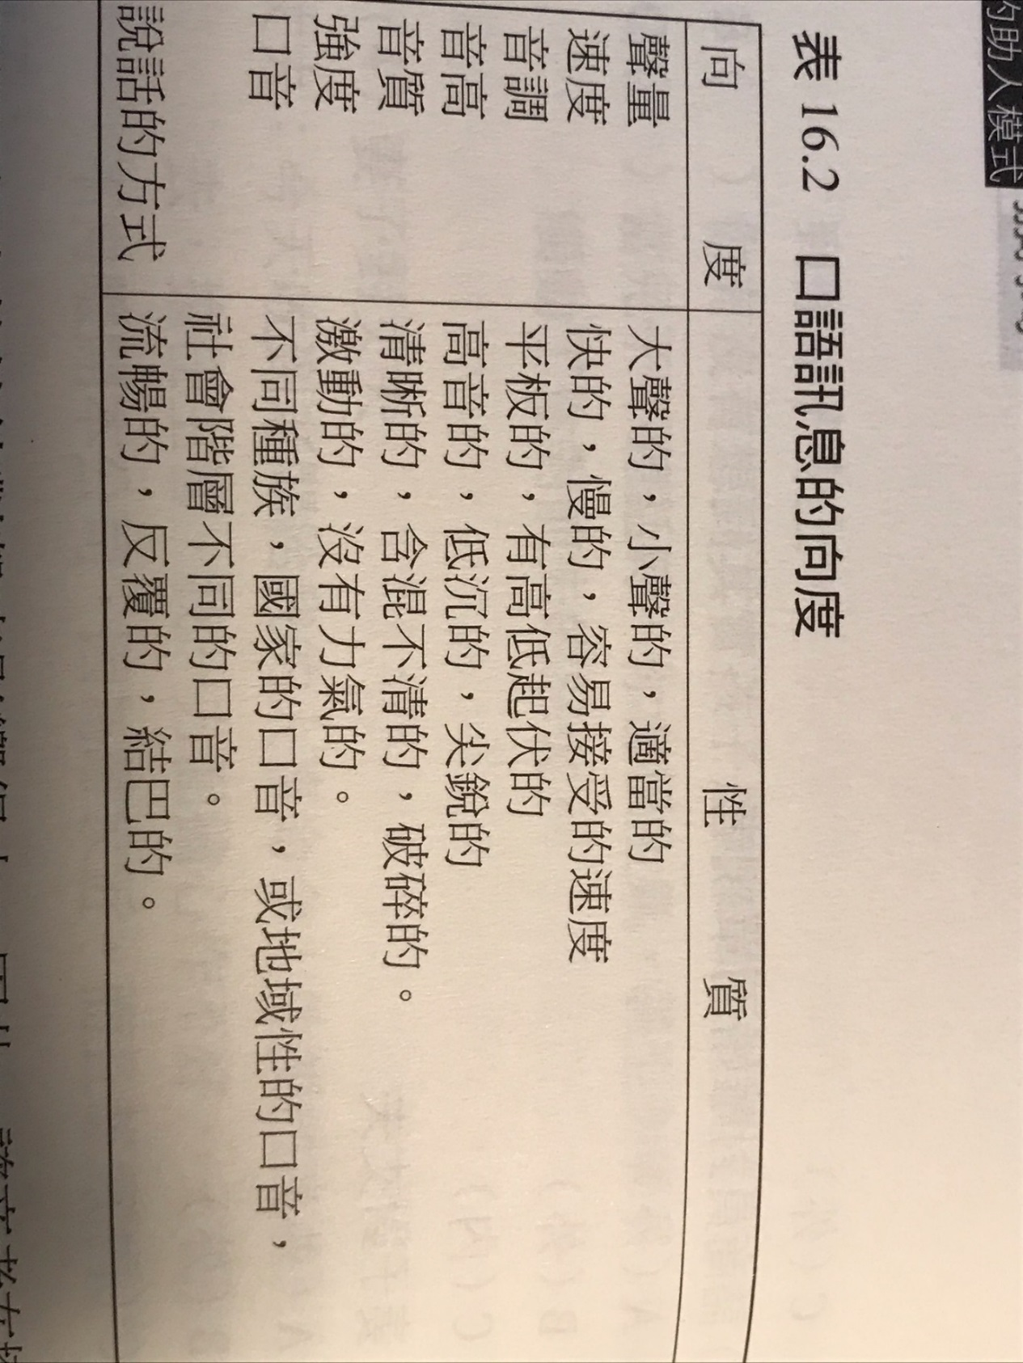

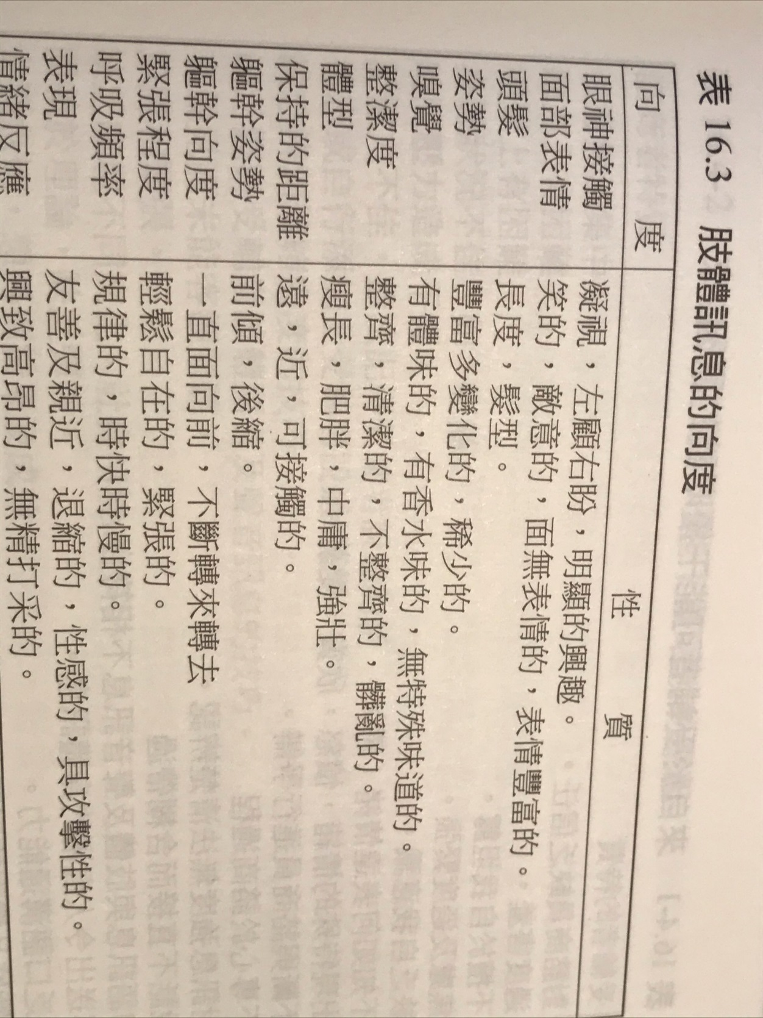

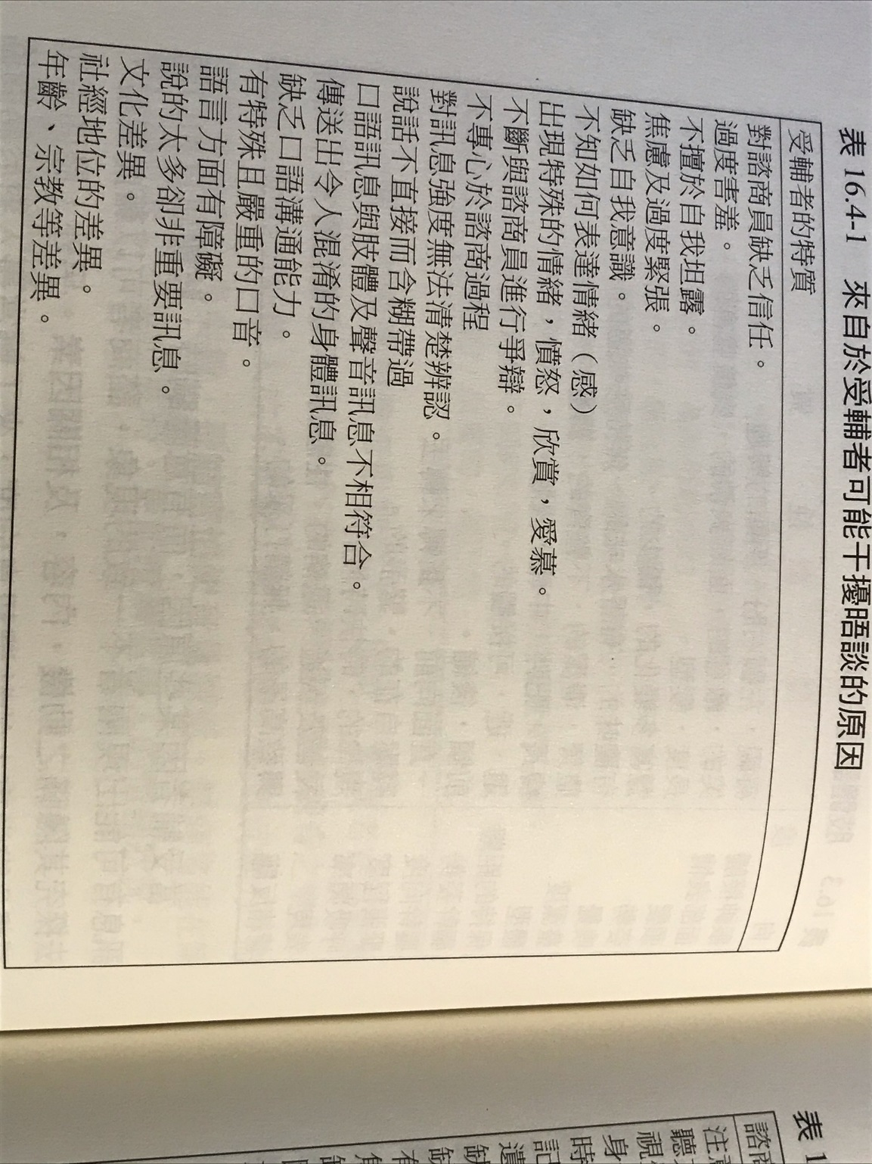

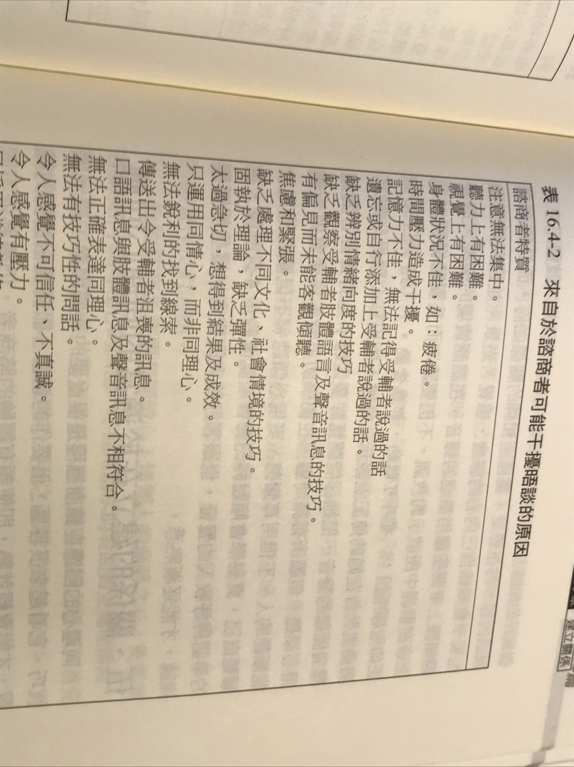

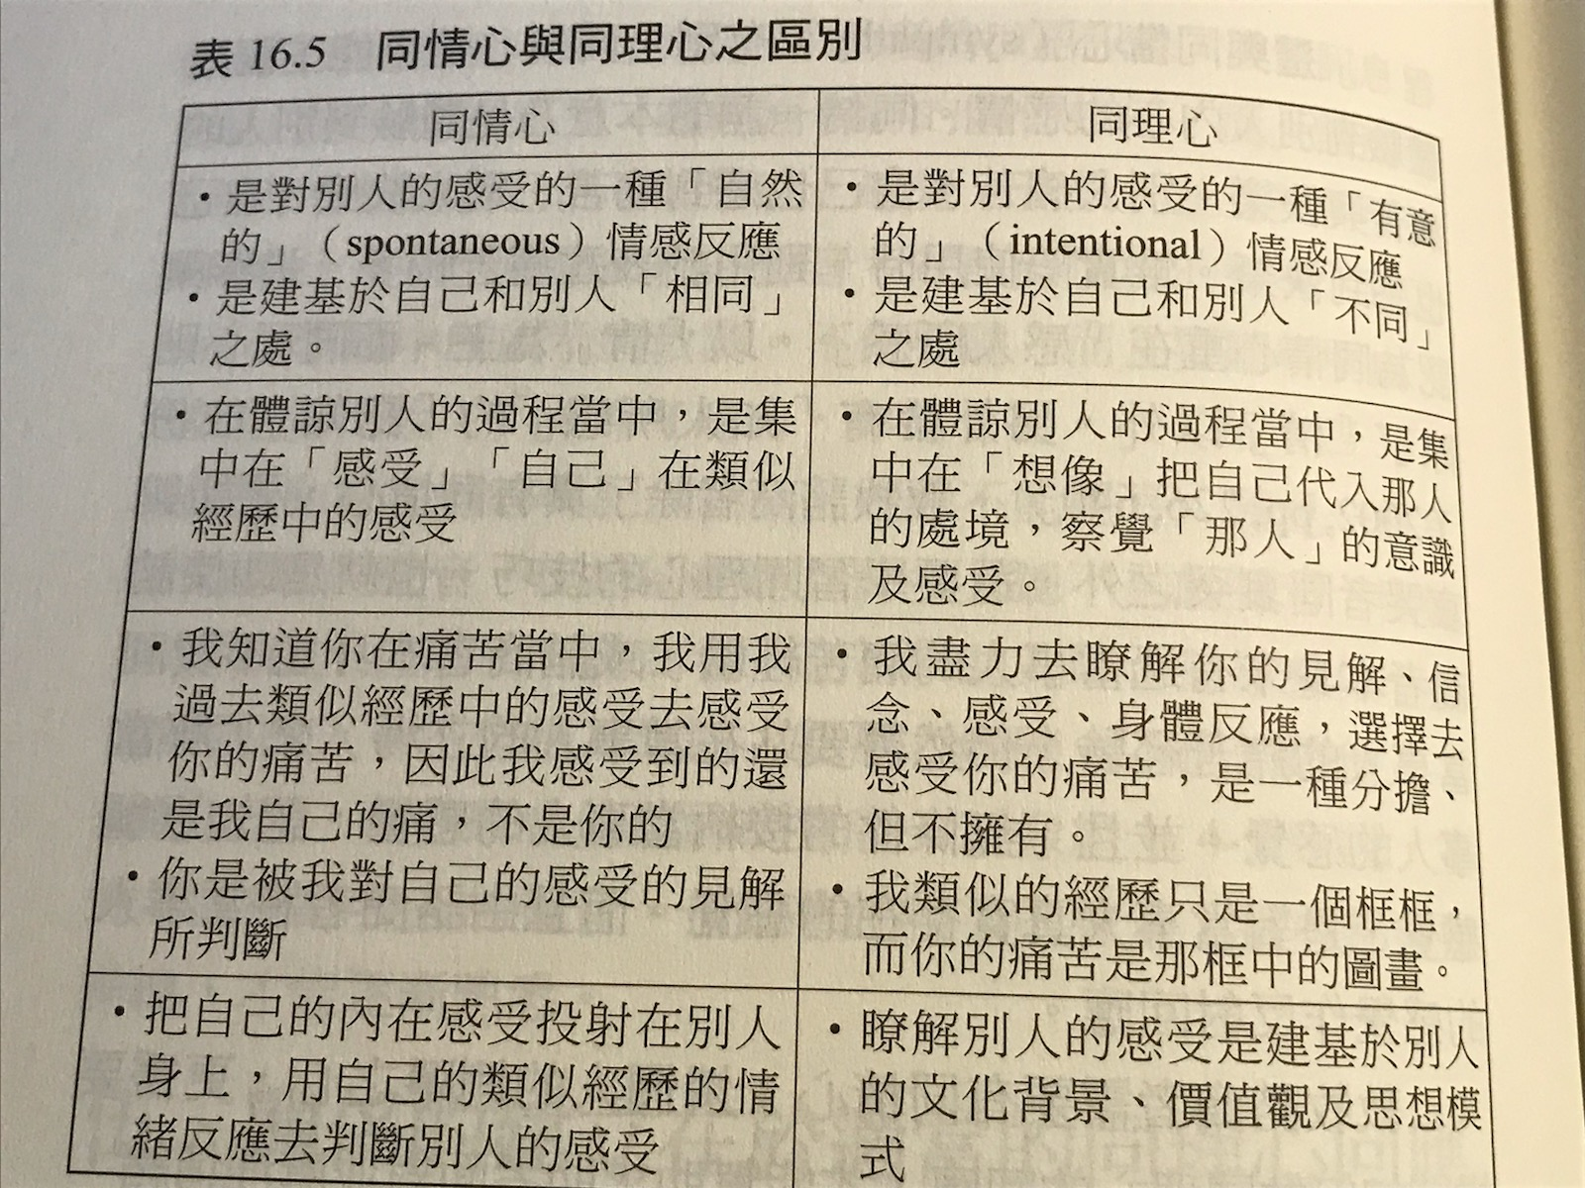

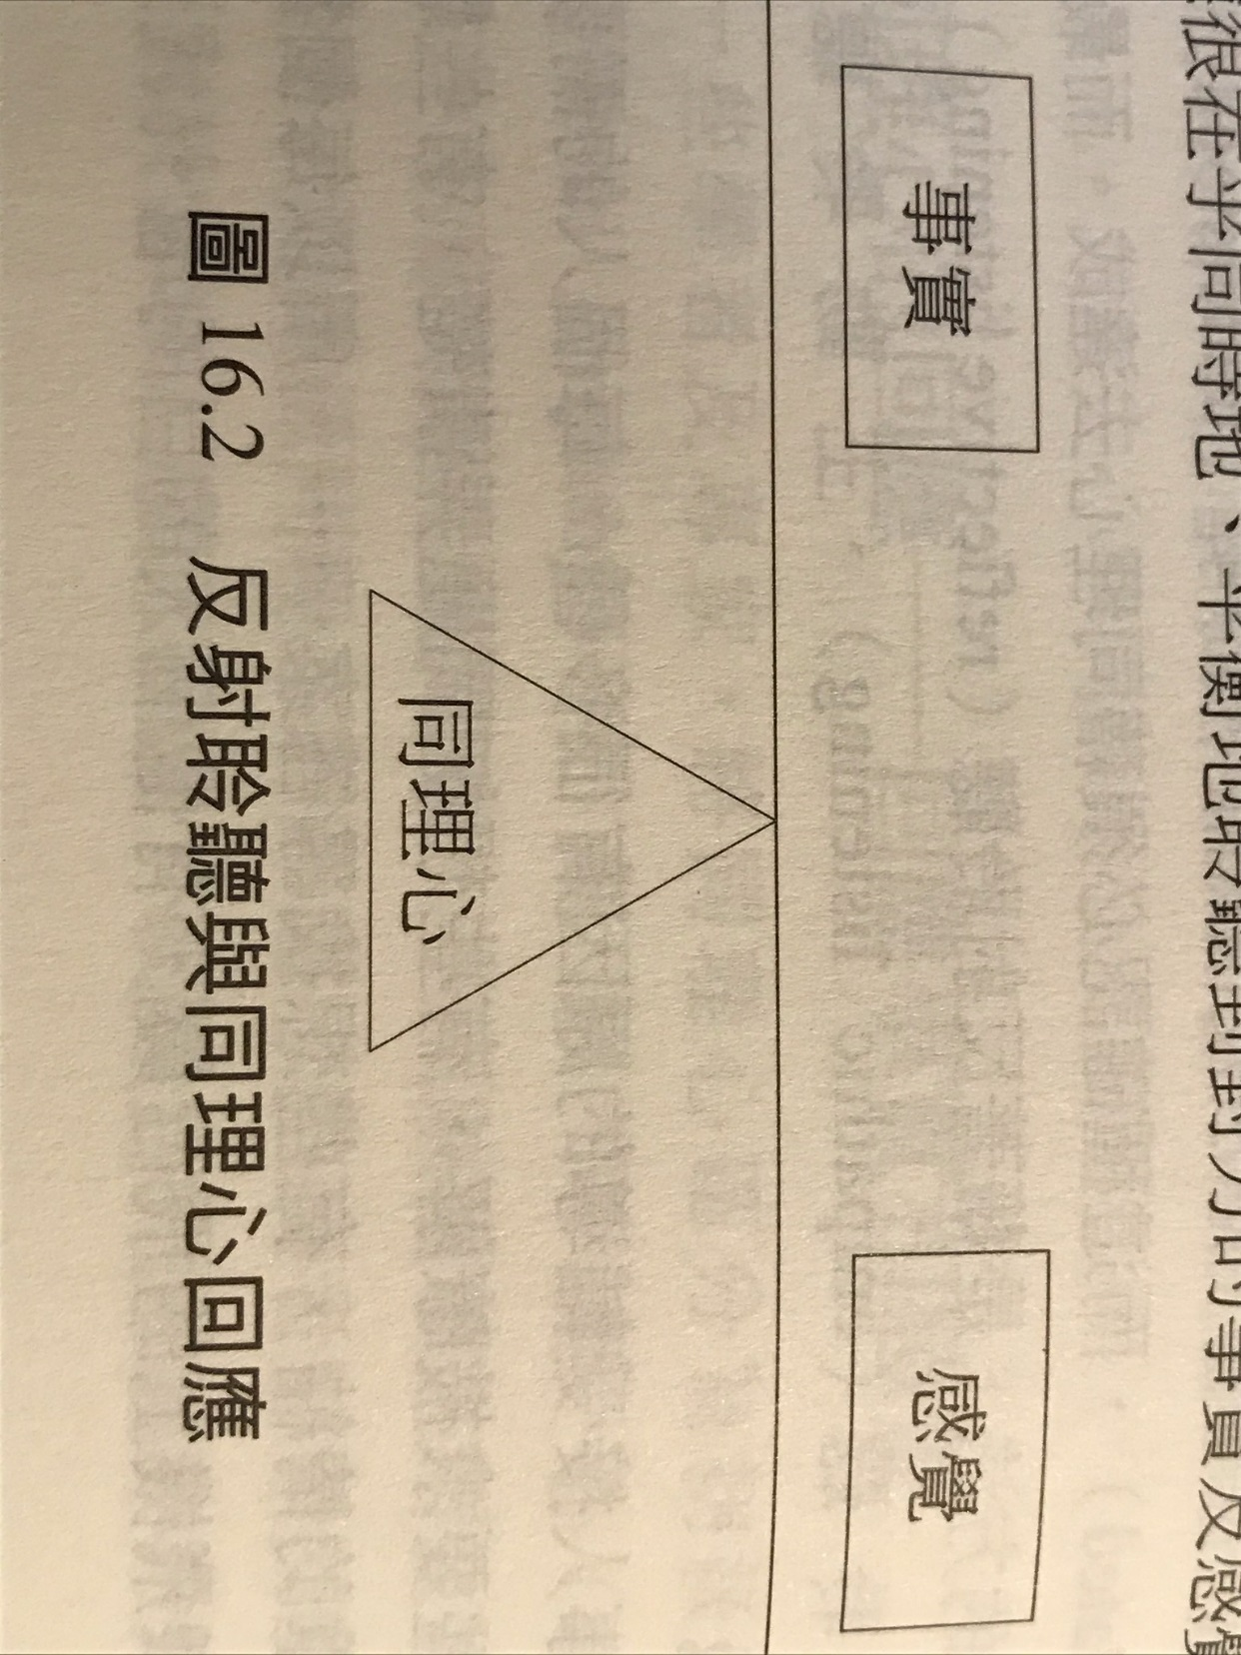

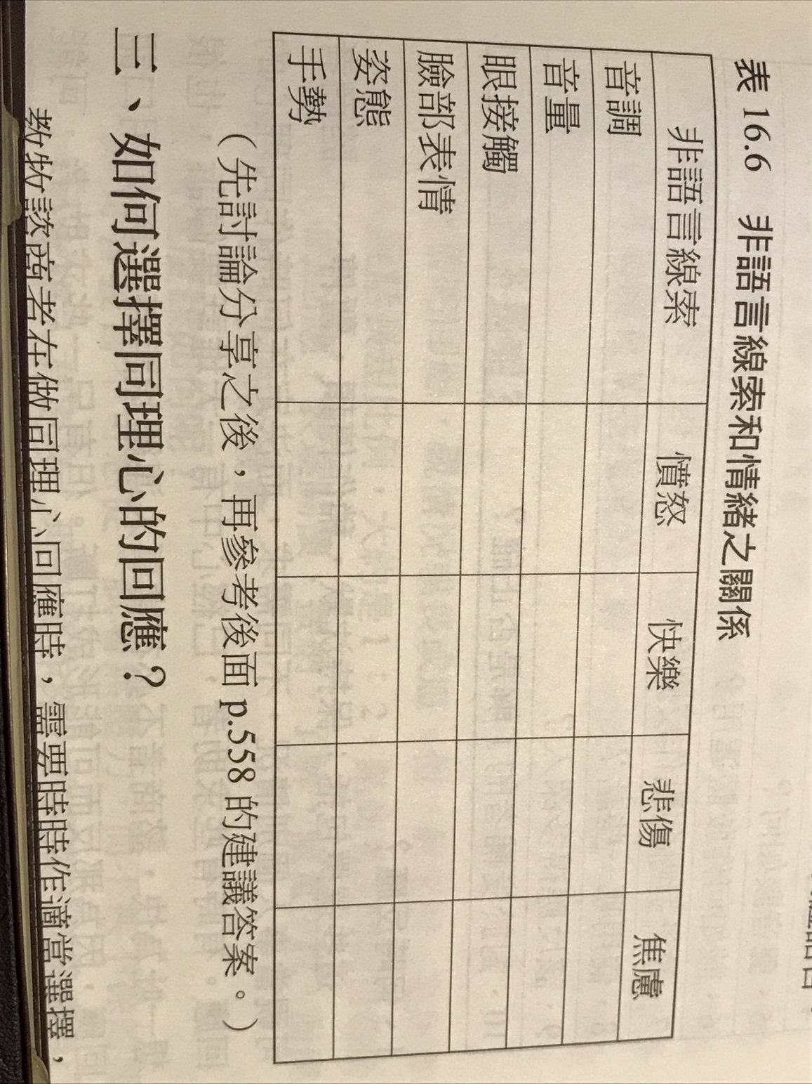

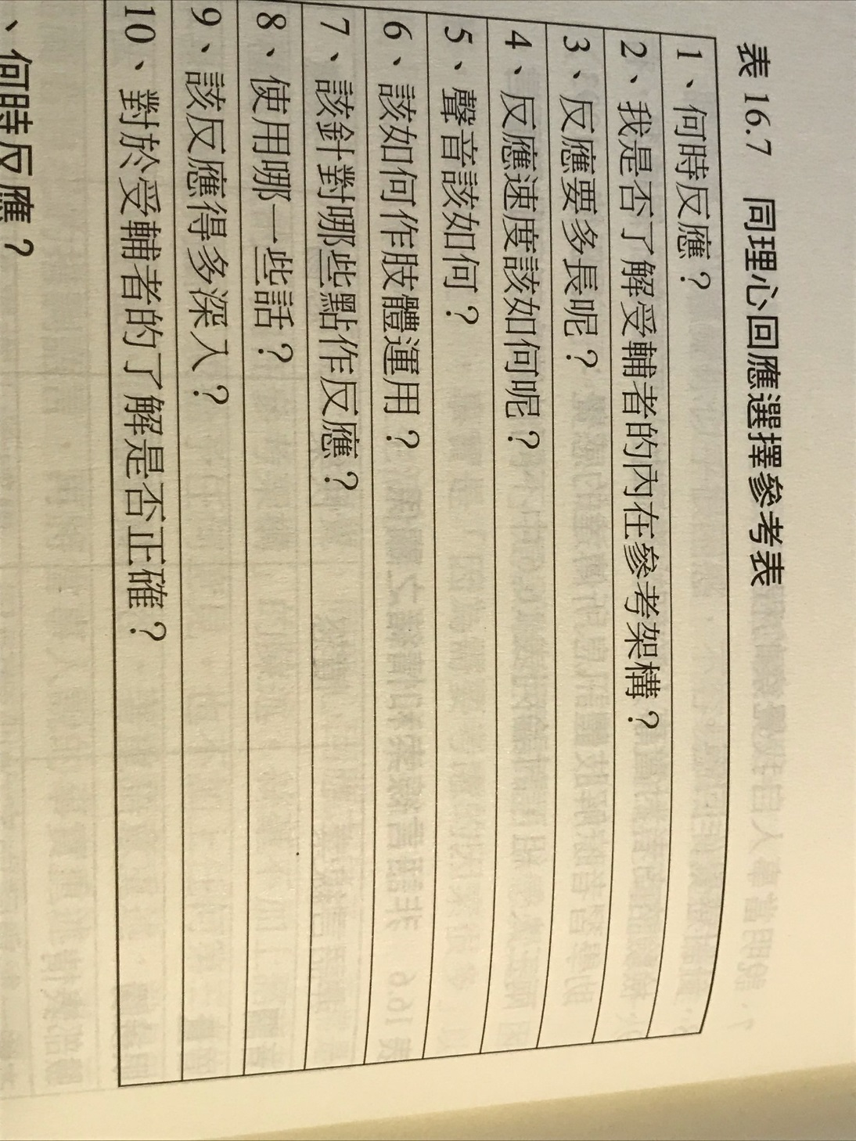

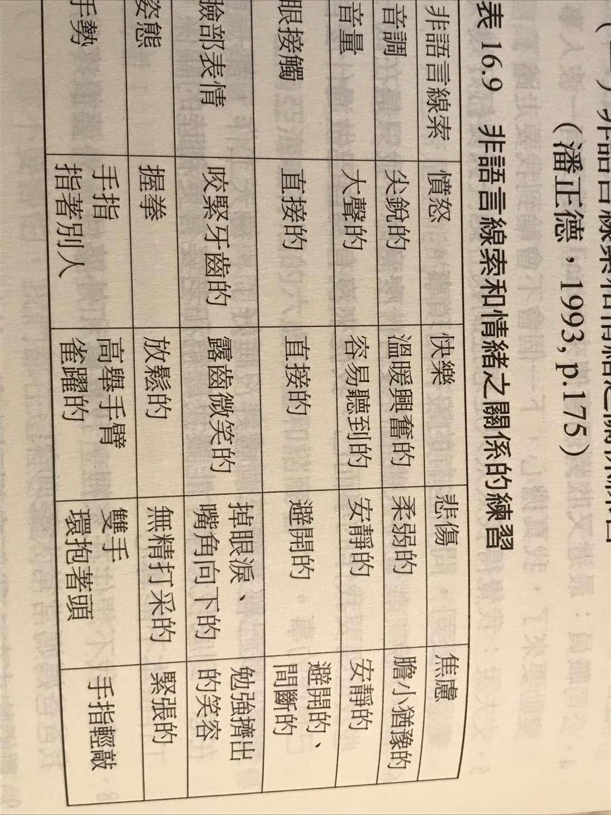

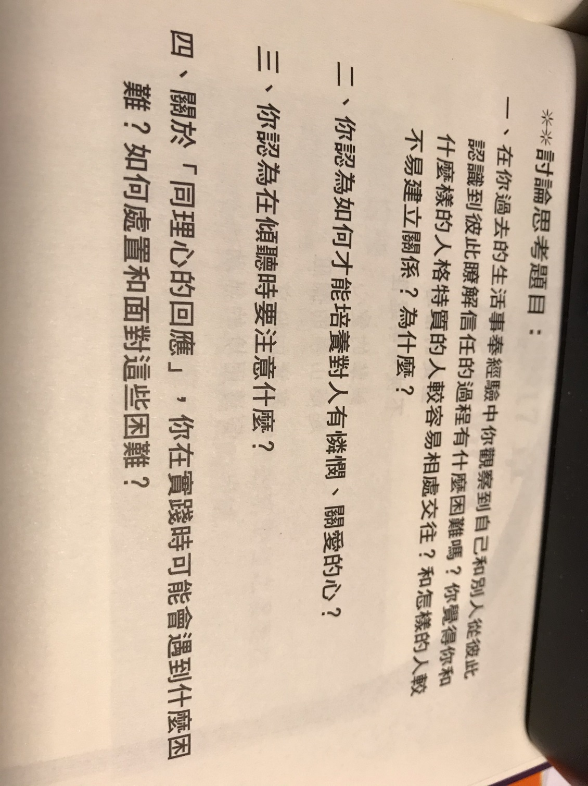

+++++++++++++++++++++++++++++++++++++++++++++++++++++++++++++++++++++++++++++++++++++++++++++++++++++++++++++++++++

Chapter 17: Inspire Hope

- The Hope in the Bible.
- Who needs hope the most? Those have problems for a long time; those who have special problems; those who were wrongly diagnosed; those who are trapped in fear and horror; those who lost hope in the past; those who failed the second time; old people need hope; those who are depressed need hope; those who are prone to suicide need hope; those who experience painful lives need hope.
- False hopes come from materials or satisfaction of the senses; false hopes come from denied facts; false hopes come man’s ideas and views; false hopes come from attitudes of instant rewards; false hopes come from unrealistic fantasies; false hopes come from salvation by works; false hopes come from only enjoying life; false hopes come from wrong interpretation of the Bible; false hopes come from wrong prayer attitude; false hopes come from random Bible reading; false hopes come from resisting opponents’ views; false hopes come from mysterious and superstitious way of thinking.
- Real hopes come from correct Bible interpretation; real hopes come from Christ’s salvation and resulting new life; real hopes come from faith in Christ; real hopes come from fitting the realities; real hopes come from daily renewal principles; real hopes are not selfish; real hopes uphold God’s kingdom; real hopes are correct choice of the will; real hopes bring self-control; real hopes have executable plans; real hopes have sufficient related knowledge; real hopes have experiential backing; real hopes come from God’s word.
- Help others to have relationship with Christ; help others to grow in Christ; help others to view the world using Biblical views; help others by examples and testimonies; help others to do what the Bible teaches; help others to do what is necessary; help others to have alternative choices; help others to pray and praise God; help others to discern sins and sicknesses; help others to understand the Bible; help others to do executable plans; help others to do what is possible now.

第17章：激发希望

1.圣经中的希望。
2.谁最需要希望？那些长期存在问题；有特殊问题的人；那些被错误诊断的人；那些陷入恐惧和恐惧中的人；那些过去失去希望的人；那些第二次失败的人；老年人需要希望；那些沮丧的人需要希望；那些容易自杀的人需要希望；那些经历痛苦生活的人需要希望。
3.错误的希望来自物质或感官的满足；错误的希望来自被否认的事实；错误的希望来自人的想法和观点；错误的希望来自即时奖励的态度；错误的希望来自不切实际的幻想；虚假的希望来自于救赎；虚假的希望只来自享受生活。错误的希望来自对圣经的错误解释；错误的希望来自错误的祷告态度；错误的希望来自随机阅读圣经；错误的希望来自抵抗对手的观点；错误的希望来自神秘而迷信的思维方式。
4.真正的希望来自正确的圣经解释；真正的希望来自基督的救赎以及由此带来的新生命；真正的希望来自对基督的信仰；真正的希望来自于现实。真正的希望来自日常更新原则；真正的希望不是自私的；真正的希望维护着神的国度；真正的希望是对意志的正确选择；真正的希望带来自制力；真正的希望有可执行的计划；真正的希望有足够的相关知识；真正的希望有经验支持；真正的希望来自上帝的话。
5.帮助别人与基督建立关系；帮助别人在基督里成长；帮助他人使用圣经的观点看世界；通过榜样和证词帮助他人；帮助他人按照圣经的教导去做；帮助他人做必要的事情；帮助他人有其他选择；帮助别人祈祷和赞美上帝；帮助他人辨别罪恶；帮助他人理解圣经；帮助他人制定可执行计划；帮助他人做现在可能的事。

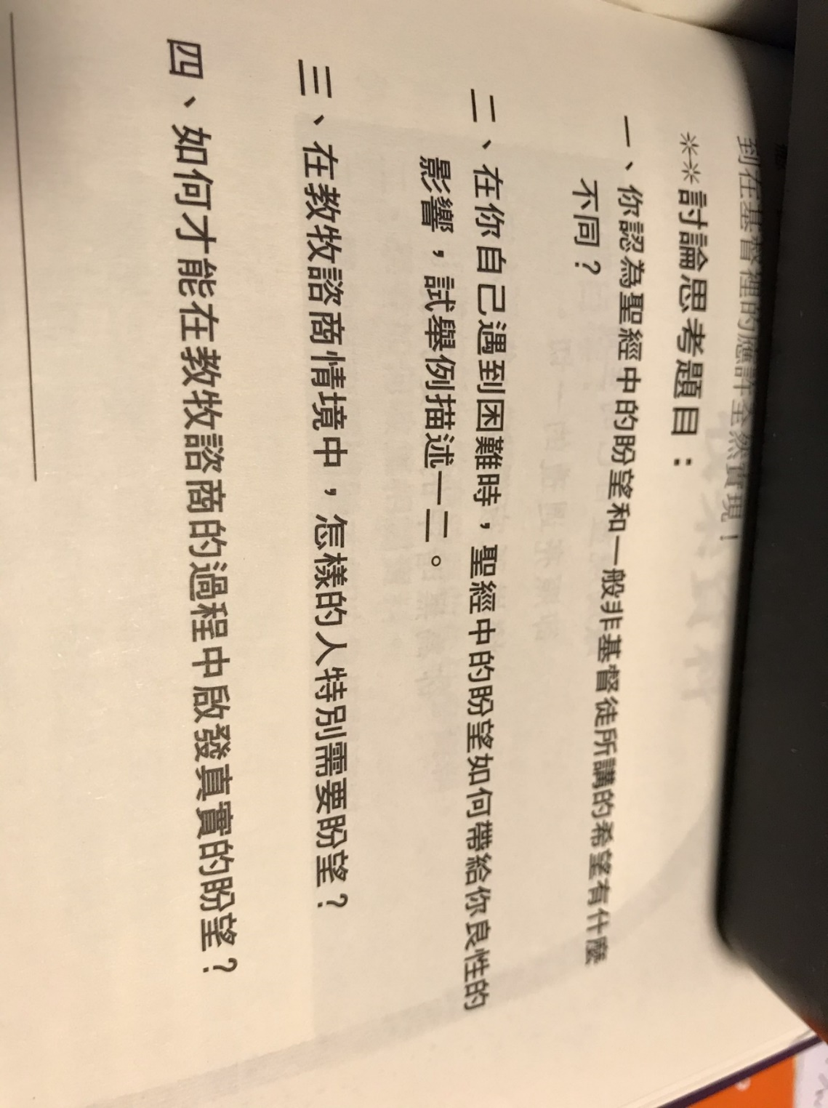

Chapter 18: Gather information

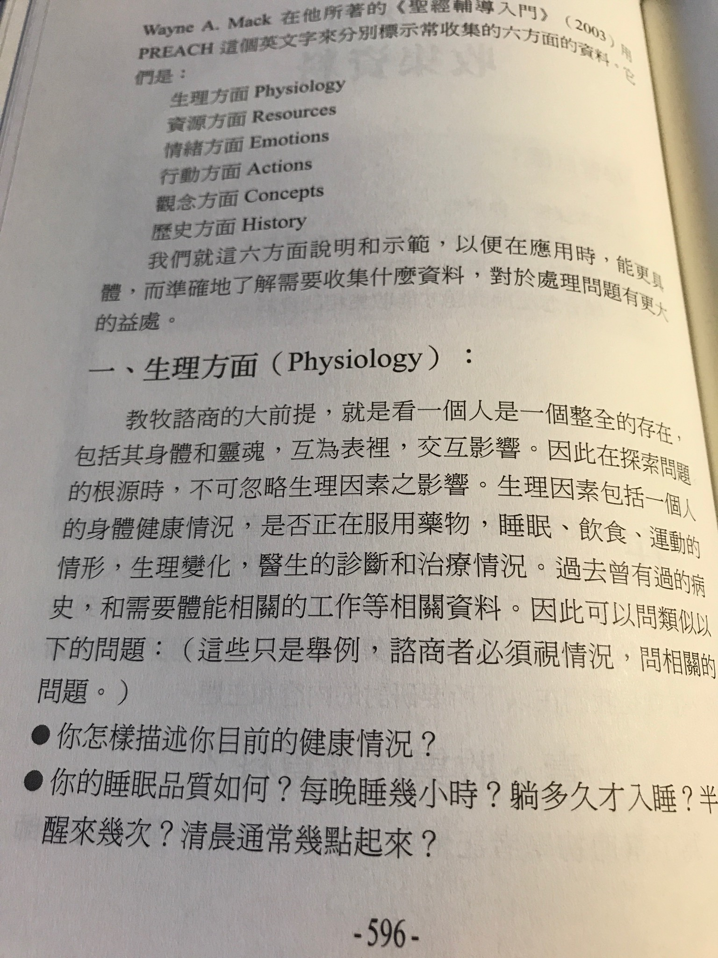

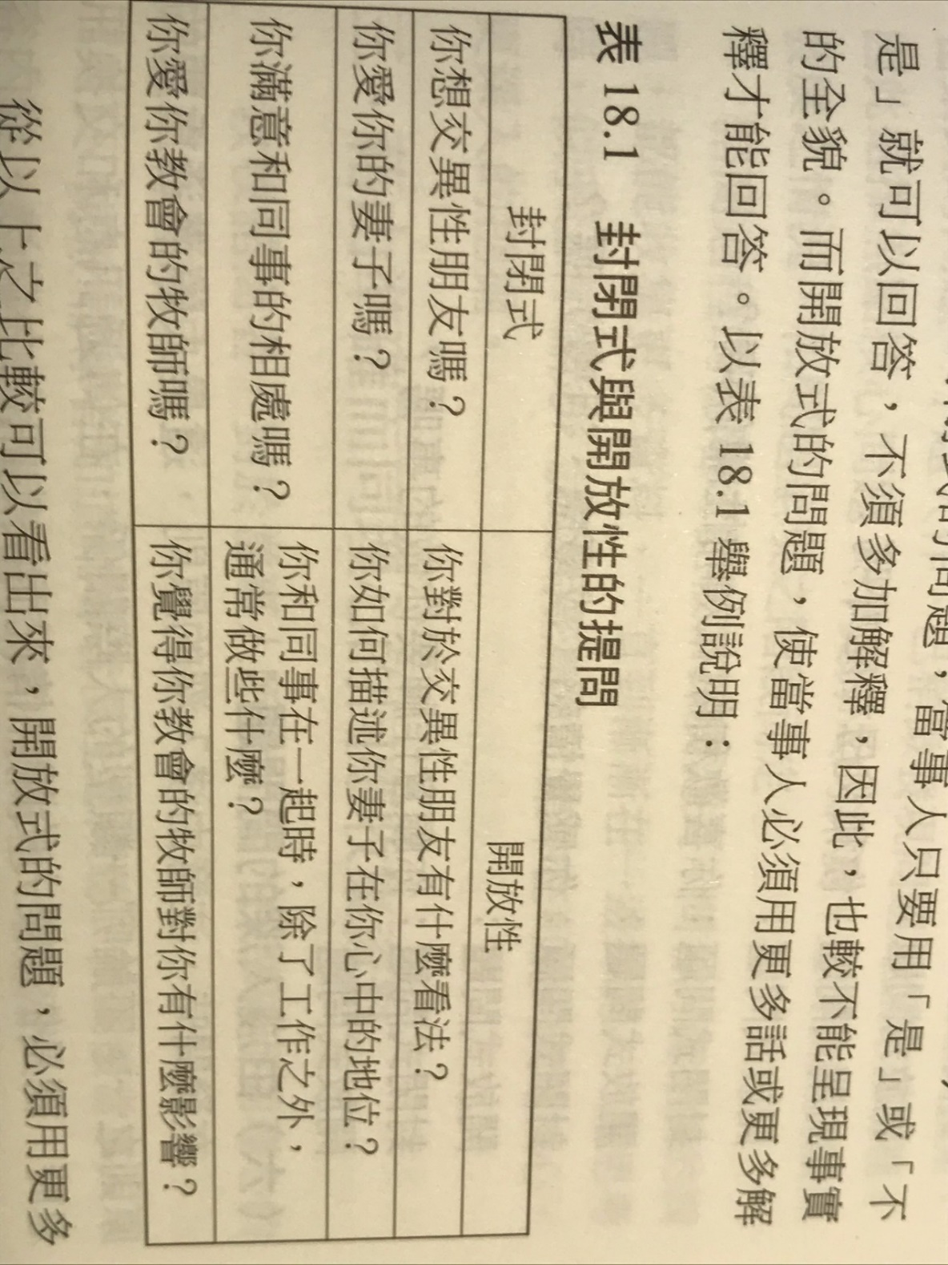

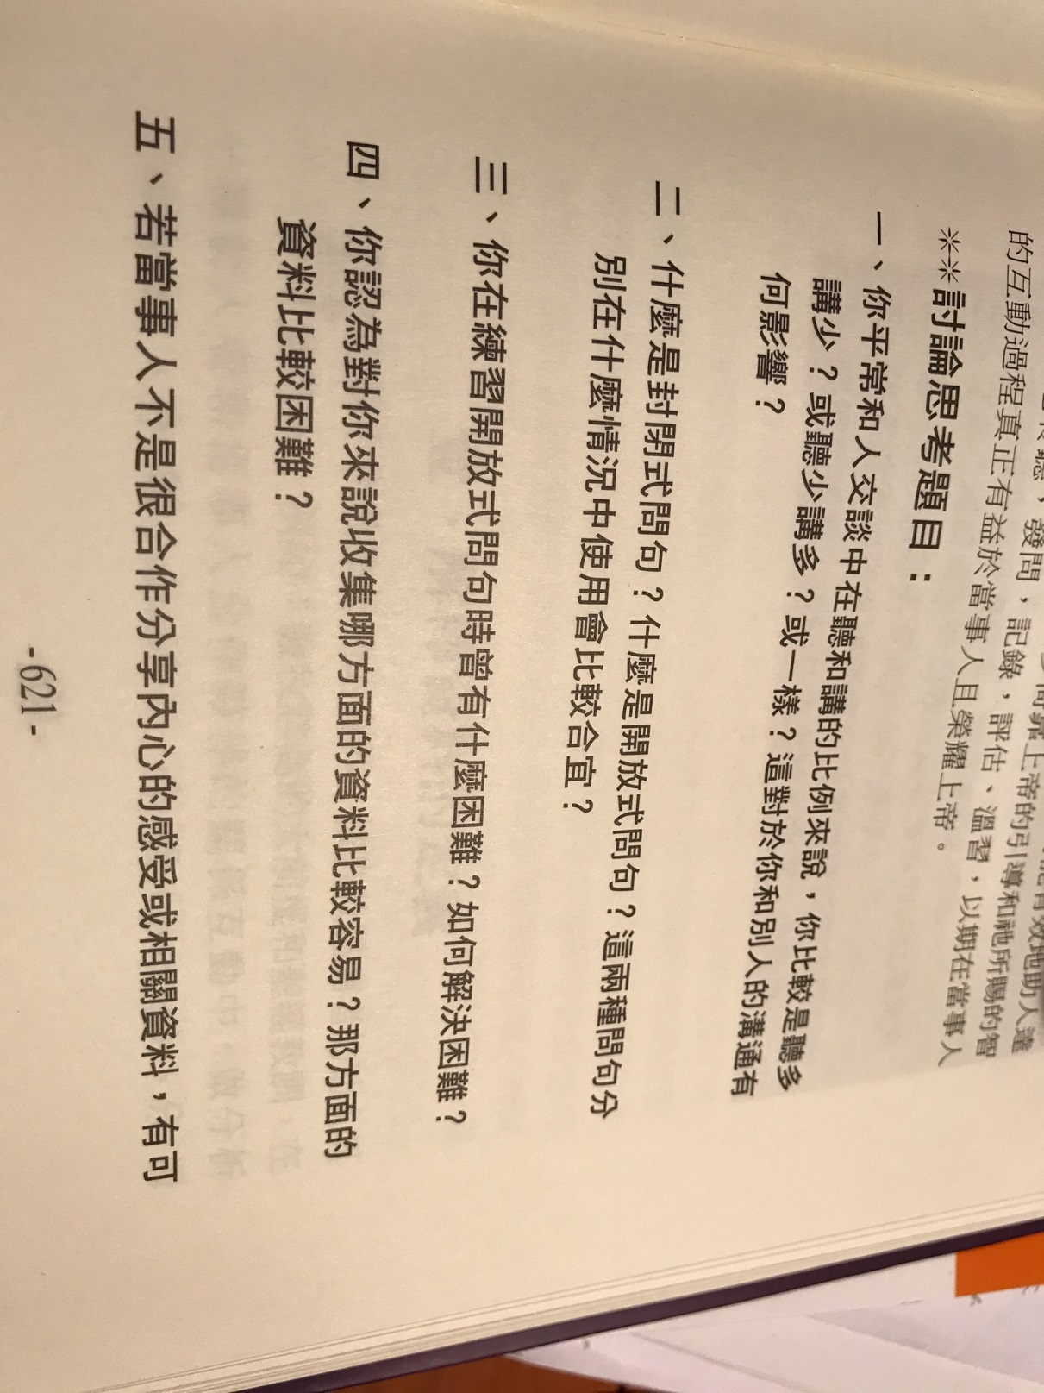

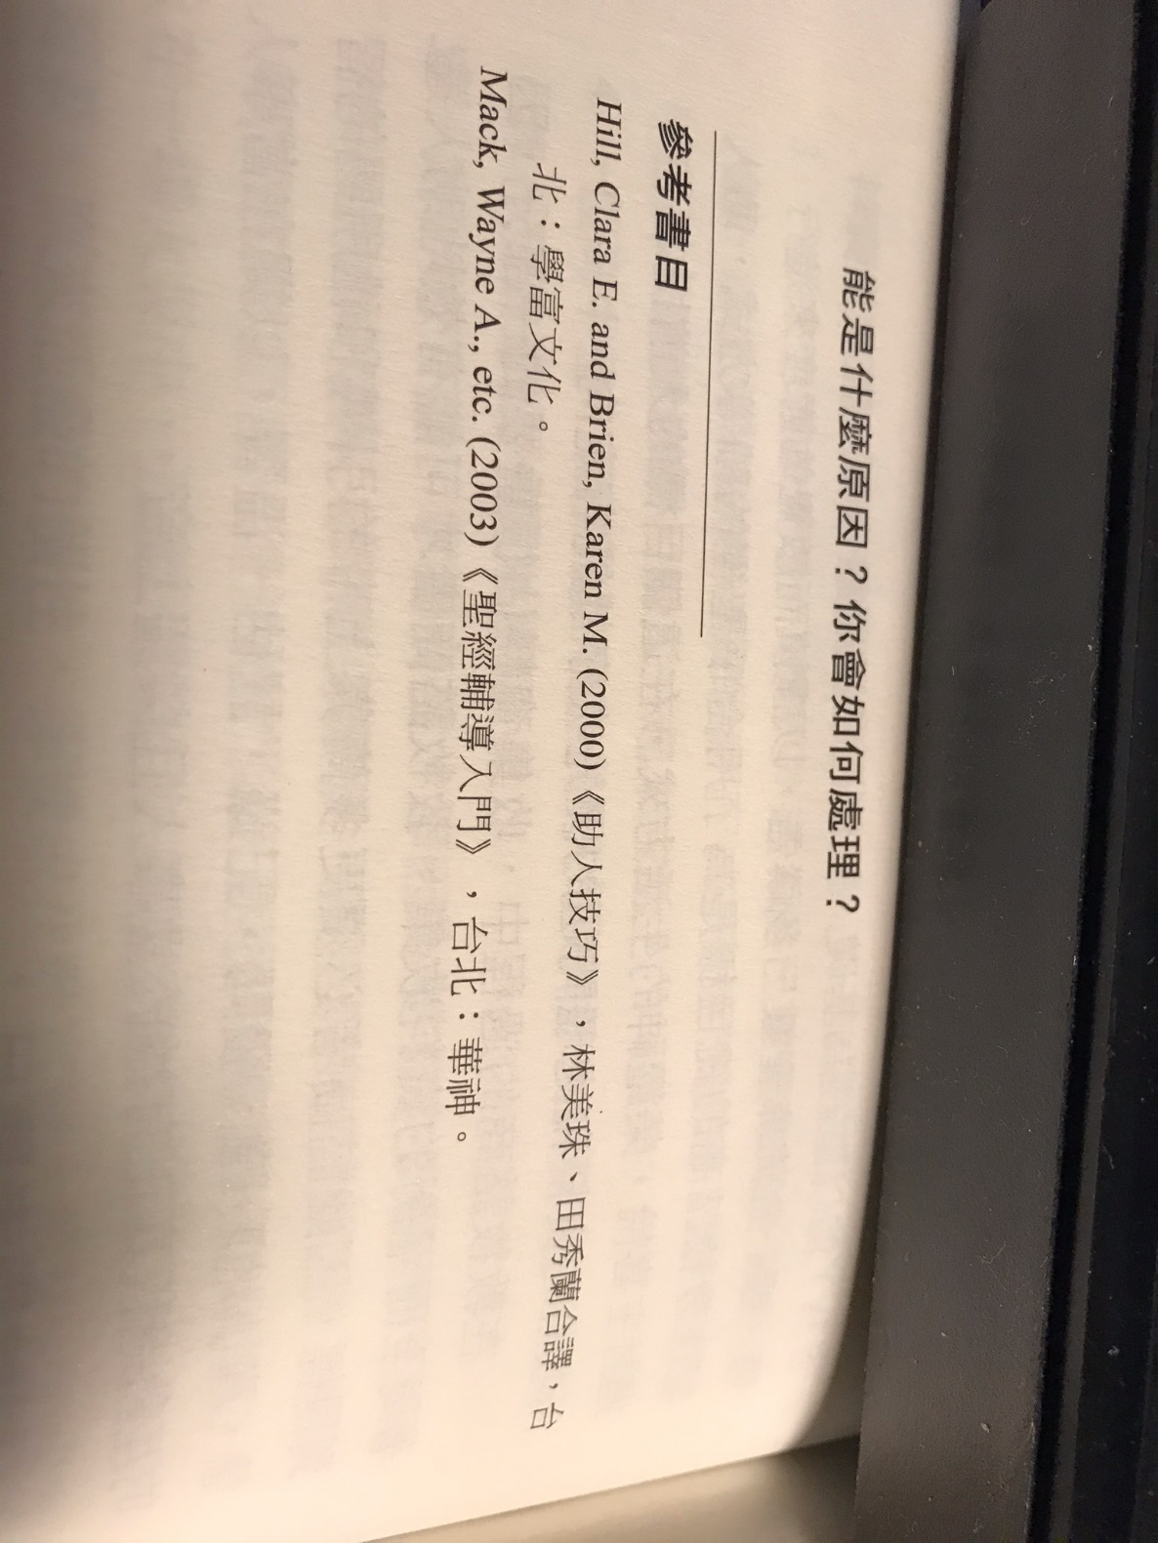
++++++++++++++++++++++++++++++++++++++++++++++++++++++++++++++++++++++++++++++++++++++++++++++++++++++++++++++++++++++
第 9 周 2页的摘要, 问题和解答到期。

Chapter 19: Explaining information.

- From the Bible, find words that describe sins.
- From the Bible, find the root causes of the problems: foul language; illogical deductions; fighting; abuses; fears; inner sickness; sleep problems; melancholy; depression; lying.
- Use past experience in counseling.
- Explain information, make assumptions, decision and testing.

第19章：解释信息。

1.从圣经中找到描述罪恶的词。
2.从圣经中找出问题的根本原因：粗言秽语； 不合逻辑的推论； 战斗; 虐待； 恐惧, 内心疾病, 睡眠问题； 忧郁, 萧条; 说谎。
3.利用过去的咨询经验。
4.解释信息，进行假设，决策和测试。
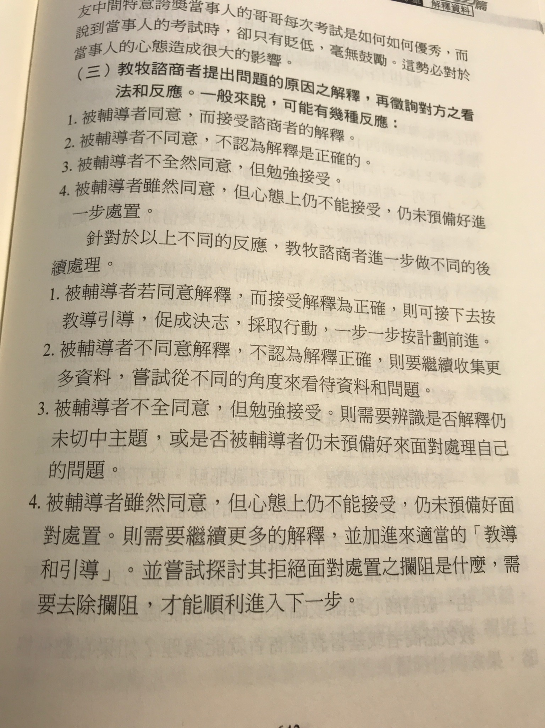
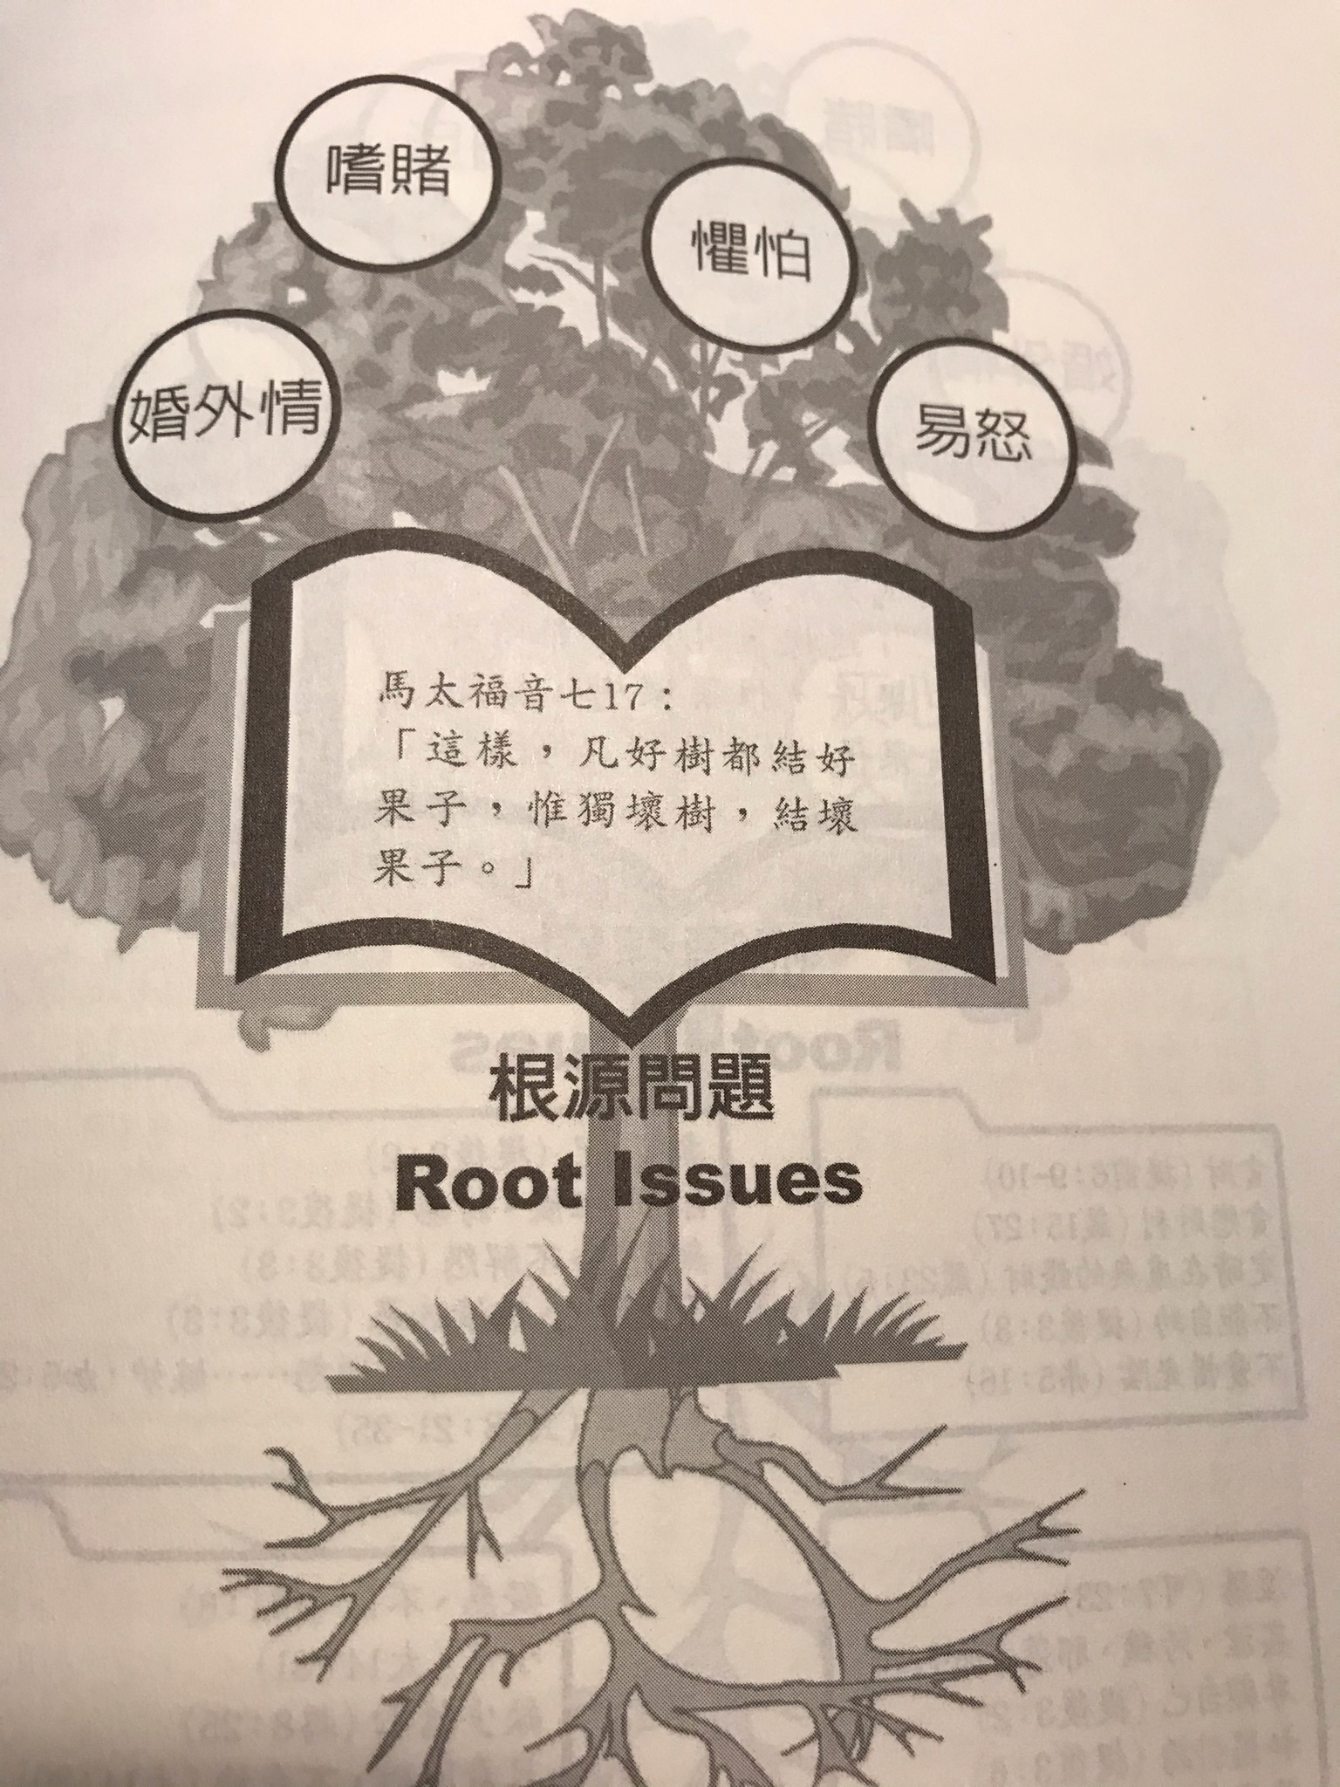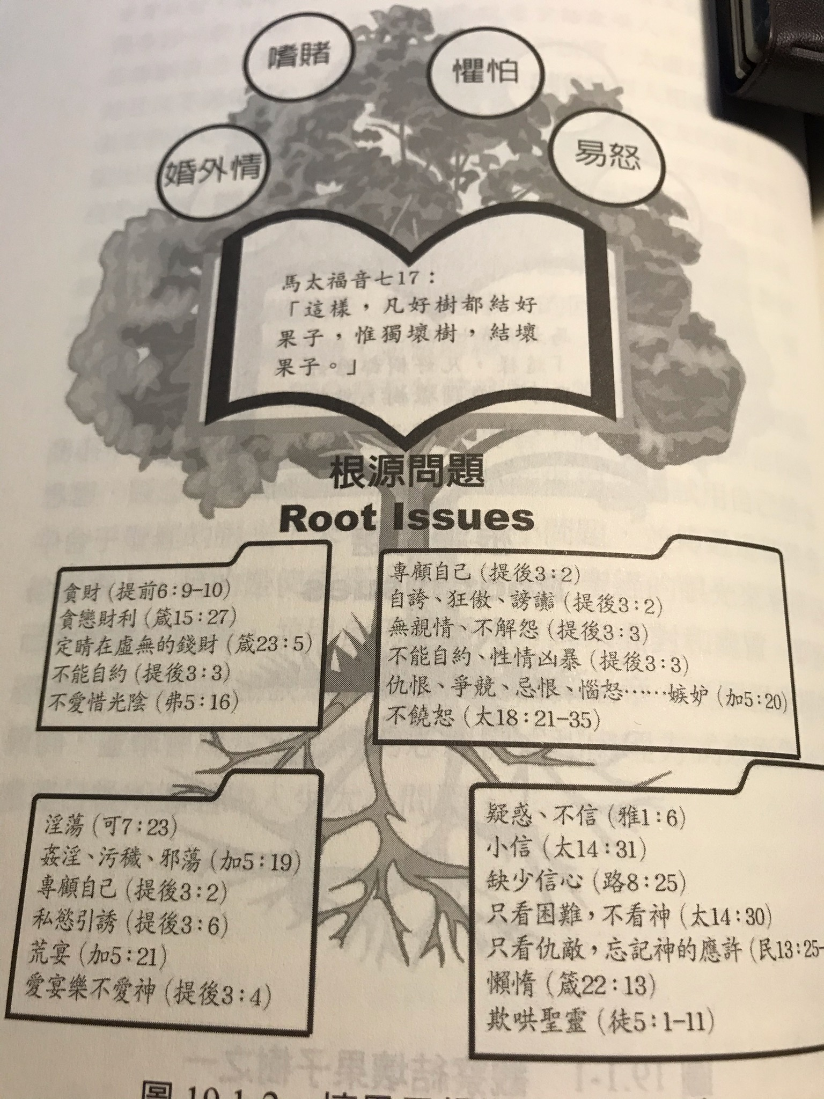
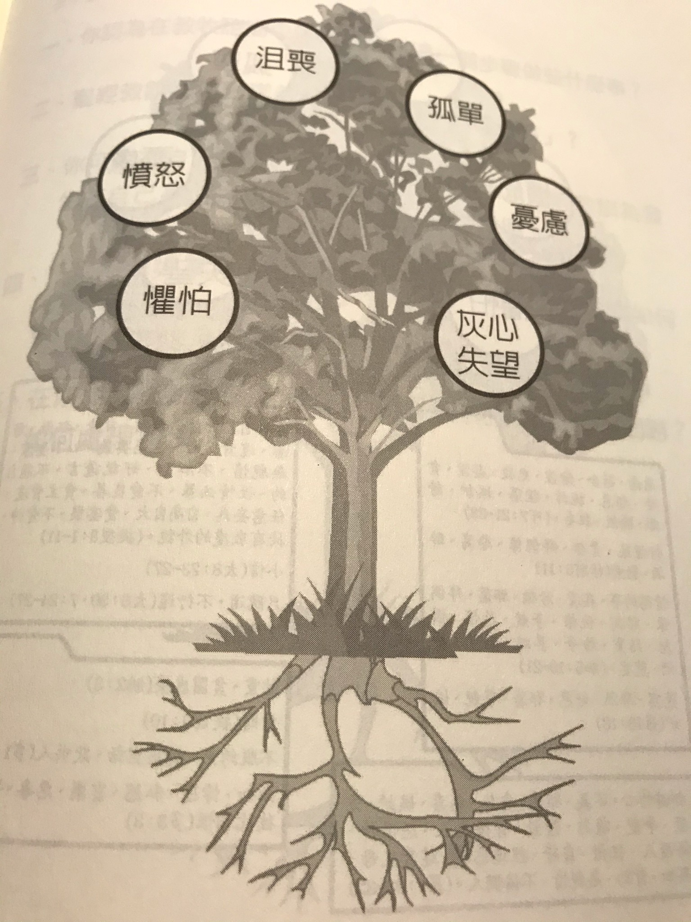
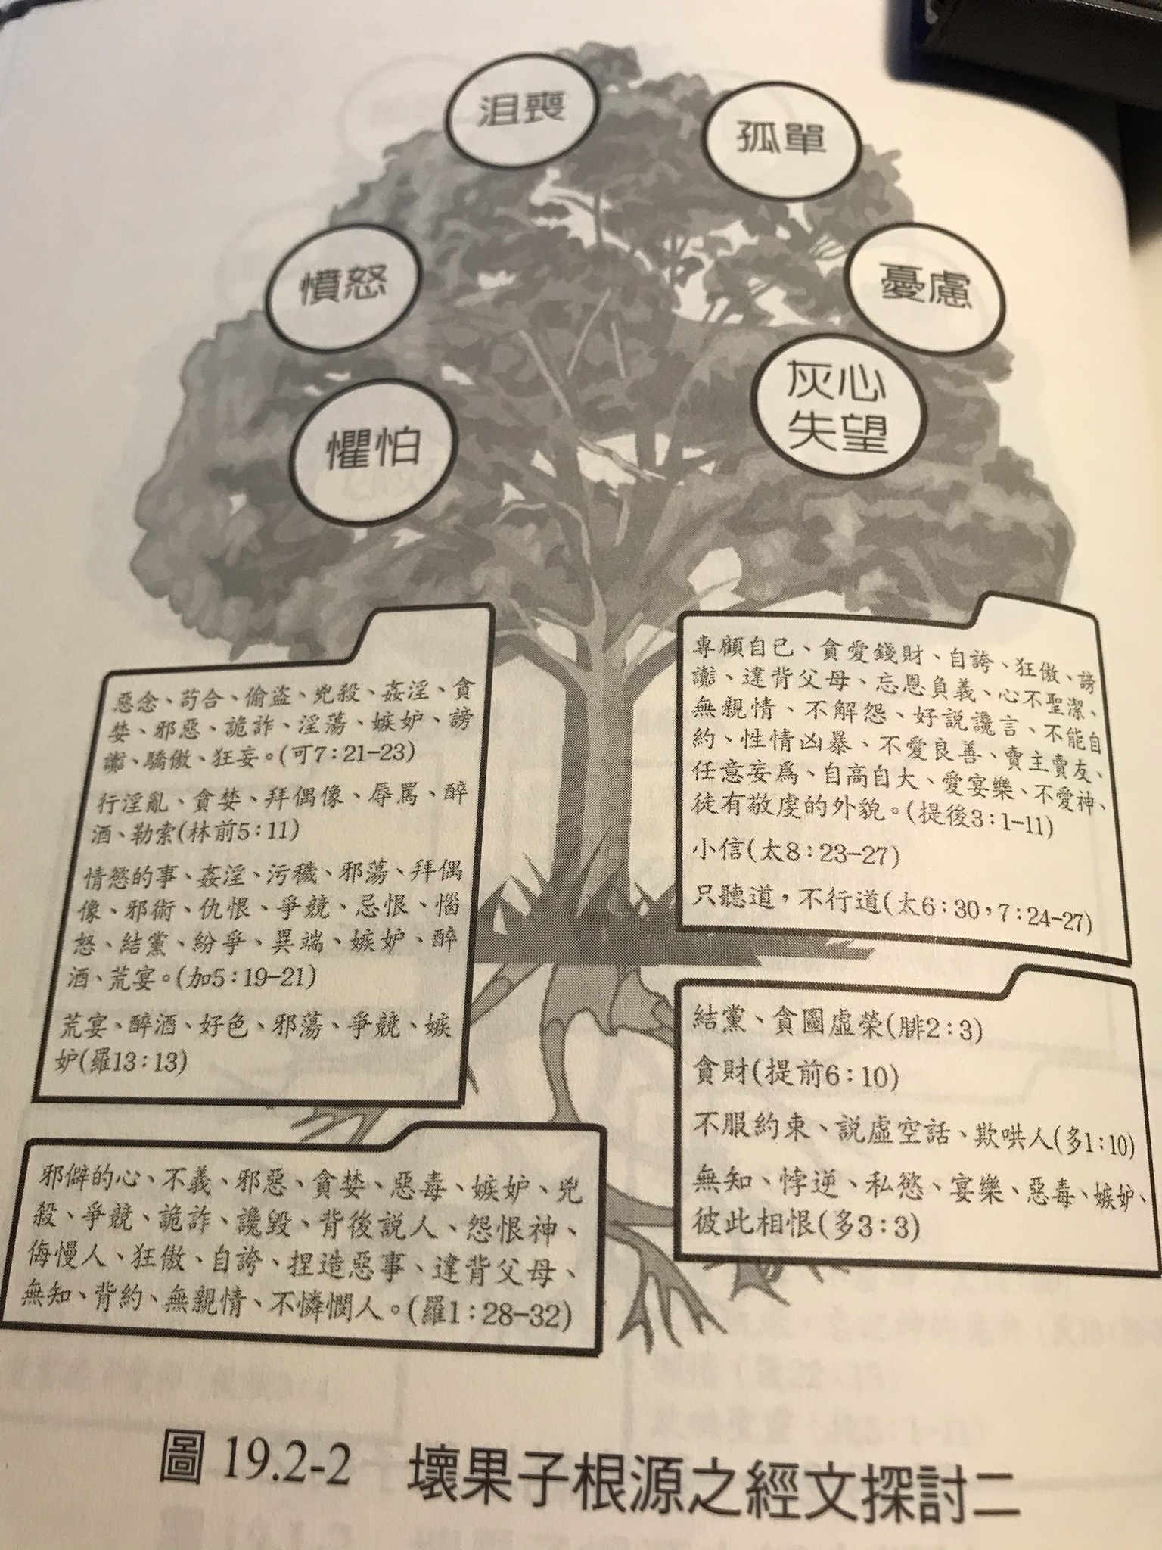

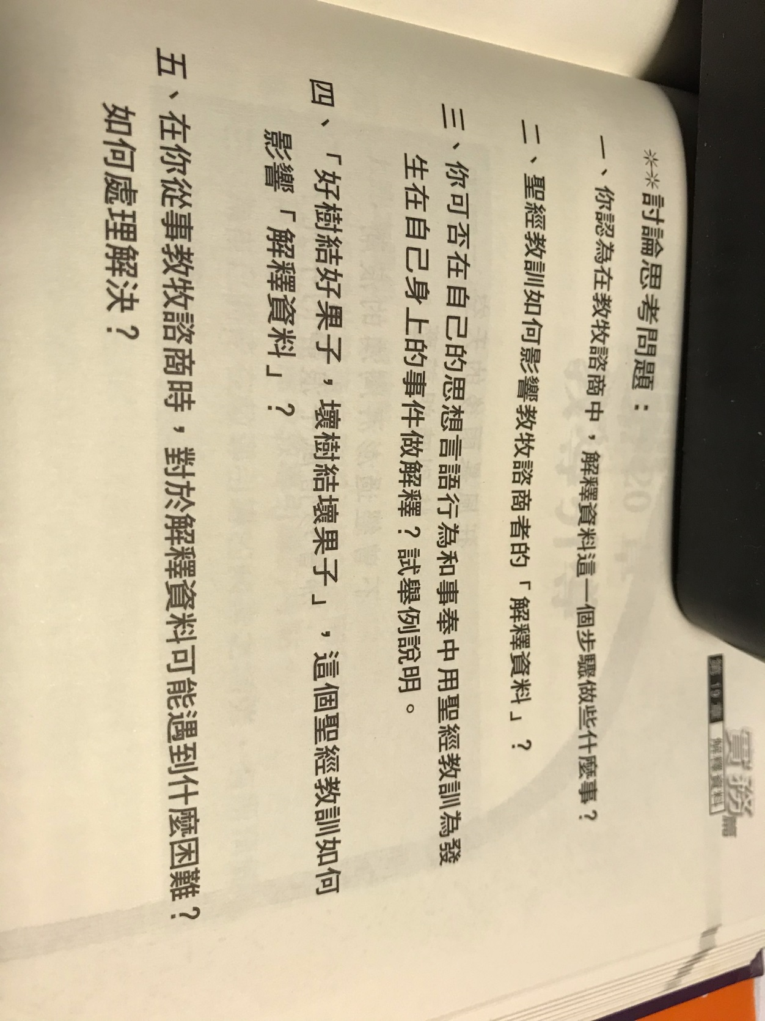

+++++++++++++++++++++++++++++++++++++++++++++++++++++++++++++++++++++++++++++++++++++++++++++++++++++++++++++++

- Counseling does not just recommend some information.
- Counseling is not some friendly chat.
- Counseling is not interview or interrogation.
- Counseling is not just teaching.
- Counseling is not to explain some information.
- Counseling is not to make decisions for other people.
- Counseling is not to solve superficial problems for others.
- Counseling is not only being a partner.
- Counseling is not to blame.
- Counseling is a process.
- Counseling is a one-to-one talk.
- Counseling is a relationship.
- Counseling is a teaching and learning process.
- Counseling is a process to help people to go through difficult times.
- Counseling teaches the Bible.
- Counseling obeys the guidance of the Holy Spirit.
- Counseling emphasizes Christ and centered in the Gospel.
- Counseling stresses on Biblical principles and God’s word.
- Counseling must make a distinction between God’s word and man’s suggestions.
- Counseling must point out what man needs to change and how to change.
- Counseling must teach appropriate materials.
- Teach by means of lecture, observation, experience, research, discussion, questions, reading assignments, evaluations, self-disclosure, illustration, role-playing, interview.

1.咨询不只是推荐一些信息。
2.咨询不是友好的聊天。
3.咨询不是面谈或讯问。
4.咨询不仅仅是教学。
5.咨询不是要解释一些信息。
6.咨询不是为他人做决定。
7.咨询不是解决别人的肤浅问题。
8.咨询不仅是合作伙伴。
9.咨询不是罪魁祸首。
10.咨询是一个过程。
11.咨询是一对一的谈话。
12.咨询是一种关系。
13.咨询是一个教学过程。
14.咨询是一个帮助人们度过困难时期的过程。
15.辅导教圣经。
16.咨询服从圣灵的指导。
17.辅导强调基督，并以福音为中心。
18.咨询强调圣经的原则和神的话语。
19.咨询必须区分上帝的话和人的建议。
20.咨询必须指出人需要改变什么以及如何改变。
21.咨询必须教授适当的材料。
22.通过演讲，观察，经验，研究，讨论，问题，阅读作业，评估，自我披露，插图，角色扮演，面试等方式进行教学。

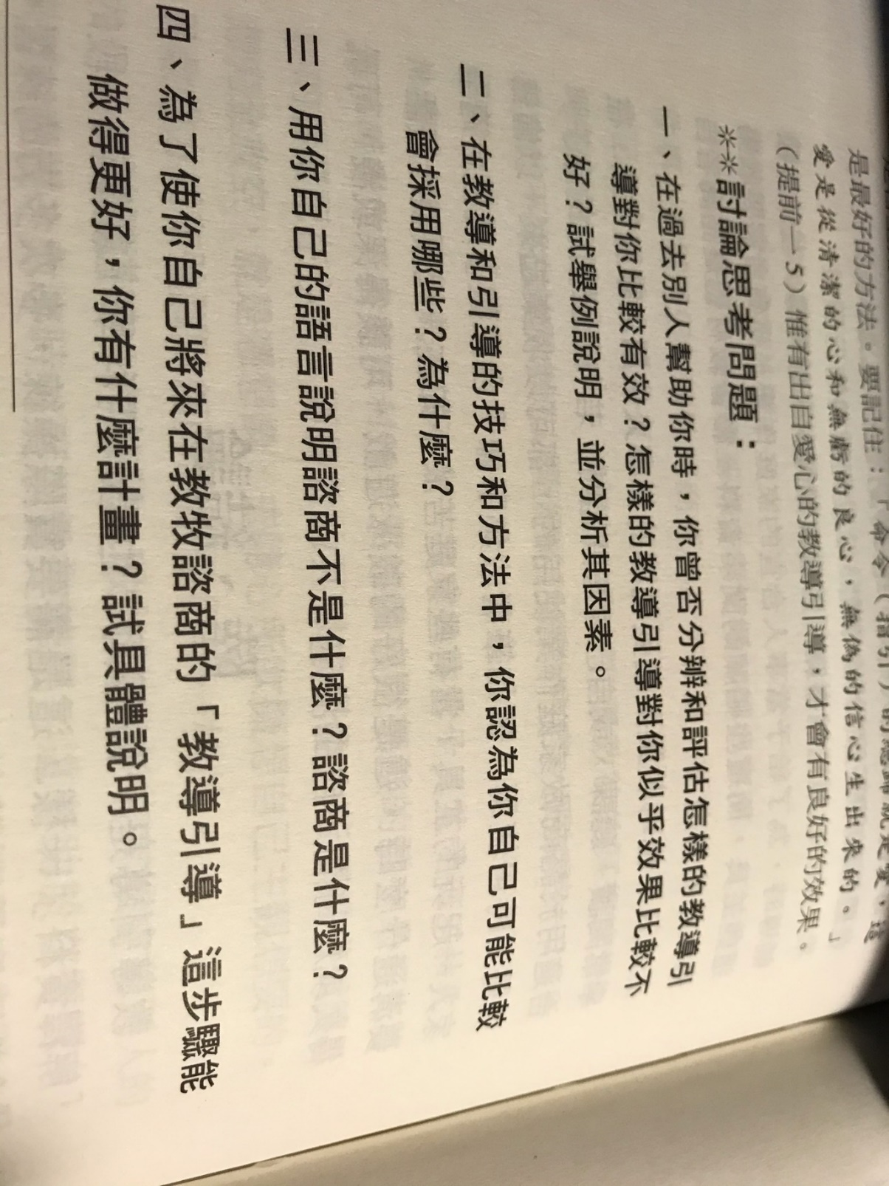

+++++++++++++++++++++++++++++++++++++++++++++++++++++++++++++++++++++++++++++++++++++++++++++++++++++++++++++++++

- Help people to be responsible their thoughts, motivation, feeling, attitude, and actions.
- Help people to change according to God’s way.
- Help people to understand that changes start from their heart.
- Help people to get rid of unwanted desires, thoughts, actions.
- Help people to make a commitment to change.
1.帮助人们对自己的思想，动力，感觉，态度和行为负责。
2.帮助人们按照上帝的方式改变。
3.帮助人们了解变化是从心开始的。
4.帮助人们摆脱不必要的欲望，思想和行为。
5.帮助人们做出改变的承诺。

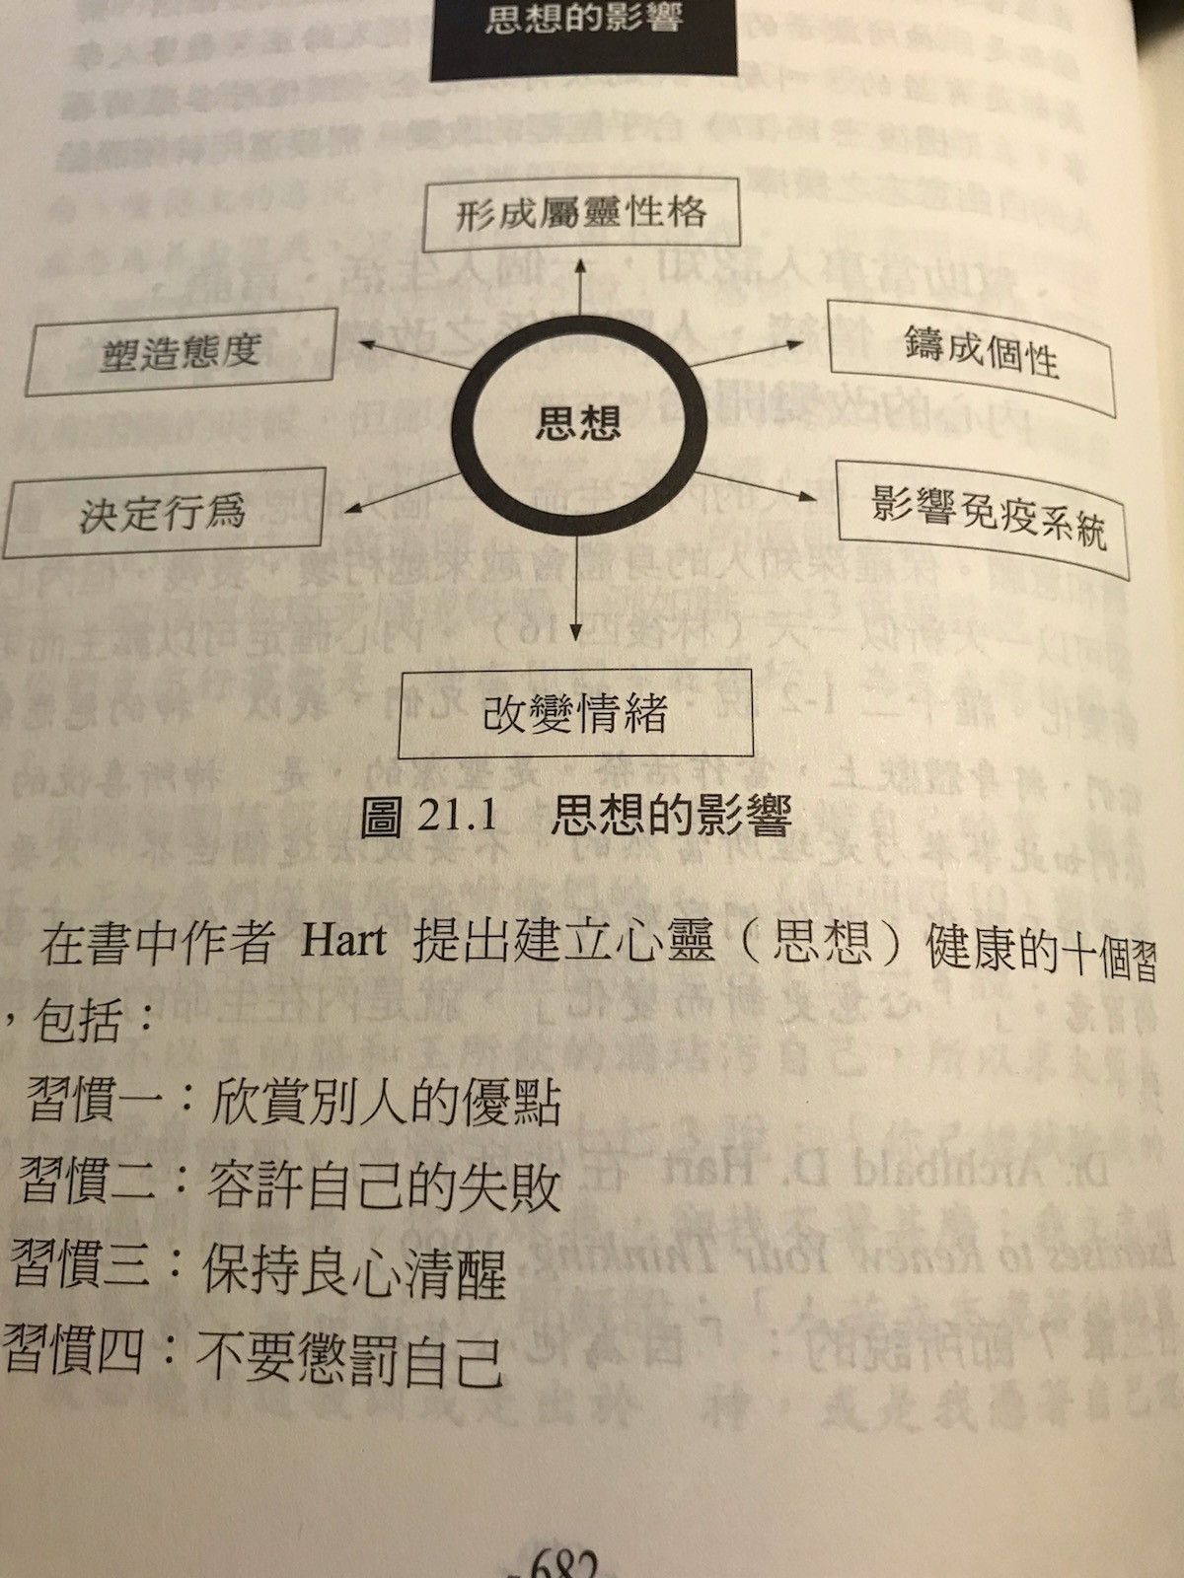
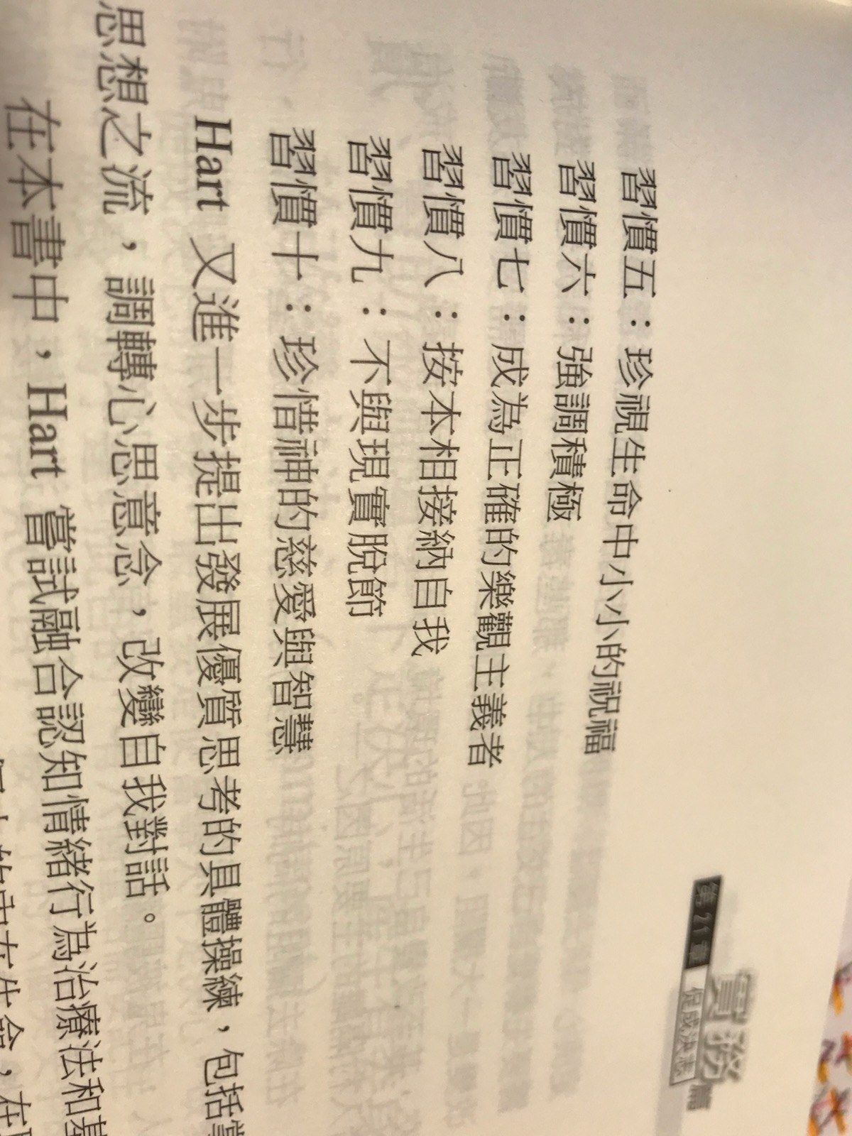

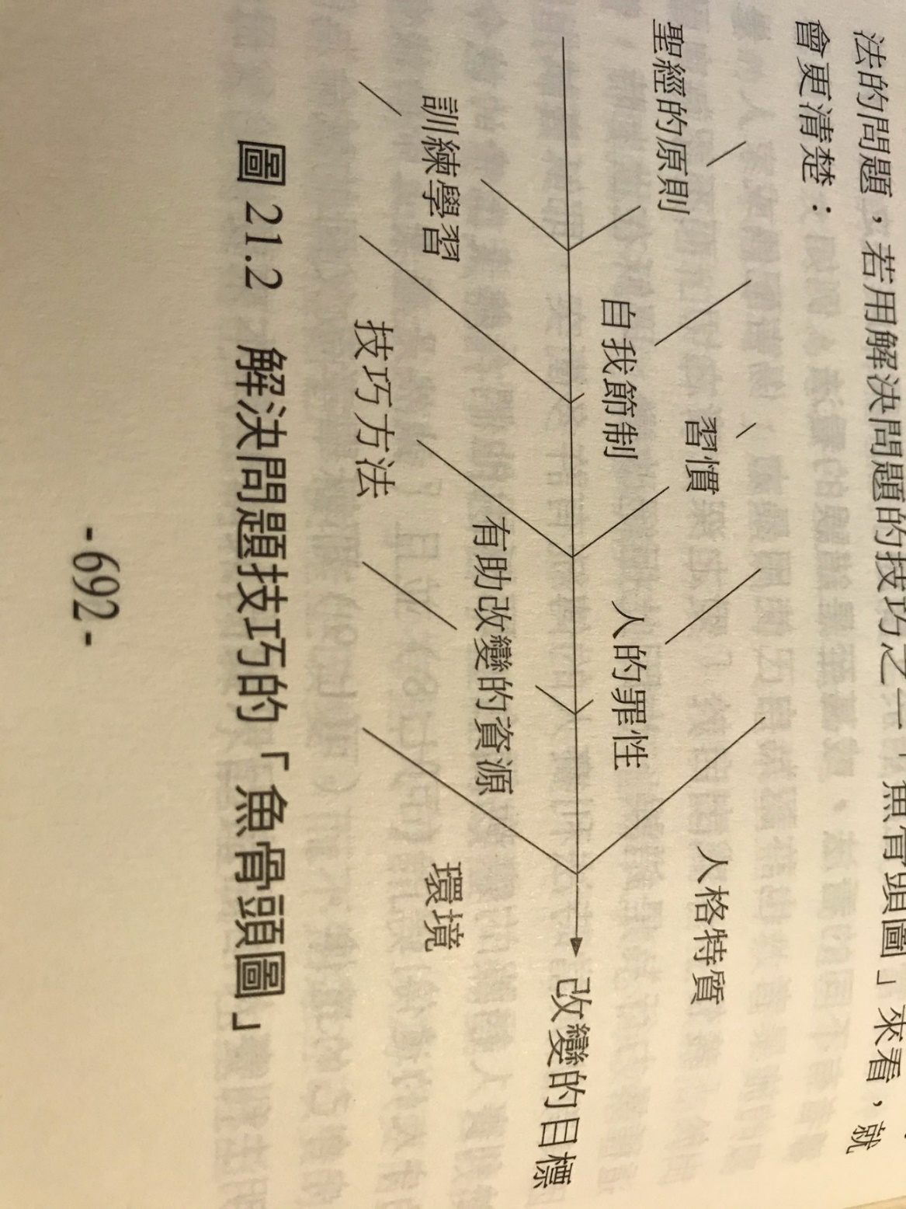

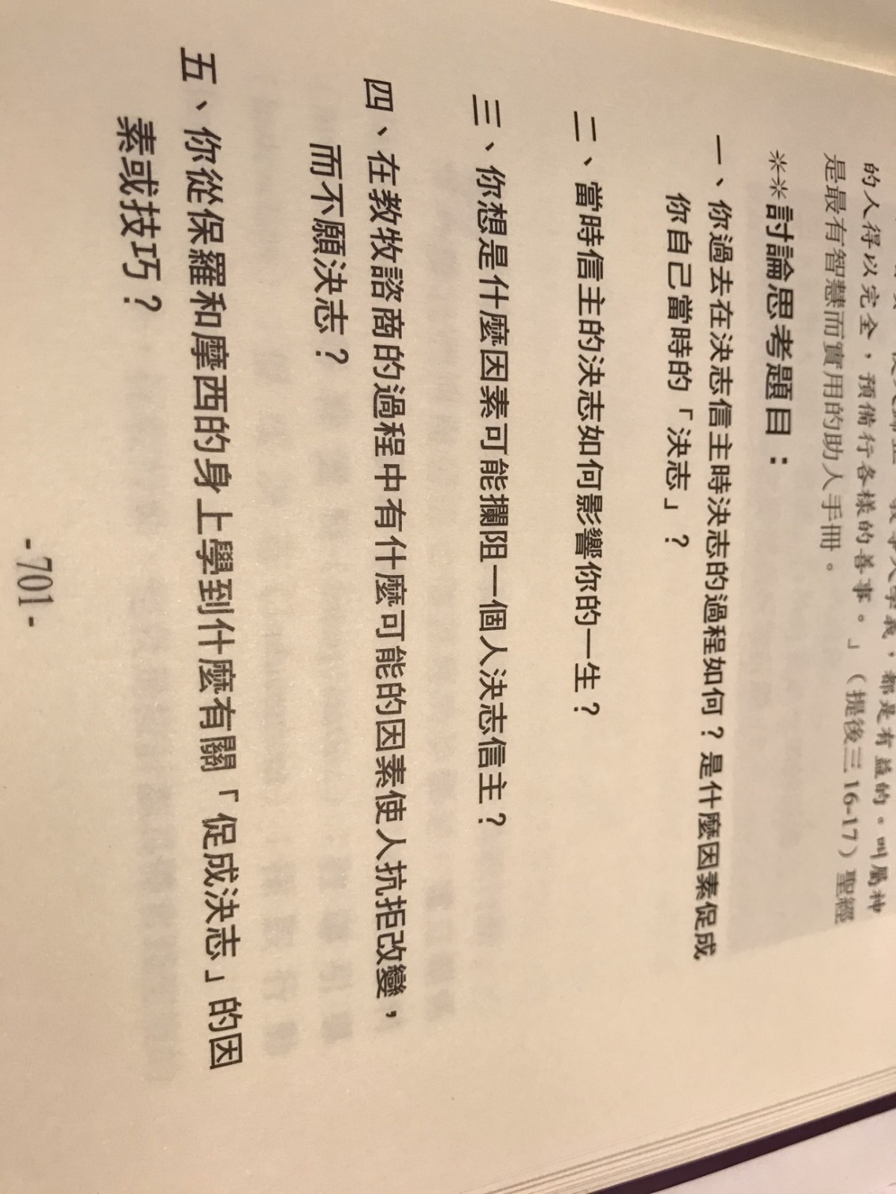
++++++++++++++++++++++++++++++++++++++++++++++++++++++++++++++++++++++++++++++++++++++++++++++++++++++++++++++
第10 周 2页的摘要, 问题和解答到期。

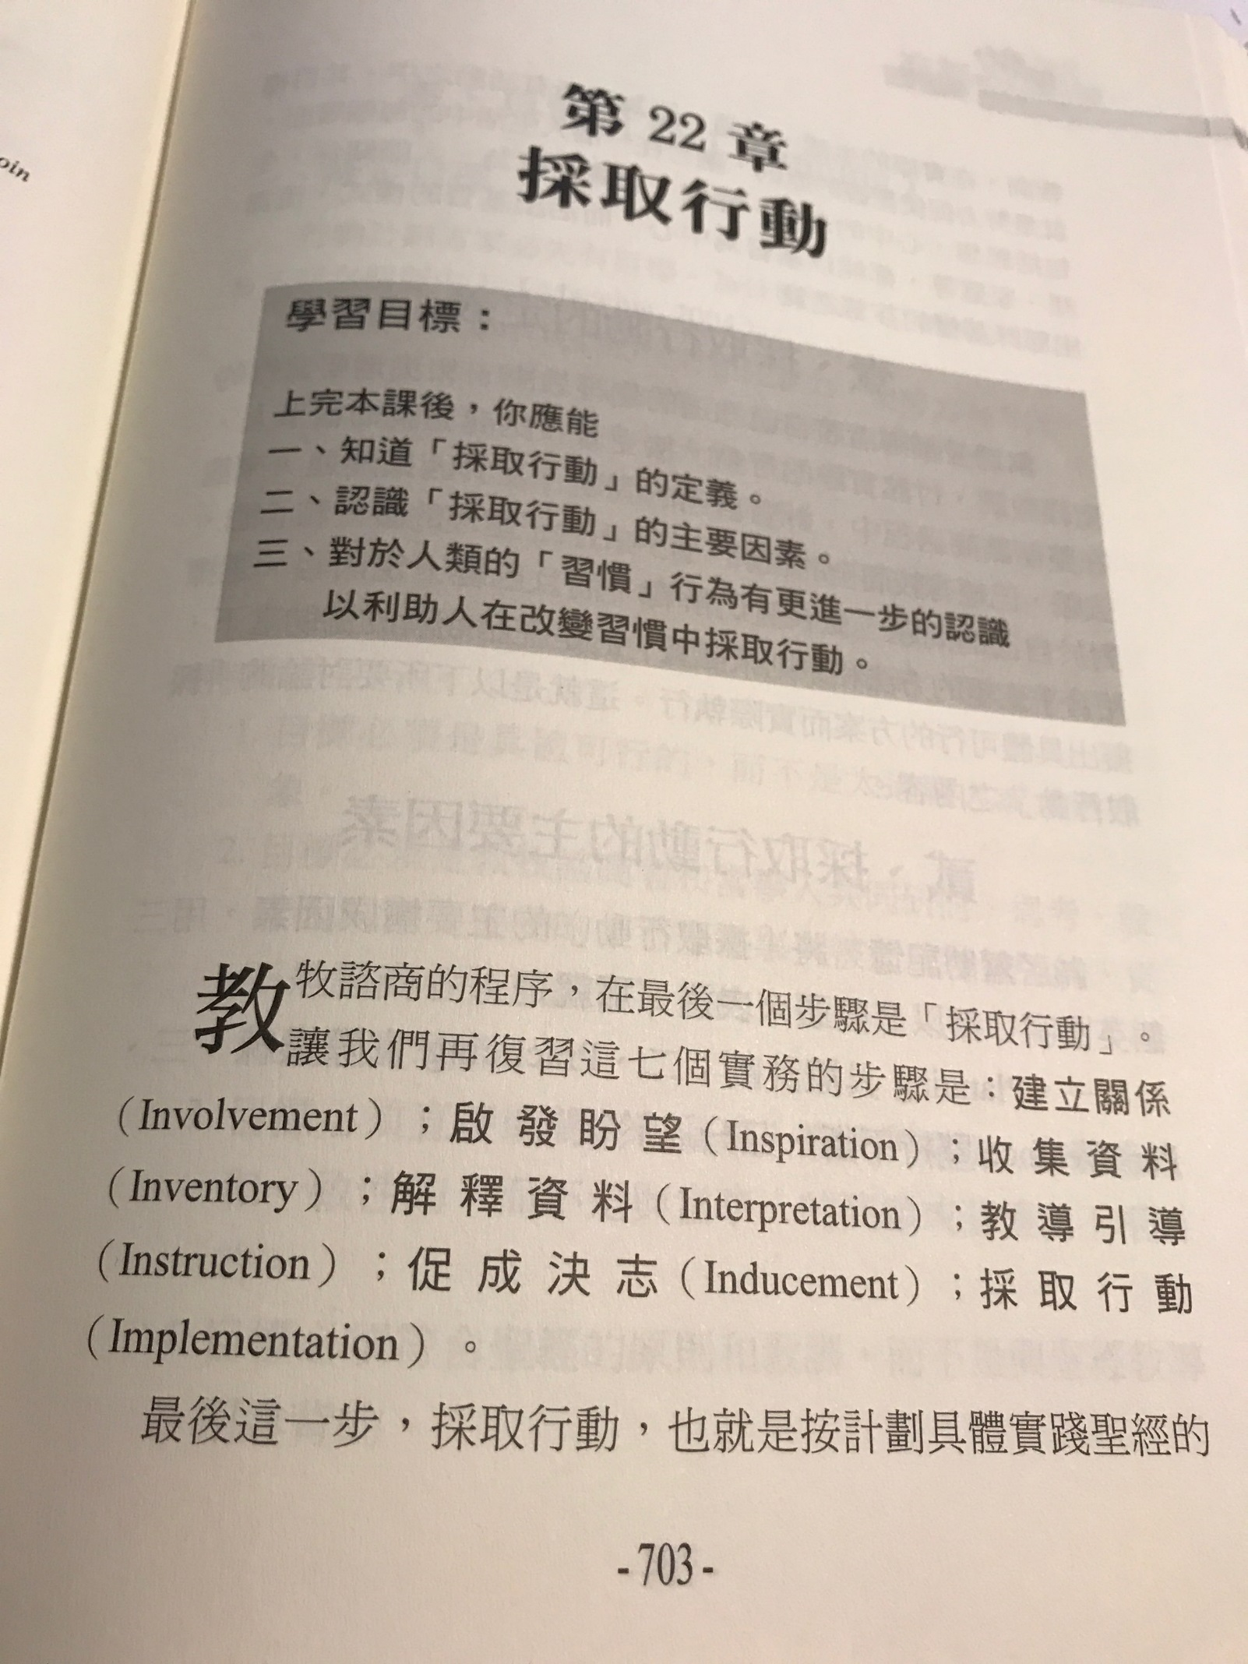
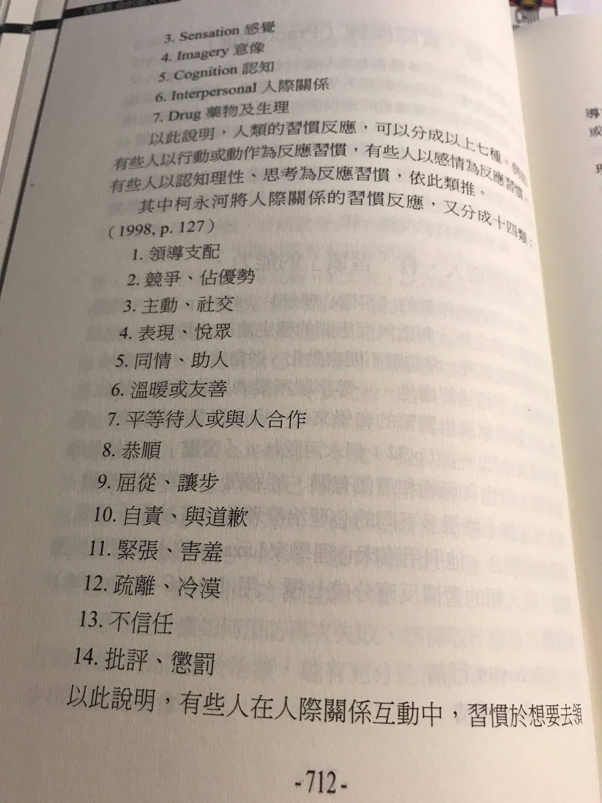

- God created man to have the ability to get to a habit.
- Habits to learn, to act, to think, to have emotions and to get into relationships.
- Habits to learn and to practice change.
- Habits that agree with the Bible should be reinforced; those that do not agree with the Bible should be changed.
- Habits that agree with the Bible should be counselled to be reinforced.
- Change is a process.
- Change should be practiced daily.
- Change needs to be continually practiced.

1.上帝创造了人, 人可以养成习惯。
2.习惯于学习，行动，思考，具有情感并建立关系。
3.学习和实践改变的习惯。
4.应当加强与圣经相符的习惯； 那些不同意圣经的应该改变。
5.应该劝告加强与圣经相符的习惯。
6.改变是一个过程。
7.应该每天进行更改。
8.变革需要不断实践。

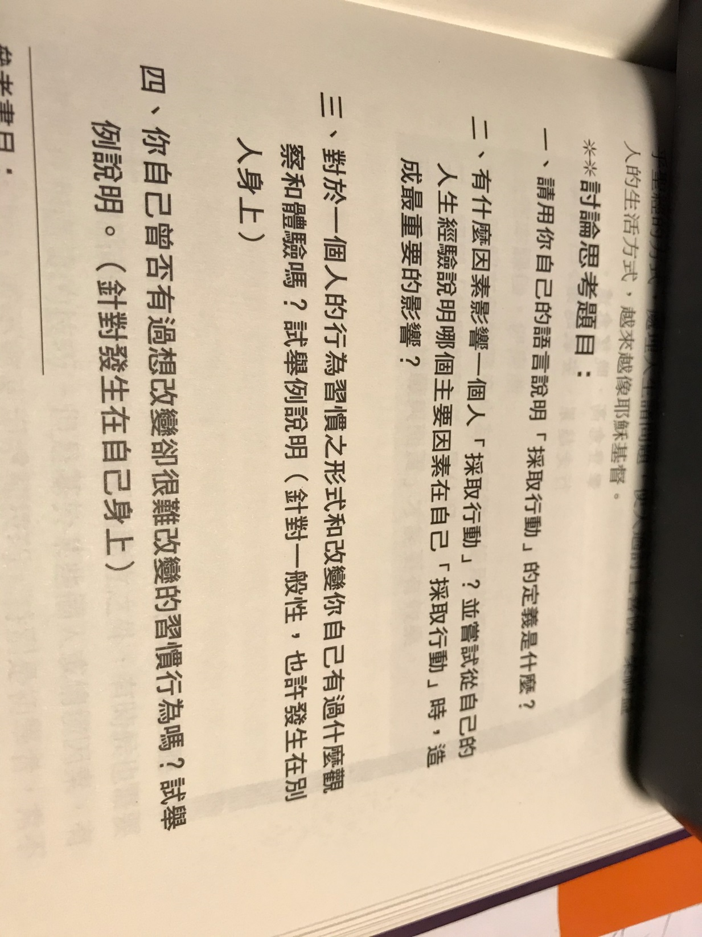

++++++++++++++++++++++++++++++++++++++++++++++++++++++++++++++++++++++++++++++++++++++++++++++++++++++++

Challenge and confrontation do not follow Biblical principles.
挑战和对抗不遵循圣经的原则。
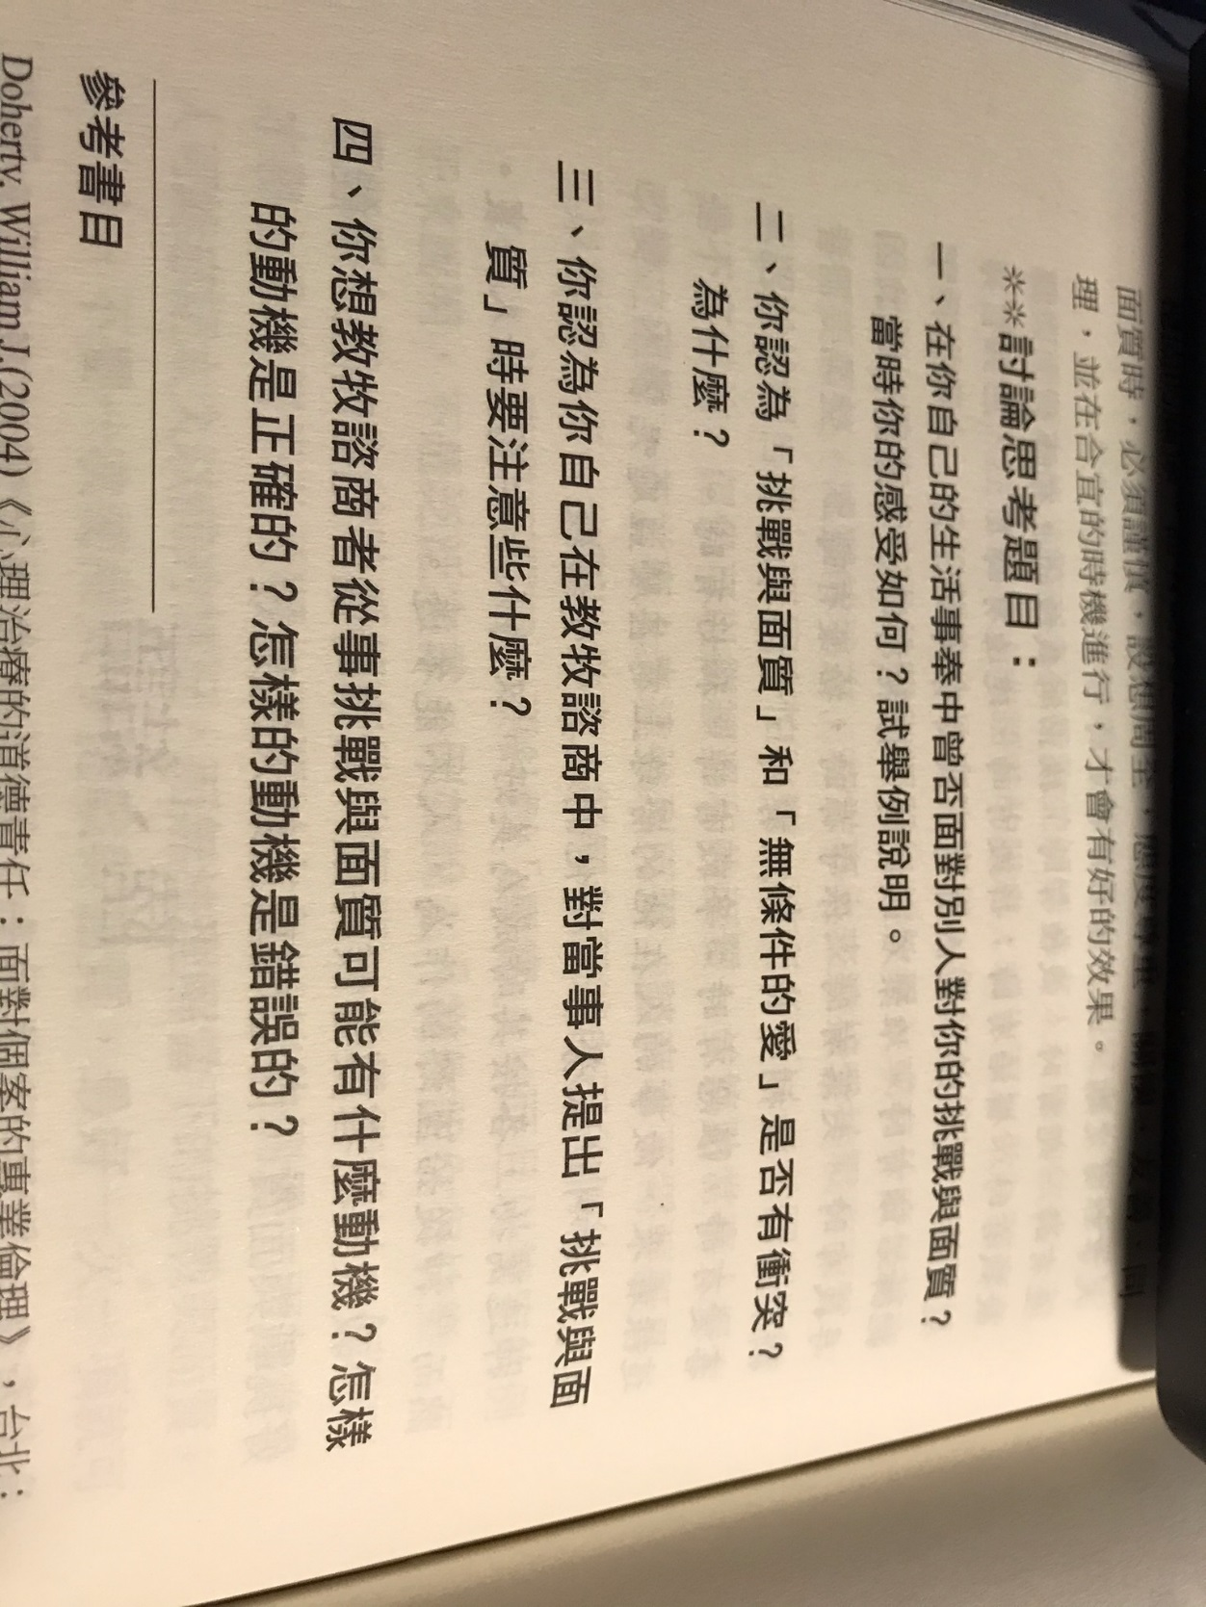

Transfer and Conclusion.
转让和结论。
